Particle model: knowledge check
- Add the following labels to the diagram below.

boiling condensing freezing gas

liquid melting solid
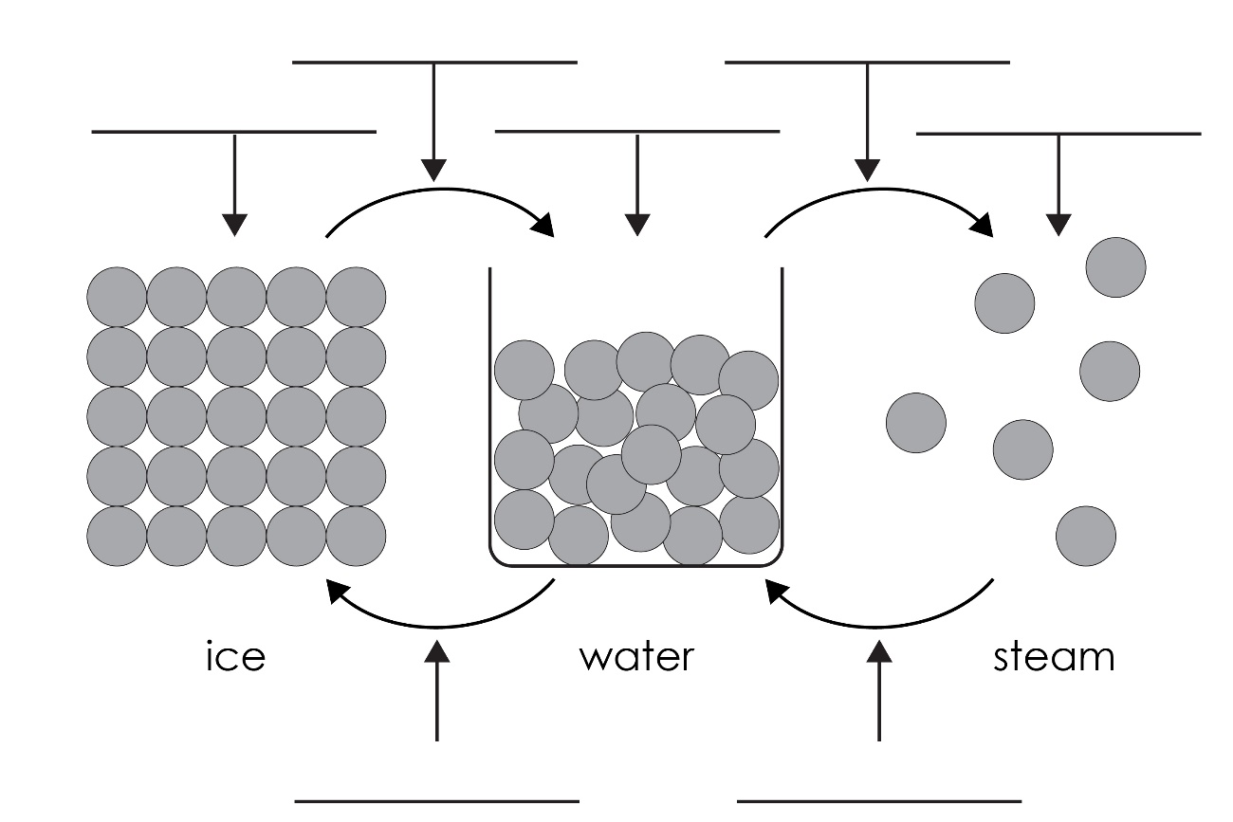
- Use the words to complete the sentences.

close together regular shape vibrate

In solids, the particles are very close together in a _____________________________________ pattern. The particles _____________________________________ around a fixed position. Solids have a fixed _____________________________________. Solids cannot be easily compressed because their particles are _____________________________________ with no space to move into.

- Use the words to complete the sentences.

compressed flow less more

particles randomly shape

In liquids, the particles are very close together and are ___________________________ arranged, but still touching. The particles move around each other and have ___________________________ energy than in a solid but ___________________________ than in a gas.

Liquids do not have a fixed ___________________________. Liquids can ___________________________ and take the shape of their container, because their ___________________________ can move around each other. Liquids cannot be easily ___________________________ because their particles are close together with little space to move into.
- Use the words to complete the sentences.

energy flow particles

quickly randomly space

In gases, the particles are far apart and ___________________________ arranged.
The particles move ___________________________ in all directions. The particles in a gas have much more ___________________________ than the particles in a liquid or solid. Gases do not have a fixed shape and can ___________________________ and completely fill their container. Gases can be compressed, because their ___________________________ are far apart with ___________________________ to move into.

Particle model: test myself

Choose suitable words to complete the sentences.
- Write the words that describe the following changes of state.
  - Solid → liquid (eg ice to water) is known as ___________________________.
  - Liquid → solid (eg water to ice) is known as ___________________________.
  - Liquid → gas (eg water to steam) is known as ___________________________.
  - Gas → liquid (eg steam to water) is known as ___________________________.

- In which state do the particles have most kinetic energy?

Particles have most kinetic energy in the ___________________________ state.
- What happens to the kinetic energy of the particles when a solid changes to a liquid?

The kinetic energy _______________________________________.

- Describe the arrangement of particles in a solid.

The particles in a solid are in a ___________________________ arrangement. All the particles are ___________________________ and ___________________________ around a fixed position.

- How do the particles in a gas move?

The particles in a gas move ___________________________ in ___________________________________________________________.

What happens to the movement of gas particles when the temperature is increased?

When temperature is increased, the particles in a gas move more ___________________________ because they have more ___________________________ energy.

- What is meant by ‘melting point’?

The melting point is the temperature at which a ___________________________ becomes a ___________________________.

- What is meant by ‘boiling point’?

The boiling point is the temperature at which a ___________________________ becomes a ___________________________.

If a substance has a melting point of 50°C and a boiling point of 170°C, in what state will it be at 100°C?
  - Below 50°C, the substance is a ___________________________.
  - Above 170°C, the substance is a ___________________________.
  - So, at 100°C, the substance is a ___________________________.

If a substance has a melting point of –220°C and a boiling point of –112°C, in what state will it be at room temperature (25°C)?
  - Below –220°C, the substance is a ___________________________.
  - Above –112°C, the substance is a ___________________________.
  - So, at 25°C, the substance is a ___________________________.

Particle model: feeling confident?
- Use the melting and boiling point data for the following substances to decide which state they are at 0°C and 100°C. Write solid, liquid or gas to indicate the state.
Substance | Melting point (°C) | Boiling point (°C) | State at  0°C | State at  100°C
A | 44 | 280 | solid | liquid
B | 30 | 2403
C | –39 | 357
D | –101 | –35
E | –209 | –183
F | –71 | –62
G | –7 | 59
H | 302 | 669
I | 27 | 677

Particle model: what do I understand?

Think about your answers and confidence level for each mini-topic. Decide whether you understand it well, are unsure or need more help. Tick the appropriate column.
Mini-topic | I understand  this well | I think I understand this | I need more  help
I know the states of matter.
I can describe the arrangement of particles in:
- solids
- liquids
- gases.
I know the names of state changes.
I understand the relative energy of particles in:
- solids
- liquids
- gases.
I understand the changes in kinetic energy when substances change state.
I understand that different substances have different melting and boiling points and know what these represent.
I can use melting and boiling point data to deduce the state of a substance at a given temperature.
Feeling confident? topics | I understand  this well | I think I understand this | I need more  help
I can use melting and boiling point data to identify the state of a substance at different temperatures.

