Analysis of aspirin on a microscale – student sheet

In this experiment you will be finding out how much 2-hydroxybenzoic acid (salicylic acid) is present in 2-ethanoyloxybenzenecarboxylic acid (aspirin) tablets.

You must wear eye protection.

2-Hydroxybenzoic acid (salicylic acid) is formed in the following reaction:

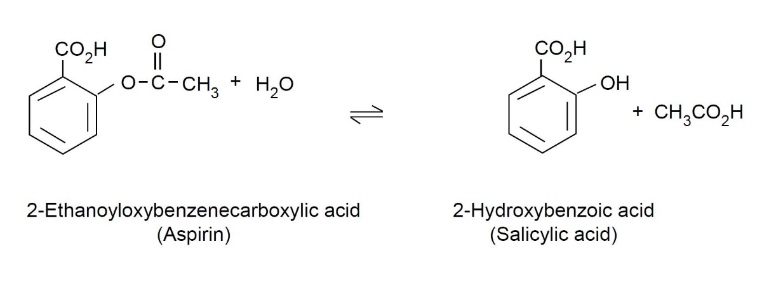

Instructions

Part 1: preparation of standard solutions

In this part of the experiment you will be preparing a set of standard solutions with different colour intensities from the standard 2-hydroxybenzoic acid (salicylic acid) solution. You will be using these to match the intensity of the colour produced from the 2-ethanoyloxybenzenecarboxylic acid (aspirin) solution and so find out how much 2-hydroxybenzoic acid (salicyclic acid) there is in your 2- ethanoyloxybenzenecarboxylic acid (aspirin) tablet.

Taking your 24-well plate, add drops of solutions as indicated below.

Well no | A1 | A2 | A3 | A4 | A5 | A6
No. of drops of: 2- ethanoyloxybenzenecarboxylic acid (salicyclic acid) soln. | 5 | 15 | 25 | 35 | 45 | 50
Water | 45 | 35 | 25 | 15 | 5 | 0
Iron(III) nitrate solution | 5 | 5 | 5 | 5 | 5 | 5
Resulting mass (mg) of 2- hydroxybenzoic acid (salicyclic acid) per 25 cm3 solution | 0.25 | 0.75 | 1.25 | 1.75 | 2.25 | 2.5

Part 2: analysis of aspirin tablets

- Record the mass of a 2-ethanoyloxybenzenecarboxylic acid (aspirin) tablet and place it in a 100 cm³ beaker.
- Add 10 cm³ of the 50% ethanol–water mixture (from a measuring cylinder) and swirl the mixture. The tablet will begin to disintegrate.
- Using the microscale filtration method, filter the mixture into a 25 cm³ volumetric flask. Wash the beaker with a small quantity of the ethanol–water mixture and add to the flask. Make up to the mark, stopper and mix.
- Add 50 drops of this 2-ethanoyloxybenzenecarboxylic acid (aspirin) solution to well B3 followed by five drops of the iron(III) nitrate solution.
- Match the colour to that of one of the standard solutions.

Calculations

Calculate the percentage of 2-hydroxybenzoic acid (salicylic acid) in the 2-ethanoyloxybenzenecarboxylic acid (aspirin) tablet as follows:

- Identify the standard well that matches the colour intensity of the 2-ethanoyloxybenzenecarboxylic acid (aspirin) sample well.
- The mass of 2-hydroxybenzoic acid (salicylic acid) (in 25 cm³) in the solution from this standard well is therefore the same as the mass of 2-hydroxybenzoic acid (salicylic acid) in the 25 cm³ of solution of your 2-ethanoyloxybenzenecarboxylic acid (aspirin) tablet solution.
- Divide this mass (mg) by the mass of your 2-ethanoyloxybenzenecarboxylic acid (aspirin) tablet (mg) and multiply this value by 100 to give a percentage by mass.

Question

By considering the equation for the formation of 2-hydroxybenzoic acid (salicylic acid) from 2-ethanoyloxybenzenecarboxylic acid (aspirin), are there any differences in how much 2-hydroxybenzoic acid (salicylic acid) is present in both old and new bottles of 2-ethanoyloxybenzenecarboxylic acid (aspirin) tablets?

Health, safety and technical notes

- Wear eye protection throughout.
- Do not ingest the aspirin tablets.
- Iron(III) nitrate, Fe(NO₃)₃.9H₂O(aq), 0.1 mol dm^{–3} is of low hazard.
- 2-hydroxybenzoic acid (salicylic acid) solution (0.1% w/v) is of low hazard.
- Ethanol/water mixture (1:1) is FLAMMABLE.

