Investigating evaporation
Education in Chemistry
July 2021
https://rsc.li/3AjGiFG
Evaporation is an important physical process that we experience in everyday life and the laboratory. Help students to investigate this process with simple practicals.

Practical 1: evaporation rates
Investigate some factors that affect how quickly a liquid evaporates.

Equipment
- Test tube and rack
- Small beaker
- Evaporating dish
- Measuring cylinder (10 cm³)

Method
- Measure 10 cm³ of water into each container.
- Leave the containers in the same environment for a few days.
- Measure the volume of water left in each container.
- Calculate the volume of water lost from each container and relate this to the type of container used.

Notes
- You should find more water has been lost from the evaporating dish than the test tube as the water has a larger surface area in the evaporating dish.
- Investigate other factors such as temperature (find different areas in your lab or science department) or volume of air flow (close to an open window, on a shelf, on a bench).
- You can make the evaporation more obvious by colouring the water with a little food colouring.
- Use a bunged test tube of water as a control.

Practical 2: crystallisation of table salt
Dissolved substances become more concentrated as the solvent evaporates. Table salt forms cubic crystals over a few days when a saturated solution of the salt evaporates.
Safety: Wear eye protection. Ensure students handle the hot water carefully.

Equipment
- Two egg cups (or small beakers)
- A plate
- A teaspoon
- Natural fibre string, 20–30 cm long
- Table salt (sodium chloride)
- Hot water from a kettle

Method
- Add 3–4 teaspoons of table salt to each cup and half fill with just-boiled water.
- Stir to dissolve as much salt as possible. This will create a saturated salt solution – ie no more salt can dissolve.
- Place the egg cups on a plate about 5 cm apart.
- Place one end of the string in each egg cup.
- Let the middle of the string hang down between the egg cups.
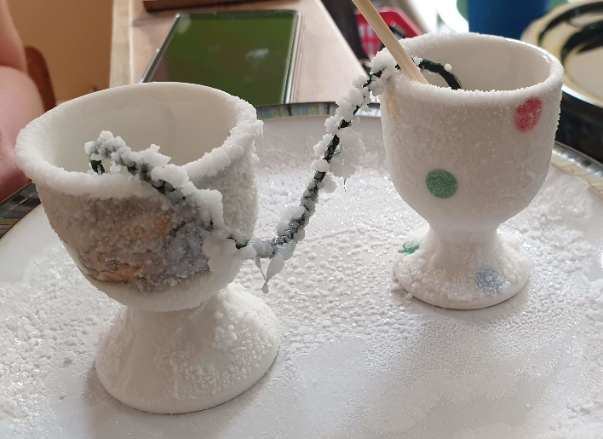
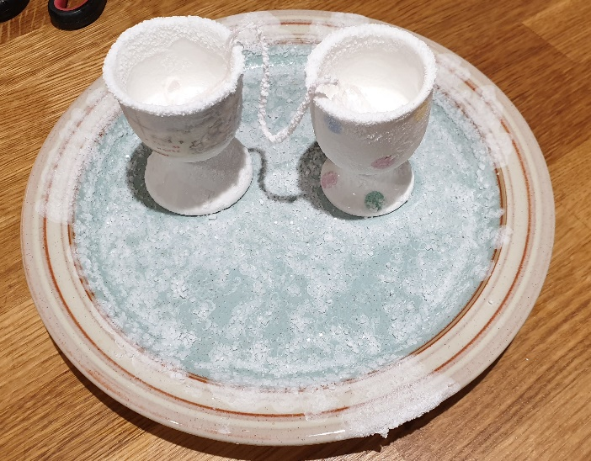
- Leave this for a few days and you’ll see the effects of evaporation of a saturated salt solution.

Notes
- Encourage the students to stir the salt/water mixture thoroughly to dissolve the maximum amount of salt.
- Students may be tempted to interfere with the practical – ensure it is placed somewhere away from curious fingers!
- If possible, carry out the practical when you will see the group at regular intervals – this will allow them to monitor the crystallisation process. They could take photos and include this in a practical report.
- When the water has fully evaporated, ask the students to look at the range of crystals formed – is there any pattern to where smaller and larger crystals form?
- Some very high-quality crystals can form – students could use close-up photos in their art lessons, making links between the subjects. Many beautiful crystals are formed by other substances, eg bismuth and gypsum (calcium sulfate-2-water).

