Measuring density – teacher notes

Topic
Scientific methodology

Timing
20 minutes

Description
In this experiment students determine and compare the density of tap water and seawater using a small measuring cylinder and a sensitive balance.

Apparatus
- Student worksheet
- Measuring cylinder, 5 cm³
- Sheet of graph paper
- Access to a balance that reads to 0.01g

Chemicals
- Tap water
- Seawater

Observations
Specimen results are given below. From these results, it is possible to distinguish the density of tap water and seawater using this method.

The experiment is simple to do, although students must work carefully to get good results. A wealth of data are produced, which when examined and interpreted show the application of mathematics to experimental science. In particular, this shows the value of treating data graphically.

Students could be told that it was as a result of appreciating the significance of small differences in mass that important scientific discoveries have been made. For example, in 1894 William Ramsay and Lord Raleigh discovered the element argon in air by investigating the small but consistent discrepancy between the (higher) density of nitrogen obtained from air by removing the oxygen (atmospheric nitrogen) and nitrogen prepared from its compounds (eg heating ammonium nitrite solution).

Note
You will require a balance that reads to 0.01 g. Specimen results measuring the densities of seawater and tap water are overleaf.
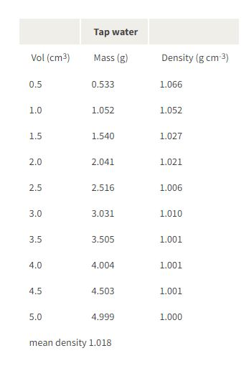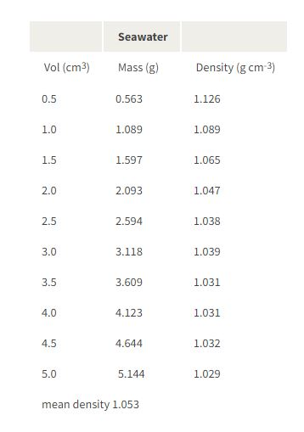

Extension
It may be interesting to extend this experiment to measure the relative densities of, for example, Coke® and Diet Coke®.

Health, safety and technical notes
- There are no significant hazards associated with this experiment.

