The preparation of aspirin – teacher notes

Introduction

In this activity you use ethanoic anhydride to convert 2-hydroxybenzoic acid into aspirin.

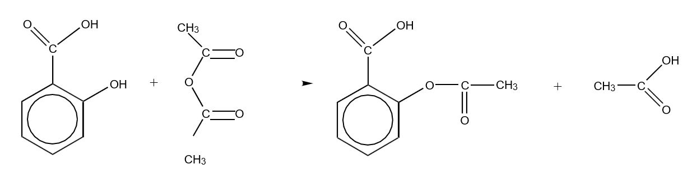

The reaction takes place easily in acidic solution but the product is formed as part of a mixture containing several other compounds. The product is formed in Stage 1 below and then separated from impurities in Stage 2.
Note that ethanoic anhydride reacts readily with water so all the apparatus must be dry.

Apparatus
- Access to a fume cupboard
- Pear shaped flask, 25 cm³
- Hot water bath
- Measuring cylinder, 10 cm³
- Bath of iced water
- Glass stirring rod
- Buchner funnel and suction apparatus
- Watch glass

Chemicals
- 2-Hydroxybenzoic acid, 1 g
- Ethanoic anhydride, 2 cm³
- Eight drops of concentrated phosphoric acid

Health, safety and technical notes
- Read our standard health and safety guidance here https://rsc.li/3AlERrN
- Wear eye protection.
- Sulfuric acid can be used in place of phosphoric acid but may give lower yields.
- Some teachers have reported problems which were due to using ethanoic anhydride that had already been hydrolised to ethanoic acid. Add a drop to water to ensure it is still reactive.
- If no precipitate appears, scratch the inside of the beaker with a glass rod or add a seed crystal of aspirin.
- As much as 40% of the mass of product after filtering may be water. Overnight drying is preferable to oven drying.
- Students should obtain about 0.9 g of crude product from 1.0 g of 2-hydroxybenzoic acid.
Relative molecular masses are:

- 2-hydroxybenzoic acid: 138
- ethanoic anhydride: 102
- aspirin: 180

Further investigations
Vary the reaction conditions to investigate the effect on percentage yield of:
- type of acid catalyst;
- concentration or volume of acid used;
- time of heating/cooling; and
- relative amounts of reagents
Use thin-layer chromatography (tlc) to investigate the purity of the product, using commercial aspirin as a reference. Ensure that this aspirin sample is not ‘soluble aspirin’ (sodium or calcium salt).

Test for impurities
- Three test-tubes together with means of labelling them;
- A few crystals of the following substances:
  - Phenol (NB phenol is a toxic substance; avoid spillage and wash hands after use)
  - 2-Hydroxybenzoic acid (salicylic acid)
  - Crude product from Activity 3
  - Pure aspirin
- One per cent iron(III) chloride solution.

Results
Phenol + Fe³⁺ (aq) | Purple solution
2-Hydroxybenzoic acid + Fe³⁺(aq) | Purple solution
Crude product + Fe³⁺(aq) | May have a purple tinge due to unreacted 2-hydroxybenzoic acid
Pure product + Fe³⁺(aq) | Very pale yellow

Answers
- The crude product may contain 2-hydroxybenzoic acid, as well as water or ethanoic acid as impurities. 2-Hydroxybenzoic acid can be formed either from incomplete reaction or from hydrolysis of the product during its isolation.
- 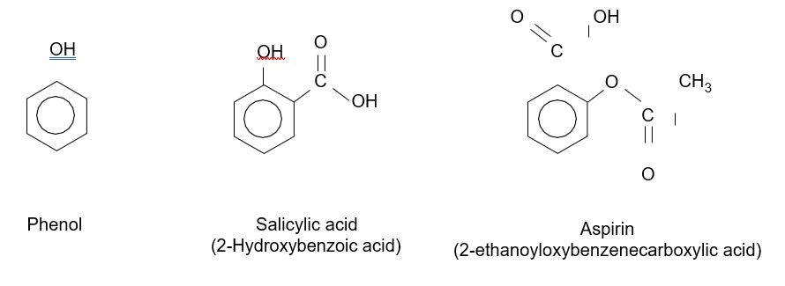
The OH group attached to the benzene ring produces a purple colour with Fe³⁺(aq) ions. The OH group in aspirin is part of the carboxylic acid group and does not react in the same way.

