Molecular fingerprints
Education in Chemistry
September 2017
rsc.li/EiC517-know-your-poison
This activity accompanies the above article ‘Know your poison’.
The team at Bath have found lots of different substances mixed in with their drugs samples. Legal drugs such as painkillers are commonly found in the samples.
Note down the molecular formula, relative molecular mass (M_{r}) and functional groups for paracetamol, aspirin and ibuprofen. This will help you in the next part of the exercise.
 | Molecular formula and M_{r} | Functional groups present
Paracetamol
Aspirin
Ibuprofen

The following pages contain infrared, ¹H NMR, ¹³C NMR and mass spectra for paracetamol, ibuprofen and aspirin. Use the structures given above and your data book to assign each of the peaks in the spectra.

The following spectra are downloaded from SDBSWeb http://sdbs.db.aist.go.jp (National Institute of Advanced Industrial Science and Technology, accessed 22 June 2017)
Paracetamol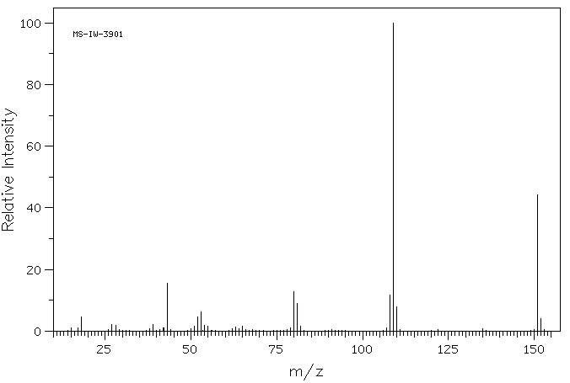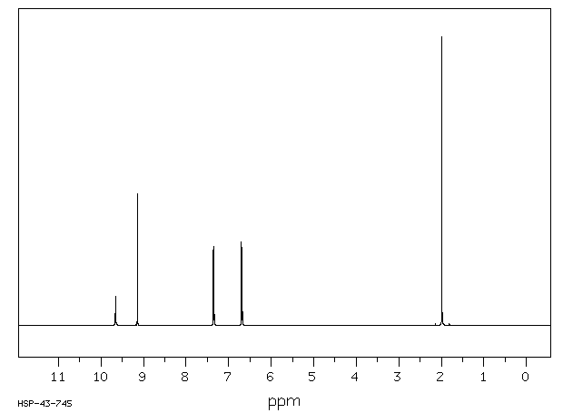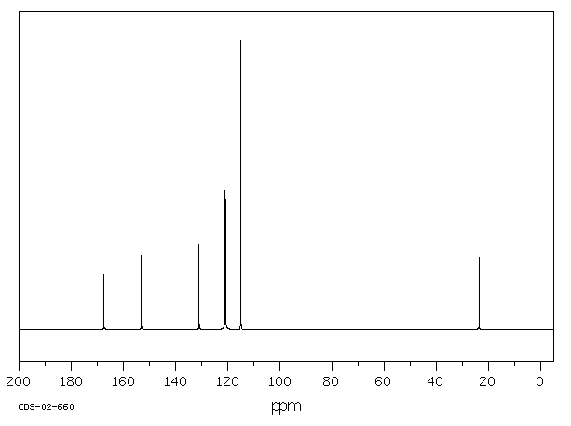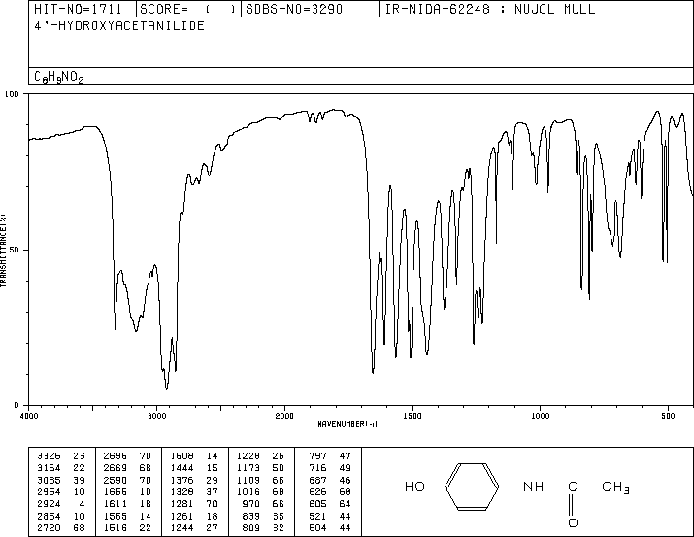
Aspirin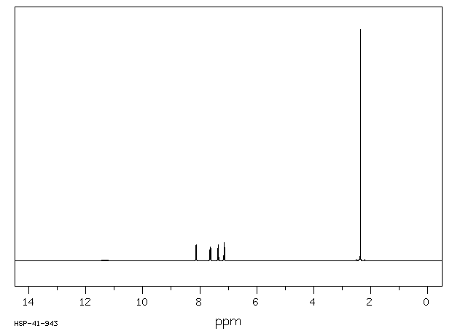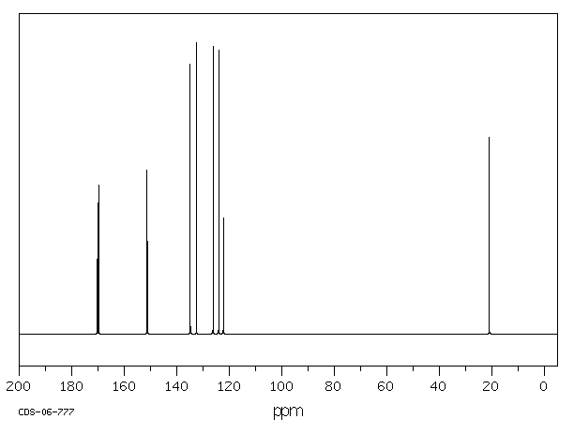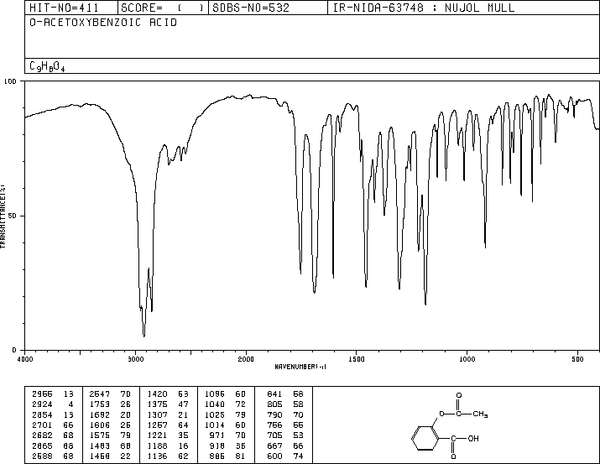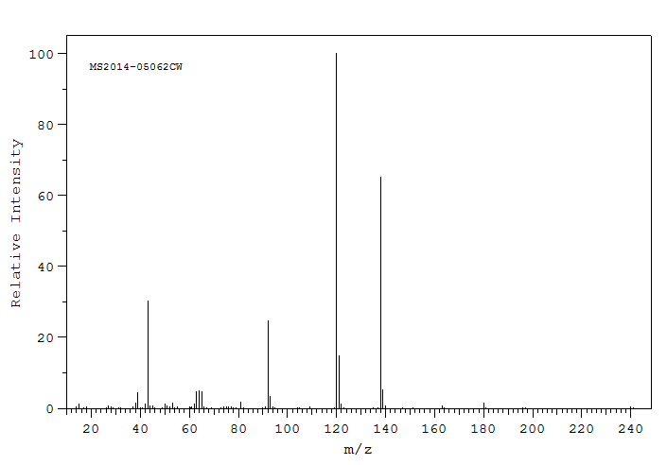

Ibuprofen