Tattooing the heart with graphene electrodes

Original article by Rebecca Trager. Adapted by Nina Notman.

Next generation electrodes for treating arrhythmias could be comprised of carbon allotrope

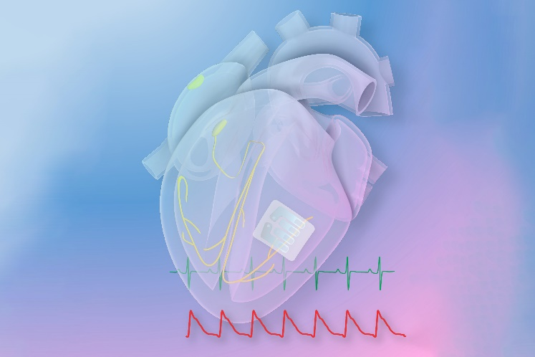
US researchers have developed the first cardiac implant electrodes made from graphene. These ‘graphene tattoos’ visually resemble temporary tattoos for children, and experiments on rats have shown they outperform conventional pacemaker electrodes.

Source: © Ning Liu/University of Texas at Austin

The smallest pacemaker ever made sticks onto the heart like a tattoo

Abnormal heart rhythms, known as arrhythmias, are one of the leading causes of death worldwide. They are often treated with devices such as pacemakers, comprised of electrodes attached to the heart that are connected via wires to an electronics box implanted in the chest. These devices sense the electrical activity of the heart and, when irregular heart rhythms are spotted, restore a normal heartbeat by delivering electrical stimulation.

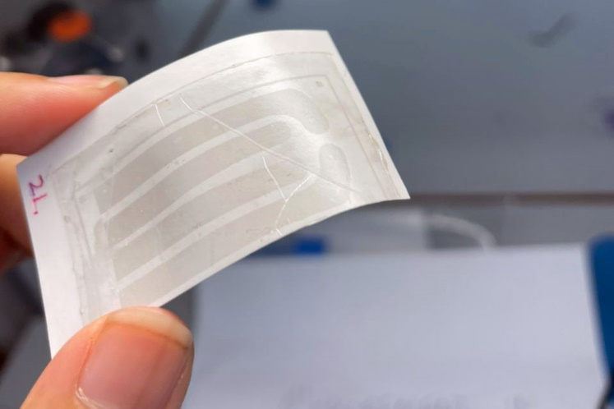
Flex for success

Source: © Ning Liu/University of Texas at Austin

The device is thin and flexible, but strong enough to endure a heart beating

Pacemaker electrodes are currently made of hard metal and other rigid materials that are not ideal for attaching to the soft, wet, dynamic muscle tissue of the heart. Graphene is comprised of a single layer of carbon atoms and is flexible enough to be moulded to fit perfectly to a heart. It is also stretchy and strong enough to withstand the motions of a beating heart.

The team led by Igor Efimov, a professor at Northwestern University in Illinois, US, has demonstrated the effectiveness of its graphene tattoos on rats. In these experiments, the scientists attached the electrodes on the rat hearts to the electronics box using foil rather than wires.

The end goal is to send electric pulses wirelessly between the electrodes and the electronics box. This would eliminate the need to implant the box, with an external device placed on the chest instead. As a significant step towards this goal, the scientists demonstrated that they could collect electrical information from the graphene tattoo and stimulate the heart using a blue light source outside the body.

Igor told Chemistry World that before such a device can enter human trials, scientists will need to prove its safety and efficacy in large animal models like pigs.

This is adapted from the article Graphene ‘tattoo’ pacemaker that wraps around the heart is thinnest yet in Chemistry World. Read the full article: rsc.li/42g5auT

