Ionic bonding: teacher guidance

This resource forms part of the Review my learning series from the Royal Society of Chemistry. Additional support for addressing misconceptions identified using these worksheets can be found at rsc.li/3mm0IeW.

This worksheet assesses content from the 14–16 specifications. The content is a subset of the Bonding worksheet and can be used to provide extra support for learners on ionic bonding. It can identify learners’ knowledge gaps and misconceptions following the completion of that part of the curriculum.

The Ionic bonding worksheet covers the following topics:
- interpreting diagrams representing ionic bonds
- the presence of ions in ionic bonds
- electrostatic forces in ionic bonds
- types of elements involved in ionic bonds.

If learners successfully answer questions on these topics, they can attempt the extension question where they can complete a diagram representing the formation of an ionic bond.

There is only one level of this worksheet. Level 1 () is a scaffolded worksheet in which learners select words from a word list to complete sentences.

The worksheet can be used in a variety of ways:
- as an assessment of learners’ knowledge at the beginning or end of a period of teaching
- as an assessment of knowledge during a period of teaching and after learners have completed the relevant section of the specification
- as a revision tool prior to the relevant examination
- as a refresher exercise for teachers or non-subject specialists.

There is also scope to use this worksheet to support learners who struggle with this type of bonding particularly. These learners could then be encouraged to attempt the partially scaffolded Bonding worksheets to reinforce their understanding.

The ‘What do I understand?’ page can be used both to identify areas needing whole class attention and as an indicator for learners to help guide their revision.

The Teacher guidance provides model answers for each level and guidance on learners’ misconceptions. Learners can use the model answers to self- or peer assess.

Answers

Ionic bonding: knowledge check
- ionic bonding
Guidance: Most learners will have no problems recognising the types of bonding in this figure, but there may be many misconceptions in understanding it. Learners need a good understanding of electronic configurations and charges within an atom to understand the diagrams. The use of dots and crosses can lead some learners to think they are used to show different types of electron, not simply where the electrons originate from. The charges on the ions and use of square brackets may be confusing for some learners. Simple rules, eg that metal atoms produce positive ions, can help learners apply the correct charges
- Ionic bonding – this bond is formed when electrons are transferred from a metal to a non-metal, forming positively charged and negatively charged ions. Strong electrostatic forces attract the oppositely charged ions to each other.
Guidance: Learners commonly confuse and misuse the terms atom and ion. Although not directly relevant for this question, many learners will use the term molecule to describe ionic compounds. Only covalent substances form molecules.

Ionic bonding: test myself
- metal and non-metal
Guidance: A common misunderstanding is that ionic and covalent bonds can form between any elements. Understanding electronic configurations and the Periodic table may help learners realise the types of bonds formed by which types of elements.
- Ionic bonds are strong.
Guidance: Since the strength of a bond is relative, this may be difficult for learners to answer if they have not studied intermolecular forces.
- Electrostatic forces of attraction hold the particles together in an ionic bond.
Guidance: The term ‘electrostatic’ is probably a new word for most learners and is easily confused with similar words such as electrolysis, electronic, etc
- The curly arrows represent electrons being transferred from one atom to another.
Guidance: When learners are drawing their own diagrams, the head and tail of the arrows must start and end exactly. Encourage learners to use the term ‘transferred’ rather than ‘move’, ‘go’, etc.

Ionic bonding: feeling confident?

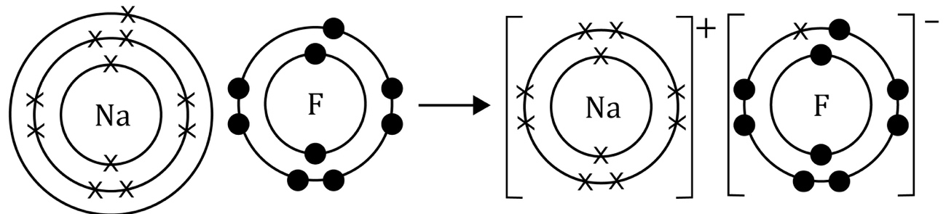
Guidance: Common errors on diagrams showing how electrons are rearranged in an ionic bond include omitting the squared brackets (many websites have similar diagrams with the squared brackets omitted), showing the wrong number of electrons transferred, adding extra electrons and errors in calculating the correct number of charges on the ions. Encourage learners to do a final total count of the total number of electrons to check that electrons have not been lost or gained.

Ionic bonding: what do I understand?
Topics | Assessed via:
I can interpret diagrams representing ionic bonds. | Q1.1, Q2.4
I know that there are ions in ionic bonds. | Q1.2
I know about electrostatic forces in ionic bonds. | Q2.3
I know the types of elements involved in ionic bonds. | Q2.1
Feeling confident? topics | Assessed via:
I can complete a diagram to represent the formation of an ionic bond. | Q3.1

