Recycling the undesired enantiomer of naproxen
A context/problem-based learning (C/PBL) resource

Workshop 2 – Handout

Nimesh Mistry, Sarah Naramore and George Burslem
University of Leeds

Produced for the Royal Society of Chemistry

Part 1 – Minimisation of hazards
One of the experiments carried out in second year involves synthesis of ethyl 2-ethanoylhexanoate. The synthetic procedure is given below.

Formation of ethyl 2-ethanoylhexanoate

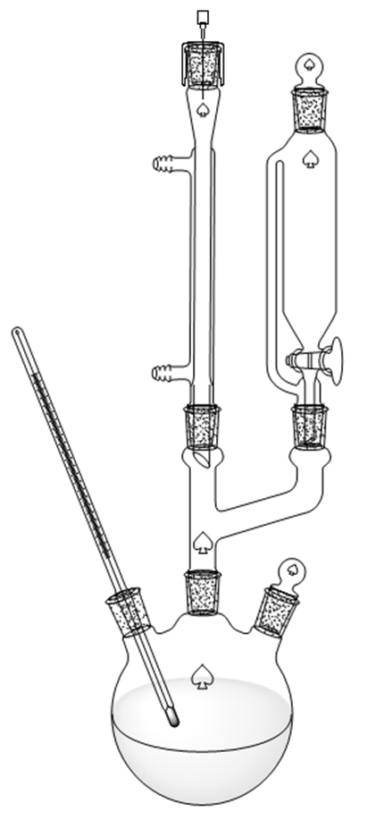
A 250 mL three-necked round bottom flask is set up as shown with a dropping funnel, condenser, thermometer, stopper and nitrogen inlet and the apparatus flushed with nitrogen.
Figure 1: Apparatus setup
Sodium hydride (50% dispersion in mineral oil, 4.8 g) is added to dry DMF (50 mL) in the flask and the mixture stirred under nitrogen. Ethyl acetoacetate (12.7 mL, 10.0 g) is added drop-wise at a rate such that the internal temperature does not exceed 40 °C.
After formation of the sodium derivative of ethyl acetoacetate is complete, as evidenced by the disappearance of the sodium hydride or the cessation of hydrogen evolution, 1-bromobutane (12.9 mL, 16.9 g) is added in portions.
Approximately 25% of the 1-bromobutane is added in one potion and if no exothermic reaction is detected, the flask is warmed to 50 °C. The remaining 1-bromobutane is then added drop-wise at a rate such that the temperature is maintained at 50 °C. The reaction is then completed by further heating. The nitrogen atmosphere and stirring are maintained throughout the heating period.
The reaction is heated for 3 hours and then heating continued until the reaction is neutral to litmus paper.
The reaction mixture is poured into water (500 mL) and the aqueous mixture extracted with DCM (3 x 50 mL). The DCM extracts are combined and washed with water (3 x 100 mL) and dried (MgSO4). The DCM is evaporated and the residual liquid purified by distillation.
This reaction cannot be carried out in a plant as it is. Some parts of it just need to be adapted while others should be changed if at all possible.
- If you were a process chemist tasked with developing this reaction to use in a pilot plant why would you investigate alternatives to DMF, DCM and sodium hydride?
- Which aspects of the reaction would you need to understand in more detail if you wanted to run it safely on a large scale?

Part 2 – project planning
In your groups discuss which reactions you will carry out and which variables you would like to investigate for each step make a detailed plan of how you would like the lab work to proceed.
You should write down.
- Who will focus on each step
- Which reactions depend on having some material from other reactions
- How to ensure that people investigating reaction conditions have enough of the starting material they need
- How will you divide up tasks like analysis and planning
- How often will you share results and discuss progress
- Which variables do you want to investigate first for the two steps that need optimisation
- How will you analyse your reactions efficiently so that you can quickly decide what conditions to try next

