- The diagram shows a fractionating tower used to separate crude oil.

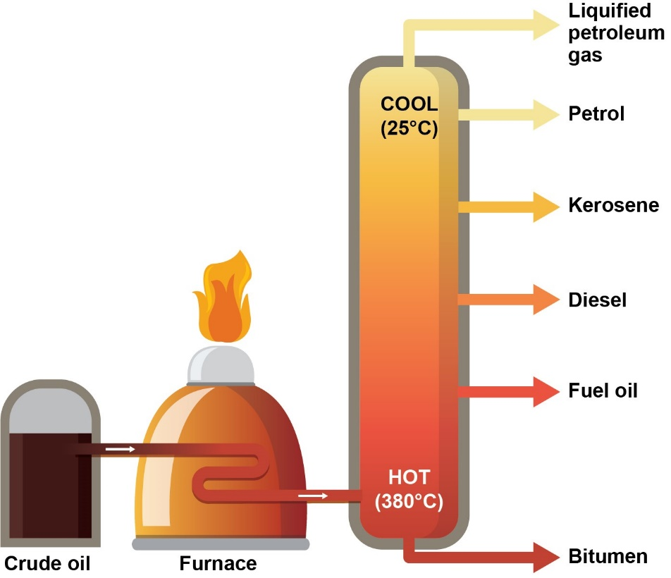
  - Explain how crude oil is separated into its constituent fractions.
Use the words in the box in your answer.
Heat energy
Boil
Vapour
Condense
Boiling point
Molecular size

Source: Royal Society of Chemistry

  - Crude oil is a finite energy resource.
What does ‘finite resource’ mean?

  - Products from crude oil are of crucial importance to us, and our lives would be very different without these.
State two important products made from crude oil that are not mentioned in the above diagram.

- Crude oil is a complicated mixture of hydrocarbons, many of which are alkanes.
Number of carbon atoms in alkane | Boiling point in °C
1 | –162
2 | –89
3 | –42
4 | –0.5
5 | 36
6 | 69
The boiling points of the first six members of the alkane homologous series are shown in the table below.

  - Plot the number of carbon atoms on the horizontal axis and the boiling point on the vertical axis on the graph below.

  - Draw a line of best fit through these points.

  - Use your graph to describe how the boiling point changes from two carbon atoms to six carbon atoms.

  - Use your graph to determine the boiling point of the alkane with seven carbon atoms.

  - Which of the hydrocarbons are gases at room temperature, 20 °C?

- A sample of petrol (gasoline) was analysed by a chemist.
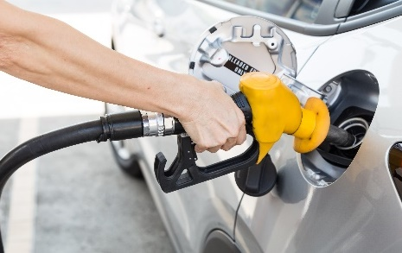
She recorded a mass of petrol of 5.20 g.

The analysis found a substance called decane in the petrol.

The percentage of decane in the petrol sample was 4.8%, by mass.
Source: Envato Elements
Decane is an alkane containing ten carbon atoms in its molecule.
  - Which two elements are present in alkanes?

  - What is the general formula for an alkane?

  - Use your answer to part b) to work out the molecular formula for decane.

  - Complete the structure to show a decane molecule.

  - Explain why a decane molecule is described as ‘saturated’.

  - Calculate the mass of decane in the petrol sample.
Give your answer to 3 significant figures.
Show your working.

