Acids and bases: knowledge check
- Label this diagram to show the pH of:
  - an acidic solution
  - an alkaline solution
  - a neutral solution.

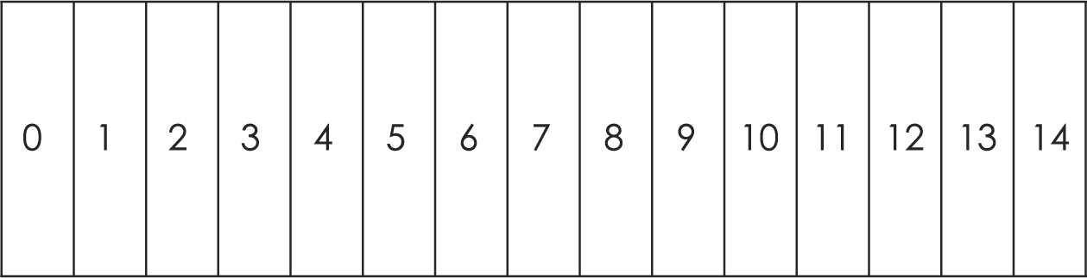
- Answer the questions using the words provided. You do not have to use all the words. You can use the words more than once. You should write a full sentence for the first question.

acidic acids alkaline alkalis neutral
  - What does the pH scale measure?

  - Which solutions have a pH less than 7? ___________________________
  - Which solutions have a pH of 7? ___________________________
  - Which solutions have a pH of more than 7? ___________________________

Answer the questions using the words provided. You do not have to use all the words. You can use words more than once.

hydrochloric acid hydrogen nitric acid

sodium hydroxide solution sulfuric acid water
  - Name three acids commonly found in school laboratories.

  - Name the type of ions present in all acid solutions.

- Complete these equations. You can use words more than once or not at all.

carbon dioxide hydrogen metal salt

water carbonate oxygen

These general equations represent some methods used to make salts:
  - acid + metal $→$ ___________________________ + ___________________________
  - acid + metal oxide $→$ ___________________________ + ___________________________
  - acid + metal hydroxide $→$ ___________________________ + ___________________________
  - acid + metal carbonate $→$ ___________________________ + ___________________________ + ___________________________

Answer the questions using the words provided. You do not have to use all the words. You can use words more than once.

baking soda common salt laundry detergent

lemon juice vinegar water
  - Name two everyday acids you might find in your home.

  - Name two everyday bases you might find in your home.

Acids and bases: test myself
- What is an indicator?

What colour is universal indicator in an acidic solution, an alkaline solution and a neutral solution?
  - Universal indicator is ___________________________ in an acidic solution.
  - Universal indicator is ___________________________ in an alkaline solution.
  - Universal indicator is ___________________________ in a neutral solution.

- What colour is universal indicator in a solution with a pH of 1?

- What colour is the indicator litmus in acidic and alkaline solutions?
  - acidic solutions

colour __________________________________________________
  - alkaline solutions

colour __________________________________________________
- What is a base? Give an example.

- What is an alkali? Give an example.

- What type of reaction occurs when an acid reacts with an alkali?

What names are given to the types of salts formed in reactions with these acids?
  - Hydrochloric acid produces ____________________________________________.
  - Sulfuric acid produces _________________________________________________.
  - Nitric acid produces ___________________________________________________.

- Name the salt made when copper oxide reacts with sulfuric acid.

- Write the formulas of these acids.
  - hydrochloric acid ______________________________________________________
  - sulfuric acid ____________________________________________________________
  - nitric acid ______________________________________________________________

Acids and bases: feeling confident?
- Write word equations for the following reactions.
  - Hydrochloric acid reacting with sodium hydroxide:

  - Sulfuric acid reacting with sodium hydroxide:

  - Nitric acid reacting with sodium hydroxide:

- Write balanced symbol equations for the reactions in question 3.1.
  - Hydrochloric acid reacting with sodium hydroxide:

  - Sulfuric acid reacting with sodium hydroxide:

  - Nitric acid reacting with sodium hydroxide:

Acids and bases: what do I understand?

Think about your answers and confidence level for each mini-topic. Decide whether you understand it well, are unsure or need more help. Tick the appropriate column.
Mini-topic | I understand  this well | I think I understand this | I need more  help
I can describe the pH scale.
I know the pH of acidic and alkaline solutions.
I can name common acids and alkalis.
I can write general word equations for reactions of an acid with a:
- metal
- metal oxide
- metal hydroxide
- metal carbonate.
I know the chemical formulas for common laboratory acids.
I can name types of salt produced by reactions with:
- hydrochloric acid
- sulfuric acid
- nitric acid.
I can use universal and litmus indicators to identify acidic, alkaline and neutral solutions.
Feeling confident? topics | I understand  this well | I think I understand this | I need more  help
I can write word equations for reactions between an acid and a:
- metal
- metal oxide
- metal hydroxide
- metal carbonate.
I can write symbol equations for reactions between an acid and a:
- metal
- metal oxide
- metal hydroxide
- metal carbonate.

