The hunt for vitamin C

This resource accompanies the article Vital vitamins in Education in Chemistry which can be viewed at: rsc.li/46meZdM

The resource has been adapted from the book series In search of more solutions, which aims to engage and motivate learners through context-based problems. You can find more practical problem-solving activities from this series at: rsc.li/3Q5bsKR.

Learning objectives
- Apply the practical techniques of preparing a standard solution and carrying out a titration to analyse the mass of vitamin C in cooked cabbage.
- Plan a practical method for your analysis from partial instructions, taking into account health and safety considerations and required accuracy and precision.
- Record, analyse and present data to reach a conclusion from your results.
- Apply concepts of redox, solubility, enzyme and numerical chemistry to the analysis of vitamin C in cabbage.

Success criteria
LO1 | Task 4 | Carry out preparation of a standard solution and titration in a safe, competent and efficient manner.
LO2 | Task 3 | Produce a plan to include consideration of health and safety, a logical order of steps, appropriate apparatus and a suitable number of readings.
LO3 | Task 4 | Record data in systematic labelled tables and perform calculations taking into account the precision of the instruments used.
LO4 | Tasks 1, 2 and 4 | - Correctly identify oxidising and reducing agents in the redox reaction between ascorbic acid and dichlorophenolindophenol (DCPIP) and write a balanced redox equation.  - Recognise that a polar solute will dissolve in a polar solvent and that hydrogen bonding between the alcohol groups and water is responsible for the solubility of vitamin C in water.  - Apply knowledge that enzymes are denatured at higher temperatures and are less active outside their optimum pH range.  - i. Correctly apply stoichiometry to reacting amounts.  ii. Correctly convert between units.  iii. Manipulate formulas in calculations correctly.  iv. Measure and record data to the appropriate accuracy and precision.

Differentiation

Two versions of the student sheet are available. Both address the learning objectives and success criteria outlined in the previous section.

The student support sheet, indicated by the file name and one star in the learner-facing worksheet header, offers more support by:
- Providing hints alongside questions.
- Presenting some questions as multiple choice.
- Emphasising key terms in bold.
- Presenting calculations in structured stages.

The student challenge sheet, indicated by the file name and two stars in the learner-facing worksheet header, offers less support and questions are more open-ended. In particular, Task 3 requires leaners to draw on their practical knowledge and experience to plan the analysis of vitamin C in cooked cabbage.

Technician notes
Read our standard health and safety guidance (rsc.li/3IAmFA0) and carry out a risk assessment before running any live practical.
See the technician notes for detailed preparation, hazard and disposal information. Read the student sheets for partial instructions to carry out the experiment. Remind learners to wear their safety glasses and to take care to avoid getting the solutions on their skin.

How to use this resource

Use the resource flexibly depending on the time available and the type of activity and assessment your learners require. Some suggestions are:
- Set learners Tasks 1 and 2 to work on independently then carry out Task 3 and Task 4 in groups.
- Set learners Tasks 1 to 3 only to give them experience of planning a practical method.
- Cover the theory for Tasks 1 and 2 as a plenary in class and provide learners with the practical method to carry out Task 4.
- With a large class, ask learners to weight out 100 g of cabbage which is already shredded.
- Use tasks from either the student support or student challenge sheets depending on the experience of the group.
- Use the presentation slides to discuss the tasks in class.

Answers

Task 1 (support)
- Alkene, secondary alcohol, primary alcohol, ester.
- i. Secondary alcohol, primary alcohol.
ii. Five should be circled (four O–H groups and carbonyl). Allow six groups if learners also circle the oxygen in the ring as this does have lone pairs available.
- Shredded cabbage has a larger surface area exposed to the solvent (polar water molecules) than a potato, therefore more vitamin C will dissolve in the water.
- A and C.

Task 1 (challenge)
- i. Carboxylic acid.
ii. Alkene, secondary alcohol, primary alcohol, ester.

- Hydrogen bonding exists between O–H groups / C=O and solvent water.
Labelled diagram shows:
- Lone pairs on oxygen atoms in water molecule and on one of the four O–H groups or C=O group.
- Dipoles on either O–H bond or C=O bond in ascorbic acid and O–H bond in water correctly labelled.
- EITHER broken line between electropositive H atom on ascorbic acid O–H group and electronegative O atom in water labelled as H bond (or vice versa). OR broken line between electronegative O atom on ascorbic acid C=O group and electropositive H atom in water labelled as H bond.
Example:
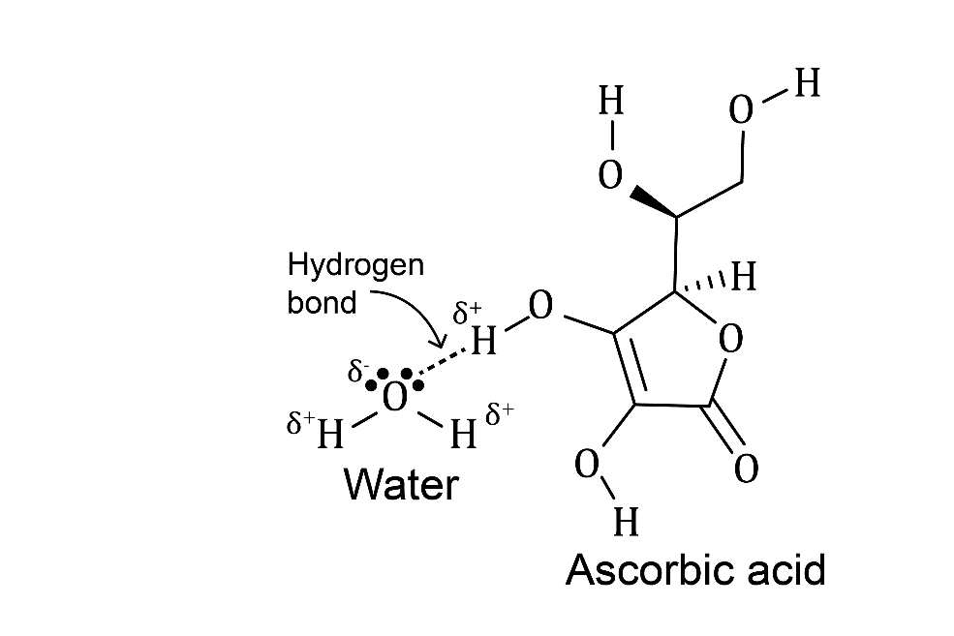
- Shredded cabbage has a larger surface area exposed to polar water solvent molecules than a potato therefore more vitamin C will dissolve in the water.

- Boiling will denture the enzyme. Enzyme will be less active in alkaline pH.

Task 2 (support and challenge)
- i. Ascorbic acid = reducing agent
ii. DCPIP = oxidising agent
- 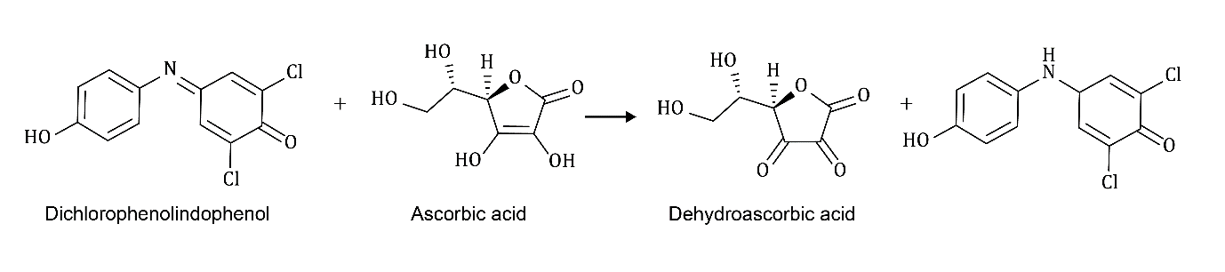
- 1:1

Task 3

Stage 1 (support and challenge)
- Pipette and safety filler for vitamin C, safety glasses.
Burette to titrate DCPIP.
- $F= \frac{25 × 200}{27.50 - 0.50 } ×1000=0.185 mg {cm}^{-3}$

Stage 2 (support)
- Supervision using sharp knives for cutting; cuts to be reported.
Bring boiling water to the beaker and use a 250 cm³ beaker.
Use cloth / gloves to protect hands when handling hot equipment.
Wear gloves and safety glasses when handling 5% phosphoric acid (H₃PO₄).
- 5% phosphoric acid.
- Titration with the standardised DCPIP solution.
- Large volume for DCPIP would be needed / titres can be replaced to get concordance with smaller volumes / volumetric apparatus not available for larger volumes.
- Analysis of 20 cm³ samples should continue until two concordant titres are obtained.

Stage 2 (challenge)
- i. Weigh out 50 g of cabbage on an analytical balance and shred finely.

ii. Place the cabbage in 100 cm³ of boiling deionised water, allow to simmer for 10 minutes.

ii. Carefully pour off the hot water after this time and liquidise the cooked cabbage.

iv. Add 250 cm³ of 5% phosphoric acid (H₃PO₄) to the liquidised cabbage, stir and weigh the mixture.

v. Remove about 20 cm³ of the mixture and weigh. Filter the mixture through muslin or glass wool. Retain the filtrate and make it up with the washings to 25 cm³. (The exact volume is not needed in the calculation so this volume can be measured with a measuring cylinder.)

vi. Transfer 25 cm³ portions to a conical flask. Titrate against standardised DCPIP until you reach the end point, where a pink colour is seen which persists for 10 seconds.

vii. Repeat the titration until you record two concordant titres.

Stage 3 (support part h; challenge part c)
- Weigh out 50 g of cabbage on an analytical balance and shred finely.
- Place the cabbage in 100 cm³ of cold deionised water and bring to the boil. Allow to simmer after reaching the boiling temperature until the total time in the water is 10 minutes.
- Carefully pour off the hot water after this time and liquidise the cooked cabbage.
- Add 250 cm³ of 5% phosphoric acid (H₃PO₄) to the liquidised cabbage, stir and weigh the mixture.
- Remove about 20 cm³ of the mixture and weigh. Filter the mixture through muslin or glass wool. Retain the filtrate and make it up with the washings to 25 cm³. (The exact volume is not needed in the calculation so this volume can be measured with a measuring cylinder).
- Transfer 25 cm³ portions to a conical flask. Titrate against standardised DCPIP until you reach the end point, where a pink colour is seen which persists for 10 seconds.
- Repeat the titration until you record two concordant titres.

Task 4 (support and challenge)
- Titration data
- Titration data table drawn showing initial and final volumes and titre used with units for each quantity.
- All titration readings should be to 0.05 cm³.
- Concordant titres should be selected.
- Mean titre is calculated from concordant titres.

Mass readings:
- Table(s) recordings:
  - M_{c}, the mass of the liquidised sample of cabbage missed with 250 cm³ of 5% phosphoric acid with units.
  - M_{c}, the mass of the 20 cm³ portion of this mixture with units.
- All mass readings should be to 0.5 g (or the accuracy of the balance used).
- Formula provided is used correctly to calculate the vitamin C content of each sample of cabbage.
- Example data for cabbage cooked in boiling water:
Mass of raw cabbage = 50.0 g
M_{c} = 242.2 g
m_{c} = 23.8 g
F = 0.12 mg cm⁻³
V = 10.00 cm³
100 g of sample contains $10.00 ×0.12 × \frac{242.2}{23.8} ×2=24.42 mg of vitamin C$

Example data for cabbage cooked in water brought to the boil:

Mass of raw cabbage = 50.0 g
M_{c} = 248.6 g
m_{c} = 25.2 g
F = 0.12 mg cm⁻³
V = 6.50 cm³
100 g of sample contains $6.50 ×0.12 × \frac{248.6}{25.2} ×2=15.39 mg of vitamin C$
- Based on the example values and given the fact that there is 36.60 mg of vitamin C in 100 g of raw cabbage the conclusion would be that:
- Cabbage cooked in boiling water has lost $\frac{36.60 - 24.42}{36.60} ×100=33.28\%$ of vitamin C. This is less than 50% of vitamin C so the hypothesis is incorrect for this sample.
- Cabbage cooked in water brought to the boil has lost $\frac{36.60 -15.39}{36.60} ×100=57.95\%$ of vitamin C. This is more than 50% of vitamin C so the hypothesis is correct for this sample.
- Cooking cabbage in boiling water is therefore a more effective way of retaining its vitamin C content.

