Metallic bonding and alloys

Learning objectives
- Describe the structure and bonding in pure metals and alloys.
- Explain the properties of pure metals and alloys using your understanding of their structure and bonding.

Introduction

A metallic bond is a type of strong chemical bond which occurs in pure metals and alloys only.

Pure metals have three-dimensional giant structures in which positive metal ions are arranged in layers surrounded by a sea of delocalised electrons. Metallic bonds are the strong electrostatic attractions between the positively charged metal ions and the sea of delocalised negative electrons.

Alloys are mixtures of two or more elements where at least one element is a metal. Different elements have different sized atoms which distort the layers of metal atoms in the giant structure and affect the metal’s properties.

Both metals and alloys have high melting points as a large amount of energy is required to overcome the strong forces of attraction between the metal ions and the negative delocalised electrons. They are also good electrical conductors owing to the sea of delocalised electrons, which are free to move through the structure and carry electrical charge.

Task 1 – True or false?

Determine whether the following statements are true or false:
- Metal ions are always positively charged.
- The metal ions are close packed in the structure.
- In metallic bonding, the outer shell electrons are delocalised.
- The delocalised electrons are in a fixed position and are unable to move.
- Metals cannot conduct electricity.
- Metals have high melting points.
- Metals are malleable and ductile.
- An alloy is a mixture of two or more elements, where at least one element is a metal.
- Pure metals are stronger than alloys.
- Alloys have a layered structure.
- In alloys, the atoms are all the same size.

Task 2 – Description of metallic bonding
- A student produced the diagram below to represent the structure and bonding in magnesium. There are some errors in this diagram.

Identify three errors and record them in the table on the next page. Suggest what is wrong with this image using your knowledge and understanding of metallic bonding.

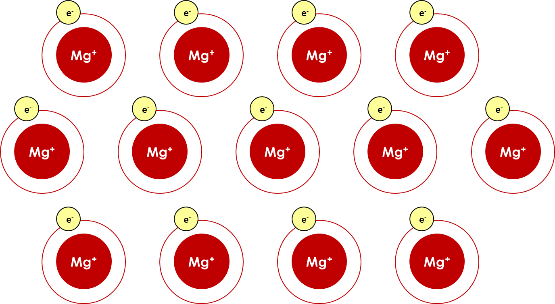

Use the following checklist to identify any issues with the diagram:
- Has the correct symbol for magnesium been used? Check on your periodic table.
- Look at the charge of the magnesium ions. Are metal ions positively or negatively charged? If magnesium is in group 2 on the periodic table is this the correct charge?
- Should the outer shell electrons be shared, donated, delocalised or still in the outer electron shell in metallic bonding?
- In pure metals the ions are the same size and arranged in layers. Is this shown in the diagram?
- Should the ions be close packed or have a lot of space between them?

Description of error | Explanation of why this is incorrect

- Complete a labelled diagram to represent metallic bonding in magnesium. Use your annotations from question 1 and your own knowledge.

Task 3 – Properties of pure metals

The list below contains several important properties of pure metals.

Match the correct explanation to each property with a line.

High melting point |  | A large amount of energy is required to overcome the strong electrostatic forces of attraction between the positive metal ions and negative electrons.
High density |  | The delocalised electrons are free to move through the structure and carry electrical charge.
Good conductor of electricity |  | Pure metals only contain one type of metal atom so the atoms are arranged in layers which can slide over one another.
Malleable and ductile |  | Metal ions are closely packed in a giant 3D lattice structure.

Task 4 - Alloys

The diagram below shows the structure of an alloy. Alloys containing aluminium are used in the manufacture of aircraft due to their increased strength compared to pure metals. Compare the structure of an alloy to the structure of a pure metal and explain why alloys are used in aircraft manufacture rather than pure aluminium.
Structure strip
Describe the structure of an alloy.
Use the words:
- size
- distorts
- electrons
- layers
Compare the structure of an alloy to the structure of a pure metal.
Explain why alloys are better than pure aluminium for aircraft manufacture.

Think about:
- strength
- density





































