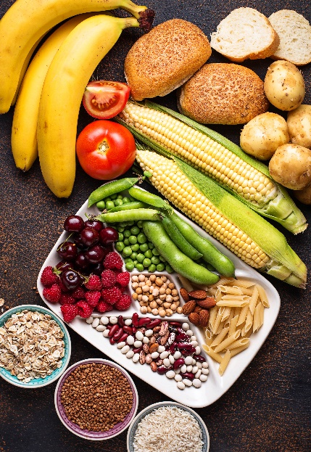
- All of these foods contain starch.
Starch is a polymer.

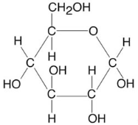
Below is the molecular structure of a molecule that can make starch.

Source: Envato Elements
Molecule 1
- What is a polymer?

- Name molecule 1 above.
.
- What is the molecular formula of molecule 1?

Molecule 1 reacts with many other identical molecules to make starch.
Water is also formed in the process.
- What is the name given to molecules like molecule 1 that chemically bond together to form a polymer?

- In the equation below, n is a whole number.
Complete the equation:

n (C₆H₁₀O₅)_{n} + n
Starch
- What type of polymerisation in taking place when starch is formed?
Give a reason for this name.

The diagram below shows how three molecule 1s react together:

- Explain what the rings show in the diagram.

- Draw a chemical bond between the three molecules to show how they chemically bond, after water has been removed.

- This question is about amino acids forming a polymer.

- What class of polymer is formed from amino acids?

The molecular structures of two different amino acids are shown below.
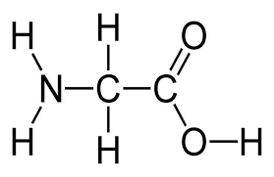
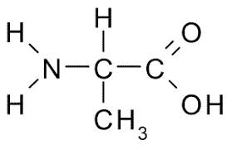

Glycine Alanine

- Name the functional groups present in each amino acid.

- Explain why these molecules are placed in the same homologous series.

One functional group is acidic and the other is basic.
They react together to form water.

The diagram shows this taking place.

- Draw the structure of the molecule formed when glycine and alanine react according to the diagram.

- What is the name of the link that bonds together amino acids in this way?

