Sustainable solution to recycling wind turbine blades

Original article by Rebecca Trager. Adapted by Emma Davies.

What happens when we need to wind down our wind farms?

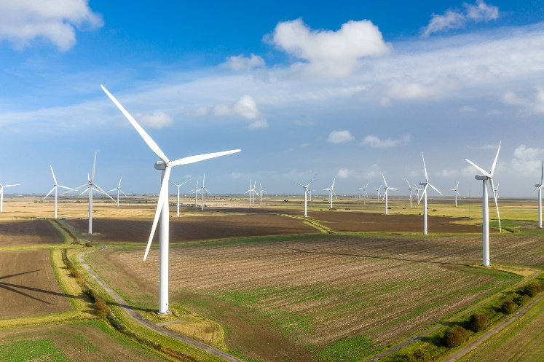
Wind turbines are essential for producing renewable energy but they don’t last forever. In the past, it was not an option to recycle the end-of-life blades, which ended up in landfill sites. The problem is so severe that several European countries have banned dumping the blades in landfill. However, Danish researchers have discovered a new way to recycle wind turbine blades using a specially designed catalyst.

Source: © Veni/Getty Images

Decommissioning our wind turbines will need a lot of recycling if we’re to save a predicted 43 million tonnes of decommissioned turbine blades from landfill by 2050

Wind energy contributed to approximately 6% of the global energy supply in 2020, but it is estimated that 43 million tonnes of decommissioned turbine blades will accumulate by 2050. A very small percentage of the old blades is shredded and used as filler in construction materials.

The thermoset plastic blades are made by embedding glass or carbon fibres in a crosslinked epoxy polymer resin. The lightweight, fibre-reinforced materials are also crucial for constructing cars, boats and aircraft. The crosslinking gives the strength needed to withstand large forces but also prevents the materials from being melted down or dissolved.

Freeing fibres

The research team from Aarhus University designed a rutheniumbased catalyst to break carbonoxygen (C–O) bonds in the epoxy resins. The discovery is perfectly timed. ‘None of the large commercial wind farms have been decommissioned yet, so most deactivated blades aren’t there yet but coming soon,’ says Alexander Ahrens from the university’s Interdisciplinary Nanoscience Center.

The catalyst teases the polymers apart so that high-quality fibres can be reused to make new materials. The method also recovers the petrochemical bisphenol A (BPA), which is harmful to humans and the environment. Retrieving it prevents its potential leakage from landfill sites. Alexander suggests reintroducing the recovered BPA into existing production chains as an alternative to using virgin BPA produced from a petrol-based feedstock.

The catalytic method targets C–O single bonds next to BPA by heating them with the solvents isopropanol and toluene at 160°C. ‘It’s a slow process, so it takes around three days, but in this time the polymer is completely disassembled,’ Alexander says. The team has tested its technique on commercial materials, including a piece of wind turbine blade. After three days it visibly separated into loose fibres, with half safely recovered.

The researchers say that their catalytic process can be considered as a proof-of-concept demonstration of circular economy. ‘The method works on commercial materials being used right now’, says Alexander. However, it requires large amounts of catalyst, which is ‘problematic’ because ruthenium is an expensive and rare transition metal, he adds. The researchers hope it will be possible to redesign the catalyst so that smaller amounts produce the same results. ‘Only if that is possible would upscaling be viable,’ cautions Alexander.

Travis Williams at the University of Southern California, is ‘excited to see that the chemistry community is starting to look more seriously at the problem of thermoset recycling, especially as the retirement of the first generation of carbon fibre epoxy composite aircraft is approaching.’

This is adapted from the article Recycling wind turbine blades by breaking them down into their constituent chemicals in Chemistry World. Read the full article: rsc.li/3X9l89e

