Acid-base indicators

This resource accompanies the article Ocean acidification in Education in Chemistry which can be viewed at: https://rsc.li/368k27r

Learning objectives
- To understand that indicators are weak acids in which the colour of the aqueous solution of the acid is distinctly different from that of its conjugate base.
- To know that the pH range over which a colour change occurs can be estimated by pH = -pK_{In} ± 1.
- To be able to sketch the pH curves for different acid-base titrations and suggest suitable indicators based on data given.

Introduction

Test learners’ understanding of acid-base equilibria with this series of questions on indicators.

Answers
- phenolphthalein:

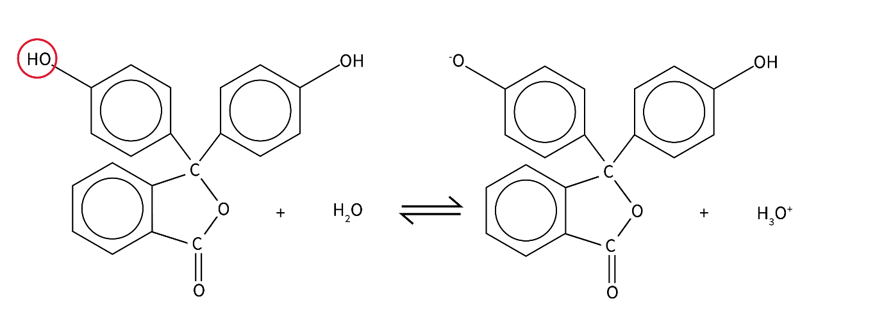

weak acid conjugate base

methyl orange:

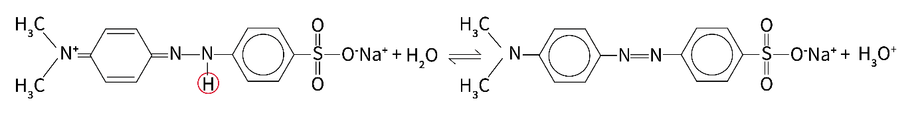

weak acid conjugate base

- The alkaline solution reacts with the H⁺ ions and removes them from the equilibrium. As a result, according to le Chatelier’s principle the equilibrium shifts to the right to replace the lost H⁺ ions. The concentration of yellow weak acid is reduced and the concentration of the red conjugate base is increased.
- According to le Chatelier’s principle, on the addition of H⁺ ions the equilibrium shifts to the left in favour of the yellow weak acid to remove the extra H⁺ ions added.
- We can express this equilibrium as:

HIn(aq) + H₂O(l) ⇌ In⁻(aq) + H₃O⁺(aq)

At the theoretical point of a colour change [HIn(aq)] = [In⁻(aq)] meaning that at this point K_{In} = [H₃O⁺] and therefore pK_{In} = pH.

If K_{In} for this equilibrium is 1.26 × 10⁻⁸ mol dm⁻³ then the theoretical pH at the point of colour change can be determined as:

pH = -log (1.26 × 10⁻⁸) = 7.9

The colour change is assumed to be distinguishable when [HIn] and [In⁻] differ by a factor of 10 meaning that the pH range over which the colour change occurs can be estimated as:

7.9 ± 1 = 6.9–8.9

- Addition of ammonia solution to hydrochloric acid:

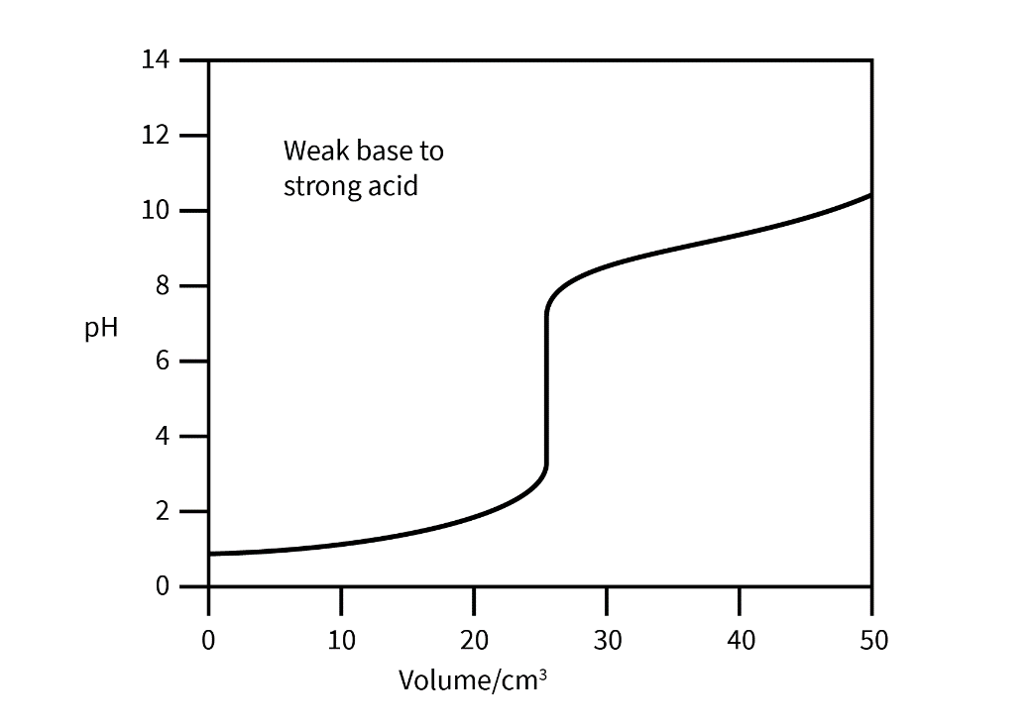

Suitable indicator = methyl orange or 4-nitrophenol

- Addition of ethanoic acid to sodium hydroxide.

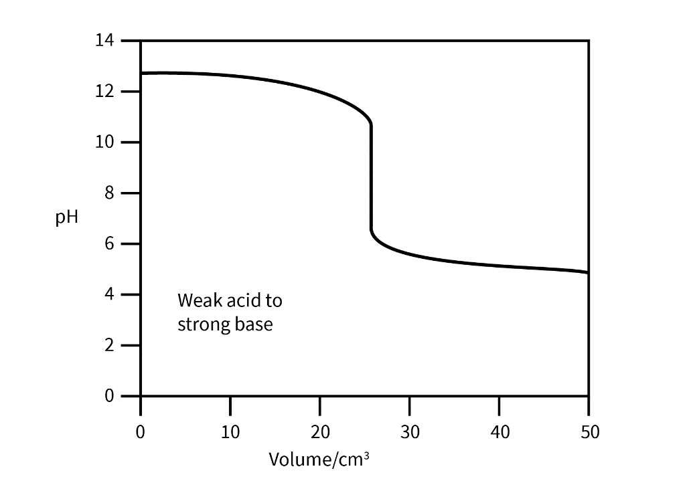

Suitable indicator = phenolphthalein

