Thermodynamics

Important definitions

For each of the transformations represented by the equations 1-5, name the enthalpy change and provide a full definition.

e.g. ½ N₂(g) + 3/2 H₂(g) → NH₃(g)

Name: The standard molar enthalpy change of formation of ammonia
Definition: The enthalpy change when one mole of a compound is formed from its elements under standard conditions, all reactants and products in their standard states

1. O⁻(g) + 1 e⁻(g) → O²⁻(g)
Name:
(1 mark)
Definition:
(1 mark)
2. K⁺(g) + aq → K⁺(aq)
Name:
(1 mark)
Definition:
(1 mark)
3. NaCl(s) + aq → Na⁺(aq) + Cl⁻(aq)
Name:
(1 mark)
Definition:
(1 mark)
4. Mg²⁺(g) + O²⁻(g) → MgO(s)
Name:
(1 mark)
Definition:
(1 mark)
5. HCl(g) → H⁺(g) + Cl⁻(g)
Name:
(1 mark)
Definition:
(1 mark)

Born Haber cycles

In 1918, a chance meeting of two German scientists, Max Born and Fritz Haber led to a discussion of the manner in which an ionic compound is formed when a metal reacts with a non-metal. This resulted in the creation of what we know today as Born Haber cycles.

The Born Haber cycle for the formation of calcium oxide is shown in the diagram below;

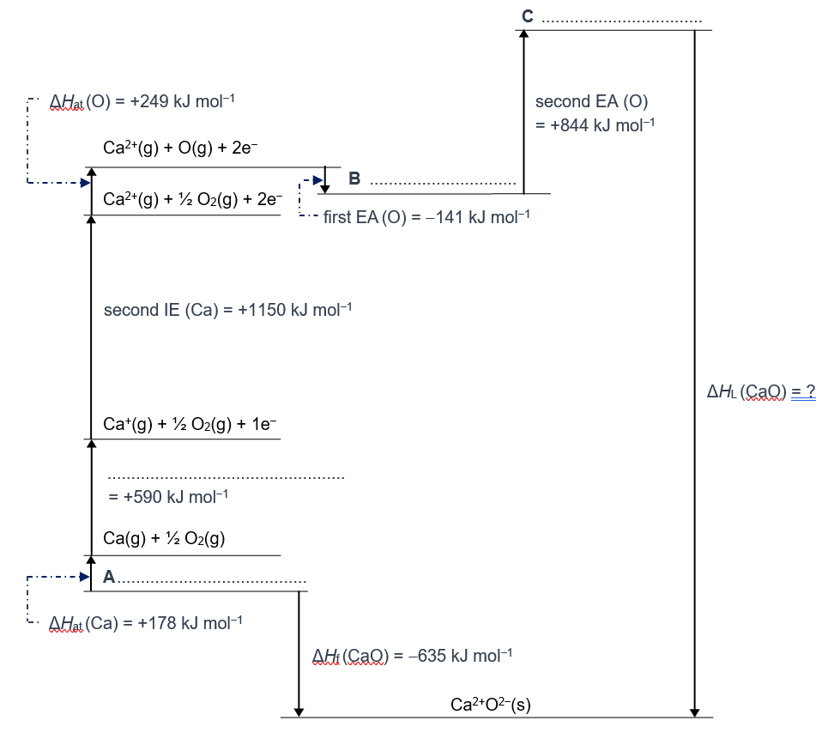
1. Complete the cycle by adding suitable labels for the one missing enthalpy change and the missing intermediate species on the three stages labelled A-C.
(7 marks)
2. Explain why the second electron affinity of oxygen is positive.
(2 marks)
3. Use the values for the enthalpy changes given to calculate the lattice dissociation enthalpy for calcium oxide.
(1 mark)

Enthalpy of solution

The tables below give some data on the lattice formation enthalpies for three different salts, and the enthalpies of hydration of the different ions in the salts.

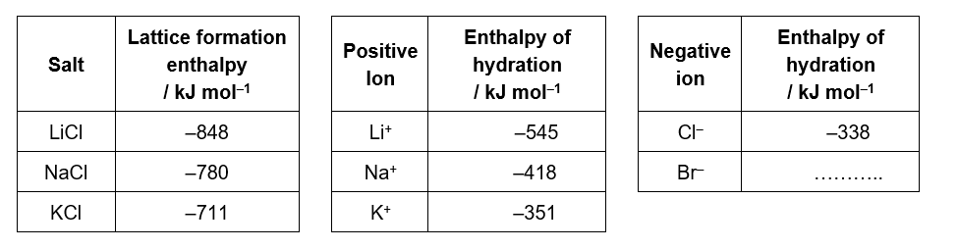

1. (a) Describe and explain the trend observed in the enthalpies of hydration of the group one ions.

(3 marks)
(b) The enthalpy of hydration of the bromide ion is not given in the table. Complete the table with a predicted value for the enthalpy of hydration of bromide ions.
(1 mark)

2. The enthalpy of solution of a salt can be calculated from its lattice enthalpy and the enthalpies of hydration of the individual ions in the salt.

Use the data in the table above to calculate the enthalpy of solution of each of the following salts. Show full working for your answers.
(6 marks)

Entropy

Entropy is a measure of the randomness of a system. The more disorder in a system the more positive the entropy.

1. For each of the pairs of systems below, circle the one with the higher entropy;

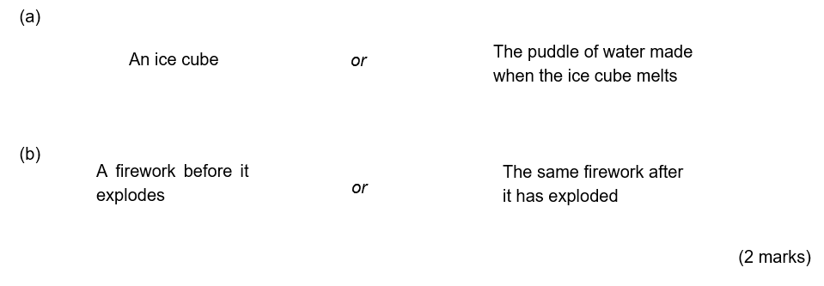
2. Use your understanding of entropy to predict whether each of the reactions (a)-(d) have a positive or negative entropy change.
(4 marks)
(a) H₂O₂(l) → H₂O(l) + O₂(g)
(b) 2 Fe₂O₃(s) + 3 C(s) → 4 Fe(s) + 3 CO₂(g)
(c) C₄H₈(g) + H₂(g) → C₄H₁₀(g)
(d) Ag⁺(aq) + Cl⁻(aq) → AgCl(s)

3. Use the data below to now calculate the entropy changes for each of the reactions (a)-(d) and see if your predictions were correct.

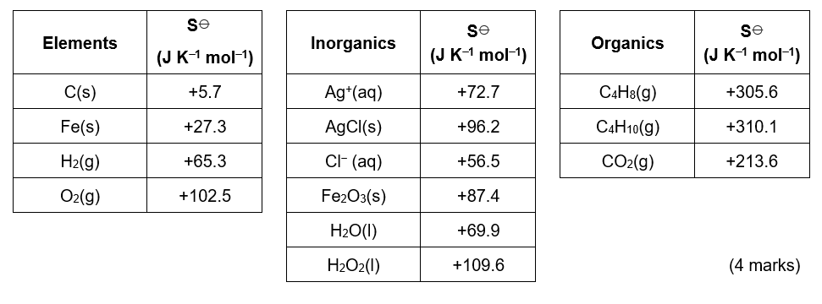

Gibbs free energy

1. The second law of thermodynamics states that for a reaction to be feasible, the total entropy has to increase i.e. ΔS_{total} > 0.

The total entropy change, ΔS_{total} can be defined as;

ΔS_{total} = ΔS_{surroundings} + ΔS_{system}

The entropy of the surroundings is affected by the enthalpy change of the reaction (e.g. in an exothermic reaction, heat energy is transferred to the surroundings and hence there is an increase in disorder). The relationship between the enthalpy change of a reaction, ΔH_{reaction} and the entropy change of the surroundings, ΔS_{surroundings} is given by;

ΔS_{surroundings} = − ΔH_{reaction}
T
If −TΔS_{total} is equal to the Gibbs free energy change, ΔG, use the facts above to derive the equation;
ΔG = ΔH_{reaction} − TΔS_{system}
(3 marks)

2. Iron can be extracted from haematite, Fe₂O₃, using either C or CO₂ as the reducing agent;

Fe₂O₃(s) + 3C(s) → 2 Fe(s) + 3 CO(g) ΔH = +492.7 kJ mol⁻¹
Fe₂O₃(s) + 3CO(g) → 2 Fe(s) + 3 CO₂(g) ΔH = −24.8 kJ mol⁻¹

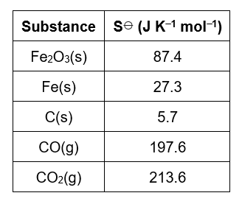
(a) Use the data on the right to;

(i) Calculate the minimum temperature at which reduction with carbon is feasible.
(2 marks)
(ii) Prove by calculation that reduction with carbon monoxide is feasible at all temperatures.
(2 marks)

(b) The lines on the graph on the next page (_____ and - - - - ) show how the Gibbs free energy changes with temperature for each of the methods of reducing haematite described in part (a).

(i) Identify which line corresponds to reduction with carbon and which to reduction with carbon monoxide.
(1 mark)
(ii) Calculate the temperature at point X
(2 marks)
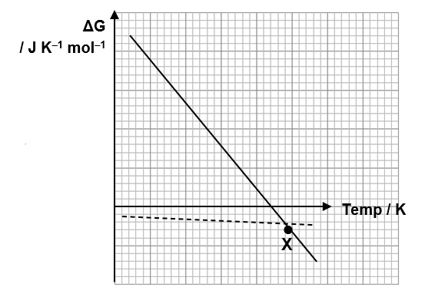

Thermodynamics – Answers

Important definitions
1. O⁻(g) + 1 e⁻(g) → O²⁻(g)
Name: Second electron affinity of oxygen
(1 mark)
Definition: The enthalpy change when a mole of electrons is added to a mole of gaseous oxygen ions each with a single negative charge, forming one mole of gaseous ions each with a two negative charge.
(1 mark)

2. K⁺(g) + aq → K⁺(aq)
Name: Molar enthalpy of hydration
(1 mark)
Definition: The enthalpy change when one mole of gaseous ions dissolve in sufficient water to give an infinitely dilute solution
(1 mark)

3. NaCl(s) + aq → Na⁺(aq) + Cl⁻ (aq)
Name: Molar enthalpy change of solution
(1 mark)
Definition: The enthalpy change when one mole of an ionic substance dissolves in sufficient water to give an infinitely dilute solution
(1 mark)

4. Mg²⁺(g) + O²⁻(g) → MgO(s)
Name: Lattice formation enthalpy
(1 mark)
Definition: The enthalpy change when one mole of an ionic substance is formed from its gaseous ions under standard conditions
(1 mark)

5. HCl(g) → H(g) + Cl(g)
Name: The H-Cl bond enthalpy in hydrogen chloride
(1 mark)
Definition: The enthalpy change when one mole of gaseous hydrogen chloride molecules breaks its covalent bond to form a gaseous hydrogen radical and a gaseous chlorine radical.
(1 mark)

Born Haber cycles

1. Missing enthalpy change is the first ionisation energy of calcium
(1 mark)
A: Ca(s) + ½ O₂(g)
B: Ca²⁺(g) + O⁻(g) + 1e⁻
C: Ca²⁺(g) + O²⁻(g)

(2 marks for each of A-C; 1 mark for correct species, 1 mark for correct state symbols)

2. The second electron affinity is positive as you are adding an electron to an already negative ion. Therefore energy is needed to overcome the repulsion.
(2 marks)
3. ΔH_{L}(CaO) = 178 + 590 + 1150 + 249 + (−141) + 844 – (−635)
= 2870 – (−635)
= 3505 kJ mol⁻¹
(1 mark)

Enthalpy of solution
1. (a) As the ions increase in size, the enthalpy of hydration decreases.
(1 mark)

As the ions increase in size the positive ions are less attractive (lower charge to size ratio) and so the attractions formed between the water molecules of the positive ion are weaker (1 mark) and hence less energy is produced when they form (1 mark).

(b) As a bromide ion is bigger than a chloride ion, following the trend described above the enthalpy of hydration is smaller (less negative). The actual value is –304 kJ mol^{–1}
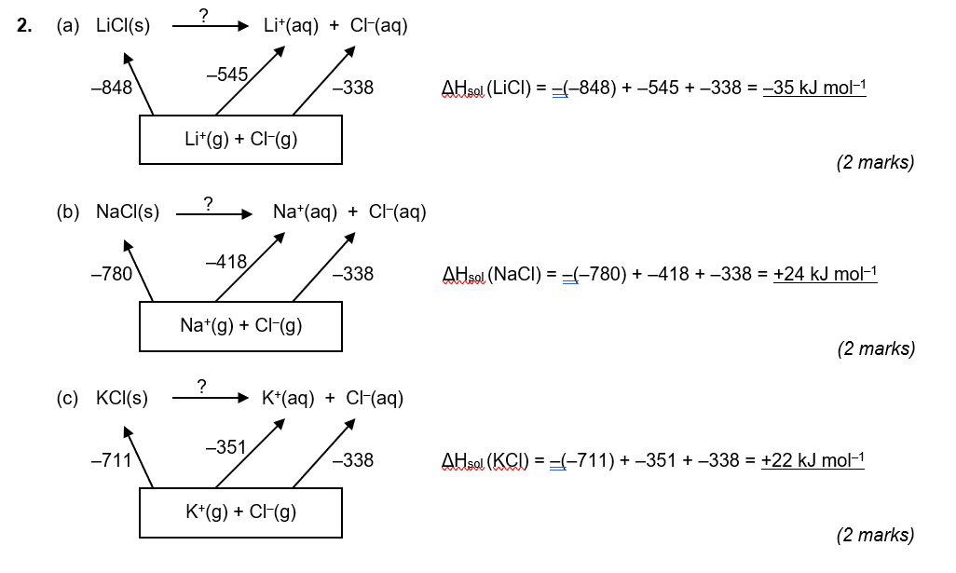

Entropy
1. (a) The puddle of water
(1 mark)
(b) The firework after it has exploded
(1 mark)

2. (a) H₂O₂(l) → H₂O(l) + O₂(g) Positive entropy change
(1 mark)
(b) 2 Fe₂O₃(s) + 3 C(s) → 4 Fe(s) + 3 CO₂(g) Positive entropy change
(1 mark)
(c) C₄H₈(g) + H₂(g) → C₄H₁₀(g) Negative entropy change
(1 mark)
(d) Ag⁺(aq) + Cl⁻(aq) → AgCl(s) Negative entropy change
(1 mark)

3. (a) H₂O₂(l) → H₂O(l) + O₂(g)
ΔS = (69.9 + 102.5) – (109.6) = +62.8 J K⁻¹ mol⁻¹
(1 mark)
(b) 2 Fe₂O₃(s) + 3 C(s) → 4 Fe(s) + 3 CO₂(g)
ΔS = [(4 × 27.3) + (3 × 213.6)] – [(2 × 87.4) + (3 × 5.7)] = 558.1 J K⁻¹ mol⁻¹
(1 mark)

(c) C₄H₈(g) + H₂(g) → C₄H₁₀(g)
ΔS = (310.1) – (305.6 + 65.3) = – 60.8 J K^{–1} mol^{–1}
(1 mark)

(d) Ag⁺(aq) + Cl⁻(aq) → AgCl(s)
ΔS = (96.2) – (72.7 + 56.5) = – 33.0 J K^{–1} mol^{–1}
(1 mark)

Gibbs free energy

1. If, ΔS_{total} = ΔS_{surroundings} + ΔS_{system,} substituting in ΔS_{surroundings} = − ΔH_{reaction} / T, the equation becomes;
ΔS_{total} = − ΔH_{reaction} + ΔS_{system} (1 mark)
T
Multiplying everything by –T we get;
–TΔS_{total} = ΔH_{reaction} – TΔS_{system} (1 mark)
Since, –TΔS_{total} = ΔG then, ΔG = ΔH_{reaction} – TΔS_{system} (1 mark)

2. (a) (i) For reduction with carbon;

ΔS = [(2 × 27.3) + (3 × 197.6)] – [87.4 + (3 × 5.7)] = +542.9 J K^{–1} mol^{–1}
(1 mark)
The reaction becomes feasible when ΔG = 0, so substituting into ΔG = ΔH – TΔS we get

0 = 492.7 – (T × 542.9/1000). Therefore, 492.7 = 0.5429T and hence T = 908 K
(1 mark)

(ii) For reduction with carbon monoxide;

ΔS = [(2 × 27.3) + (3 × 213.6)] – [87.4 + (3 × 197.6)] = +15.2 J K^{–1} mol^{–1}
(1 mark)

The reaction becomes feasible when ΔG = 0, so substituting into ΔG = ΔH – TΔS we get

0 = –24.8 – (T × 15.2/1000). Therefore, 24.8 = – 0.0152T and hence T = –1630 K. Since the lowest temperature possible is 0 K, the reaction is feasible at all temperatures.
(1 mark)

(b) (i) Comparing ΔG = ΔH – TΔS to y = mx + c we can see a graph of ΔG (y-axis) vs. T (x-axis) will have a gradient of –ΔS and a y-intercept equal to ΔH.

For reduction with C, ΔH = +492.7 kJ mol^{–1}, ΔS = +542.9 J K^{–1} mol^{–1} therefore line

For reduction with CO, ΔH = –24.8 kJ mol^{–1}, ΔS = +15.2 J K^{–1} mol^{–1} therefore line
(1 mark for correct identification)

(ii) At point X both reactions have an equal value for ΔG so we can say that;

492.7 – 0.5429T = –24.8 – 0.0152T
(1 mark)
Rearranging this becomes;

492.7 + 24.8 = 0.5429T – 0.0152T
517.5 = 0.5277T
T = 981 K
(1 mark)

