Metallic bonding and alloys

This resource accompanies the infographic poster Metallic bonding in Education in Chemistry which you can download and print to display in your classroom: rsc.li/468Rg0I

Learning objectives
- Describe the structure and bonding in pure metals and alloys.
- Explain the properties of pure metals and alloys using your understanding of their structure and bonding.

Introduction

The worksheet will support learners to answer longer questions on metallic bonding and alloys independently.

Task 1 is a true or false quiz which checks learners’ understanding of both learning objectives.

Task 2 and task 4 Q1 ask learners to describe – and show their understanding of – the structure of metals due to metallic bonding.

Task 3 and task 4 Q2 ask learners’ to use their knowledge of the structure of metals and alloys to explain their properties.

A scaffolded version of the worksheet is available which includes prompts, matching definitions and a structure strip to support learners to answer the same questions.

Answers

Task 1 – True or false?
- Metal ions are always positively charged. True
- The metal ions are close packed in the structure. True
- In metallic bonding, the outer shell electrons are delocalised. True
- The delocalised electrons are in a fixed position and are unable to move. False
- Metals cannot conduct electricity. False
- Metals have high melting points. True
- Metals are malleable and ductile. True
- An alloy is a mixture of two or more elements, where at least one element is a metal. True
- Pure metals are stronger than alloys. False
- Alloys have a layered structure. False
- In alloys, the atoms are all the same size. False

Task 2 – Description of metallic bonding

Description of error | Explanation of why this is incorrect
The charge of magnesium is 1+ | Magnesium is in group 2 so has 2 outer shell electrons. The charge should therefore be 2+ when these are delocalised.
The ions are too far apart. | The structure should be close packed.
The outer electrons are in shells. | In metallic bonding the electrons are delocalised and can move through the structure.
Magnesium should have 2 outer shell electrons. | Magnesium is in Group II of the periodic table. It produces Mg2+ ions and there will be two delocalised electrons for every magnesium ion.

- Magnesium ions must have a 2+ charge. They must be close packed. There must be the same number of electrons as there are ions.

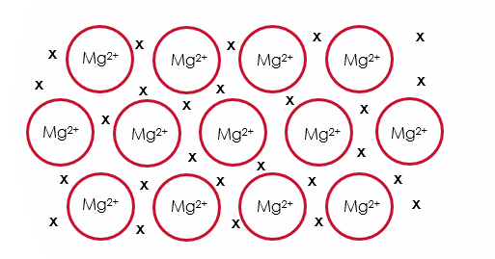

Task 3 – Properties of metals
Property of metals | Explanation using knowledge of metallic bonding
High melting point | Metallic bonds are the strong electrostatic interactions between the positively charged metals ions and the sea of delocalised electrons. Metals have high melting points as a large amount of energy is required to overcome these forces
High density | Metal ions are closely packed in a giant 3D lattice structure. The close packed nature of the metal ions means that metals have a high density
Good conductor of electricity | Metals are good electrical conductors due to the sea of delocalised electrons, which are free to move through the structure and carry electrical charge
Malleable and ductile | Pure metals only contain one type of metal atom so the atoms are arranged in layers which can slide over one another

Task 4 - Alloys
- Alloys contain different sized atoms which means that the layers are distorted.
- Alloys contain a sea of delocalised electrons which can move through the structure.
- Pure metals only contain one type of atom, whereas alloys contain two or more different types of atoms.
- The atoms in a pure metal form layers as all the atoms are the same size.
- In alloys however, the different sizes of the atoms distort the layered structure.
- Both pure metals and alloys lose their outer shell electrons to form a sea of delocalised electrons.
- Alloys are stronger than pure metals as they have two or more different atoms, which are different sizes.
- This distorts/disrupts the layer structure seen in pure metals which means that the layers cannot easily slide over one another.
- This increases the strength of the material while maintaining other properties such as low density.

