Chromatography of sweets

Learning objectives
- Recap the keywords behind chromatography.
- Investigate the dyes that are in different coloured sweets by successfully following a method.
- Analyse the results and write a conclusion.

Introduction

Food colourings contain different dyes. Your aim is to investigate the number of different dyes in coloured sweets using chromatography.

Starter questions
- What is meant by the word ‘solute’?
_________________________________________________________________________________

__________________________________________________________________________________
- What does ‘solvent’ mean?

__________________________________________________________________________________

__________________________________________________________________________________
- Define the term ‘solution’.

__________________________________________________________________________________

__________________________________________________________________________________
- What is meant by the word ‘mixture’?

__________________________________________________________________________________

__________________________________________________________________________________

__________________________________________________________________________________
- Define the term ‘chromatography’.

__________________________________________________________________________________

__________________________________________________________________________________

__________________________________________________________________________________

Method

An adjusted method is given on the student support sheet.
- Place the piece of chromatography paper on a flat surface, with the longer side horizontal.
- Draw a horizontal line in pencil 1.5 cm from the base of the paper.

Safety note: Sweets are for laboratory use only and should not be licked or eaten.
- Use a dampened paint brush to remove the colour from one of the sweets and paint this colour on the pencil line 2 cm from one end. Small spots are best.

Alternatively, add each sweet to a separate well on a spotting tile. Add three drops of water to each well. Transfer a small drop of the coloured water to the chromatography paper using a melting point tube.
- Clean the brush in fresh running water.
- Paint the colour of another sweet on the line about 2 cm from the first spot.
- Repeat this until all the colours are on the paper or until you have reached the other end.
- Use a pencil to label the colour of each spot.
- Roll the paper into a cylinder and hold this in place with the paper clips. Try to avoid any overlapping of the paper when you make the cylinder.
- Put water into a beaker up to depth of about 1 cm.
- Lower the paper cylinder into the beaker of water allowing the water to rise up the paper. Ensure that the water is below the level of the spots. Avoid moving the paper cylinder once it is in position.
- When the water approaches the top of the paper cylinder remove it from the water. Mark with a pencil the level of the water at the top of the filter paper.
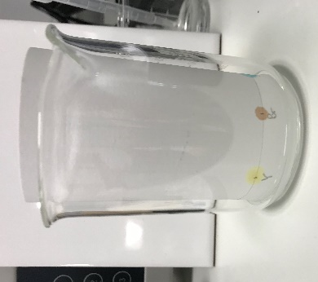
- Allow the paper cylinder to dry, using a hairdryer if available or by leaving it to dry overnight.

Step 10

Step 7

Alternative step 3
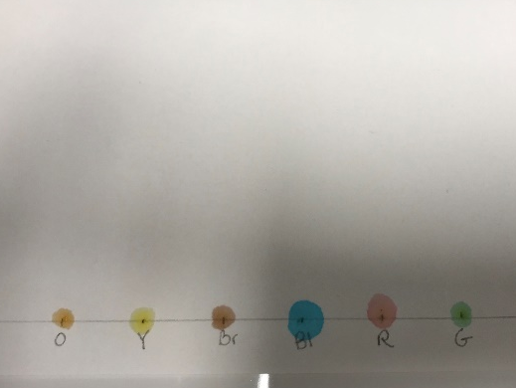
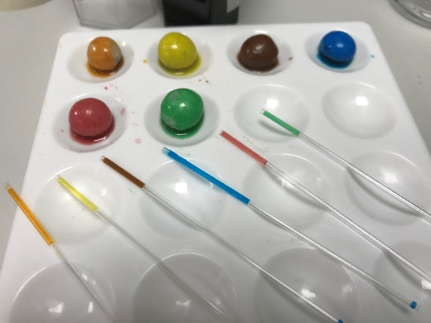

Conclusion questions
- List the sweet colours that contained one dye.

_________________________________________________________________________________

- List the sweet colours that contained a mixture of dyes.

__________________________________________________________________________________

- Identify two sweets that contained the same dye.

___________________ and ___________________ both contained _________________ dye.

- Suggest why some dyes separate out into different colours while others do not.

__________________________________________________________________________________

__________________________________________________________________________________
__________________________________________________________________________________

- Suggest why some colours move further up the paper than others.

__________________________________________________________________________________

__________________________________________________________________________________

__________________________________________________________________________________

- Give one way of improving the separation between the different spots.

__________________________________________________________________________________

__________________________________________________________________________________

__________________________________________________________________________________

- What common errors can be made during the procedure?

__________________________________________________________________________________

__________________________________________________________________________________

__________________________________________________________________________________

- Why is the start line drawn in pencil rather than pen?

__________________________________________________________________________________

__________________________________________________________________________________

__________________________________________________________________________________

