A synoptic view of cross-curricular links between chemistry and biology.
Education in Chemistry
July 2019
rsc.li/2KBGSaJ
This article demonstrates the vital role that chemists play in biomedical science. The following questions would be ideally used in revision to help students make connections between different aspects of chemistry and biology. These questions are also designed to get students thinking about common chemistry concepts in unfamiliar contexts, but ones that may be relevant to their lives.
- Vaccines are proteins – what are the chemical elements in proteins?
- Which of the following biomolecules are also proteins? Hormones, enzymes, lipids, carbohydrates, collagen.
- Nitrate ions are taken up in the roots of plants and this is vital for the production of amino acids and, in turn, proteins. What is the chemical formula of nitrate?
- What are the chemical formulas of the two main components of air?
- Which chemical element does the plant obtain from nitrates that it can’t obtain from the air?
- (Triple chemistry only) Proteins can be considered to be polymers of amino acids. What is a polymer?
- Why must a vaccine be given as an injection rather than as a tablet that is swallowed?
- (Triple chemistry only) Name one (or more) polymers made from glucose.
- (A-level) Explain why antibodies could be considered condensation polymers of amino acids, illustrate your answer with chemical structures.
- (A-level) Antibodies are proteins that are made of two heavy chains and two light chains each of which contains cysteines. Suggest what role these cysteines might play in the quaternary structure of these proteins.
- The everyday meaning of the word ‘salt’ is the stuff you put on chips and flavour food. How is the term ‘salt’ used differently in chemistry?
- What is a ‘formulation’? Would a formulation be a pure substance or a mixture?
- What is the chemical symbol formula for aluminium hydroxide? Is aluminium hydroxide a pure substance or a mixture?
- How might sodium hydroxide solution be useful when testing for the presence of aluminium?
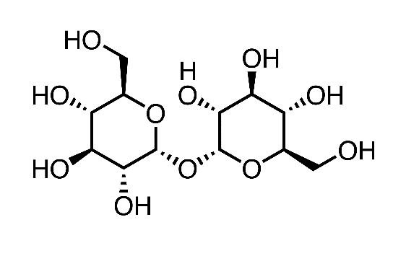
- (A-level) The right combination of salts can be used to ensure the correct pH for the vaccine. What ratio of sodium ethanoate to ethanoic acid would be required for a pH of 7.0? The K_{a} for ethanoic acid is 1.7 x 10⁻⁵ mol dm⁻³
- What is the difference between evaporation and boiling?
- Explain why a vacuum can be used to evaporate water without heating it.
- The chemical structure of trehalose is shown on the right, it consists of two glucose molecules joined by a covalent bond.
What similarities can you see between trehalose and water?
Trehalose
- Why is it necessary to keep the vaccine cold?
- What happens to an enzyme when the temperature is too hot?
- Why does the vaccine need to be kept at a constant pH? (What effect might pH have on protein structure?)
- Sketch a graph to predict the effect of storage temperature on the activity of a vaccine.
- (Triple chemistry only) What is the chemical structure of ethanol? What functional group do ethanol and trehalose have in common?
- (A-level) What type of bonding might the functional groups in trehalose be involved in with the protein? How do these bonds affect protein structure?

Answers
- Proteins contain carbon, hydrogen, oxygen, nitrogen and small amounts of sulfur.
- Enzymes, collagen and some hormones are proteins.
- The formula for nitrate ions is NO₃⁻.
- The two main components of air are N₂ and O₂.
- Plants obtain nitrogen from nitrates.
- A polymer is a substance which has a molecular structure built up of a large number of similar units covalently bonded together.
- Vaccines are proteins which are broken down by enzymes in the stomach.
- Carbohydrate – or more specifically glycogen, cellulose, starch.
- In a condensation reaction water is formed:
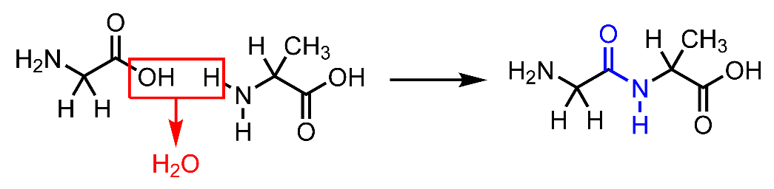
- Cysteines form disulfide bridges between the different polypeptide chains which plays a part in stabilising the quaternary structure.
- A salt is the compound that is formed when some or all of the hydrogen in an acid is replaced by a metal. It typically contains a metal and one or more non-metals.
- A formulation is a mixture of chemicals that do not react and form a useful product. Examples include sunscreen, medicines, vaccines, adhesives.
- Al(OH)₃ – it is a pure substance.
- Aluminium ions form a white precipitate of Al(OH)₃ in the presence of hydroxide ions. This is a characteristic test for the presence of aluminium ions.
- Sodium ethanoate : ethanoic acid = 170 : 1
$$\frac{\left[CH_{3}COO^{-}\right]}{\left[CH_{3}COOH\right]}=\frac{Ka}{[H^{+}]}=\frac{1.7×{10}^{-5}}{1×{10}^{-7}}=170$$
- Evaporation and boiling both involve a liquid changing state to a gas but in evaporation the particles are only changing state at the surface of the liquid whereas when a liquid is boiling, the gas forms throughout the liquid which is why bubbles occur in boiling but not in evaporation.
- When water evaporates, some water particles at the surface of the liquid have enough kinetic energy to escape into the surrounding air. If there is plenty of water vapour in the air then some will condense back onto the water surface. However in a vacuum there are too few particles in the surrounding air so there will be a net movement of water particles away from the liquid eventually drying it out.
- Both trehalose and water contain O–H bonds.
- It is necessary to keep the vaccine cold to prevent it denaturing. At high temperatures the overall shape of the vaccine is disrupted (it is denatured) and this prevents it from reacting with its target in the body.
- At high temperatures the overall shape of the enzyme is disrupted (it is denatured) and this prevents it from reacting with its target in the body.
- The vaccine needs to be kept at a constant pH because it becomes denatured at very low or very high pH. The pH is important for the overall shape of the protein.

Vaccine activity

60
40
20
0
Storage temperature (ºC)

- The chemical structure of ethanol is C₂H₅OH. Ethanol and trehalose both have an alcohol/hydroxyl/–OH functional group.
- The hydroxyl functional groups will form hydrogen bonds that will replace the ones made by water when the protein is freeze-dried. Hydrogen bonds are important in determining the secondary structure of a protein.

