Evaluate the evidence
Education in Chemistry
July 2018
rsc.li/2tBSMXI

This activity accompanies the article ‘Check my working’. Read the article and then consider this scenario.
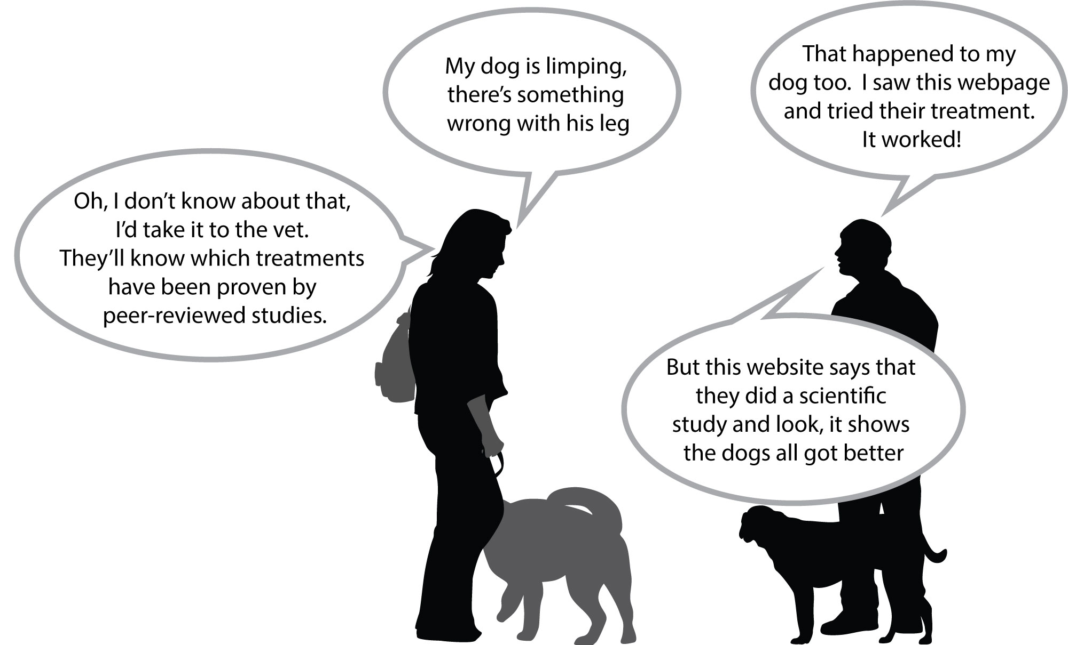
This is an extract from the website one of the dog-owners mentions:
The effect of green-lipped mussel extract on joint swelling in dogs
C N Herbie and T D Kanine
Dogs Meds Online Research Centre, Harlin, UK

Summary: Green-lipped mussel extract contains a unique form of hyaluronic acid proven to reach the joint within two hours, helping to lubricate and cushion the joint. Treatment was shown to improve joint swelling in dogs after one weeks’ treatment.
Method: Dogs were given green lipped mussel extract every day for a week. Owners were given a questionnaire to report the effect.
Results: All of the owners commented positively that the treatment had improved their dog’s mobility.
Conclusion: Green-lipped mussel extract is recommended for the treatment of joint swelling in dogs.

Use these questions to decide if you trust the claim that joint swelling will improve for all dogs after taking green-lipped mussel extract and whether you would recommend it for publication.
Checklist | You could prompt students to consider comments along these lines
- Has the author been clear about the sample size in their study? | No, there is no information on how many owners were interviewed or how many dogs were involved.
- Did the author describe the procedure they used to gather data? | They say there was a questionnaire for the owners to report how the dog’s mobility changed.
- Did the author describe how they analysed the data? | They have summarised the owners’ comments and don’t report any quantitative data.
- Is there sufficient information to enable someone else to repeat the study? | No, they don’t say how much green-lipped mussel extract was given and what form it was given in (i.e. powder or liquid) or how often. There is no information about the types of dogs involved.
- Is the conclusion consistent with the evidence? | They claim that it reduces joint swelling but their evidence is about general mobility. The two might be linked but it would be better to measure the amount of swelling as a more impartial measurement.
- Did the author discuss how well their conclusion agrees with the claims made by other groups? | No. There is some information about trials in humans on the Arthritis Research UK website, for example.
- Have the authors declared any conflicts of interest? | No, though their address – Dogs Meds Online Research Centre – is the same as the name of the website. This suggests they are employed by the people that make and sell the medicine. This might be a conflict of interest because they could gain financially from sales of the medicine.
- If you were peer reviewing this study, would you recommend it for publication? | No
- If you wouldn’t, what feedback could you give the authors to help them improve their work. | - Compare with a placebo  - Don’t tell the owners whether they got the extract or the placebo  - Have some independent measure of mobility – perhaps a pedometer attached to the dog to measure steps? Or perhaps measure a knee joint with a tape measure and see if the diameter of the knee decreases with treatment.  - Ensure that the dose and formulation of the medicine is specified

