Electrolysis gets a boost from metal scraps

Original article by Kate Tustain. Adapted by Nina Notman.

Industrial byproducts of metal alloy manufacturing get a second life as clean hydrogen fuel producers

New research shows that filings and shavings left over from grinding, drilling, and cutting metal alloys can be transformed into catalytic electrodes for water splitting. The nanotextured surface of the waste metal is perfect for holding single atoms of platinum and cobalt. These act as electrocatalysts, speeding up key reactions on the electrode’s surface.

Producing hydrogen fuel through splitting water using electrolysis will be important for addressing future global energy demands. However, the environmental impact of mining precious metals to make electrodes is an ongoing issue.

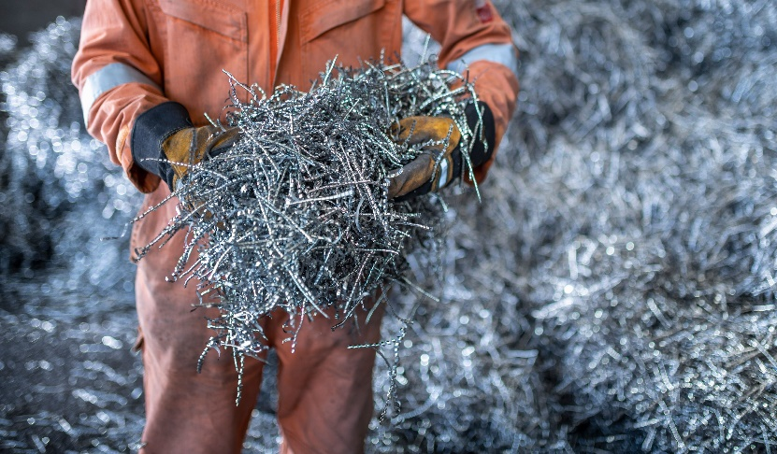
Sustainable and scalable

Source: © Monty Rakusen/Getty Images

Metal scraps from stainless steel, titanium, and nickel alloys can be transformed into electrodes for clean hydrogen production

To address this challenge, a team at the University of Nottingham, UK has taken advantage of the nanotextured surfaces of waste pieces of stainless-steel, titanium and nickel alloys. Although the metals appear smooth, the researchers used scanning electron microscopy to discover tiny grooves on their surfaces. These nanoscale grooves can anchor single atoms of platinum and cobalt to produce efficient electrocatalysts.

Importantly, the team found they needed significantly less platinum and cobalt compared to state-of-the-art commercial catalysts.

This research shows how waste metal pieces that are expensive to recycle, or that would otherwise be disposed of, can be repurposed. It also offers a route to using smaller amounts of rare elements in catalysts for water splitting. The researchers are confident their concept will be transferrable to industrial-scale production.

This is adapted from the article ‘Metal swarf transformed into electrodes for hydrogen production’ Chemistry World. Read the full article: rsc.li/3XvX6rc.

