Large molecules
Contents
- Learning objectives
- Career links
- Activity 1: modelling polymerisation
- Activity 2: polymerisation
- Activity 3: thermosoftening polymers
- Quick quiz: polymer review questions

Acknowledgements
This resource was originally developed by the University of Reading to support outreach work delivered as part of the Chemistry for All project.
To find out more about the project, and get more resources to help widen participation, visit our Outreach resources hub: rsc.li/3CJX7M3.

Learning objectives
By the end of this session, you will be able to:
- Identify the properties of a monomer.
- State what a polymer is.
- Explain the similarities and differences between polymers.
- Describe the properties and uses of thermosoftening polymers.
There are lots of possible career paths linked to chemistry that you may not expect.
Patent attorney
Watch the video job profile on slide 4 of the PowerPoint (also available from rsc.li/3JR4Yfx) to learn about Charley’s role as a patent attorney. He helps inventors get legal protection for their inventions.
Senior director of chip research
Find about Jason’s role as a senior director of chip research with his video job profile on slide 6 of the PowerPoint, also available from rsc.li/3ZMJAh1. Jason sequences DNA to identify viruses or new species.
Research innovations manager
Watch the video job profile on slide 20 of the PowerPoint to learn about Margot’s role as a research innovations manager. She develops ways to make plastic break down quickly in the natural environment. The video is also available at rsc.li/3JRakaD.
Analytical technician in plastics
Discover what Celine does as an analytical technician in plastics by watching the video on slide 23 of the PowerPoint (also available from rsc.li/3LBvfA0). She develops the structure of plastics so they will biodegrade in the environment to reduce plastic pollution.

Activity 1: modelling polymerisation
- Work in pairs.
- Each of you should put a C atom around your neck and hold a 30 $cm$ ruler in one hand.
- Turn to face your partner so that both rulers are between you.
- Take hold of both rulers.
- You are now modelling the double carbon to carbon bond found in a monomer. Each of you are carbon atoms and the two rulers between you represent the double bond holding you both together.
- Form a line of monomers around the outside of the classroom.
- If you are in the first two monomers in the line, break one of your bonds with your partner.
- If you are closer than your partner to the other pair who broke their bond, share a ruler with your neighbour.
- This models the double bond breaking and a new bond forming with the neighbouring monomer.
- Continue this process along the line to produce a polymer.

Activity 2: polymerisation
- This monomer is called chloroethene.
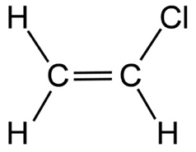
Draw the polymer made from three molecules of this monomer.
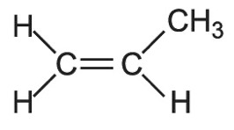
- Draw the polymer formed from four molecules of this monomer.

- Draw the monomer used to make this polymer.
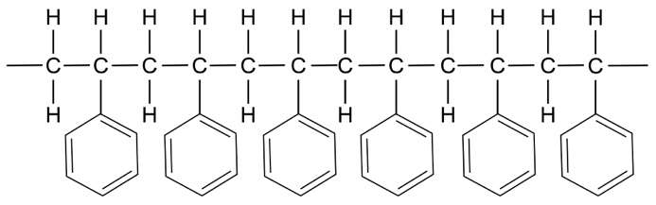

Activity 3: thermosoftening polymers
Thermosoftening polymers are a tangle of individual polymer chains.
Why might these types of polymers be useful?

Safety and hazards
Wear safety glasses.
Hot water can cause burns. Take care when transferring the polymorph into and out of the hot water. Use a glass rod to retrieve the heated polymorph and leave it to cool before handling it.
To do
- Place your sample of polymorph into very hot water. Be careful to avoid burning yourself.
- When the sample has gone translucent, use a glass rod to retrieve it from the beaker.
- Remove any excess water after taking the sample out of the water.
- Mould it into a shape or pen topper.
- Leave it to cool.
- If it becomes difficult to mould, or you want to create something else, return it to the hot water to soften.

Quick quiz: polymer review questions
- Describe the difference between monomers and polymers.

- Name two examples of polymers.

- Draw the structure of the monomer pentene.
- Identify and draw the monomer used to make poly(ethene).
