Quantitative chemistry: knowledge check
- This diagram represents a chemical equation. Label the diagram using the words below.

atom compound element

molecule product reactants
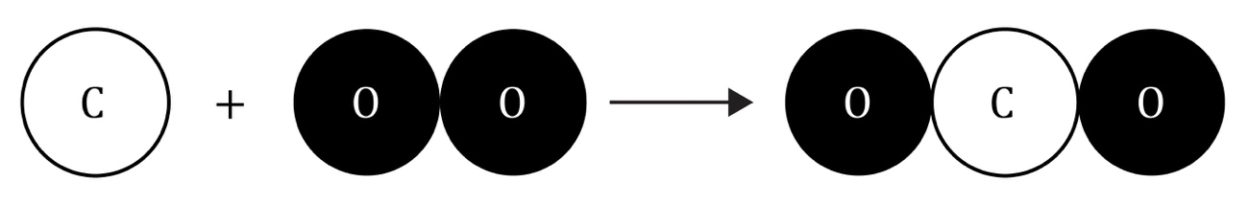
- (a) On which side of the arrow are the reactants? ___________________________
  - On which side of the arrow are the products? ___________________________
- (a) Name the reactants.

___________________________ and ___________________________
  - Name the product.

___________________________
  - How many types of particles are in an element? ___________________________
  - How many types of particles are in a compound? ___________________________

- Complete the sentences.

During a chemical reaction, ___________________________ are neither created nor destroyed. Instead, the atoms are just ___________________________ to form a new substance. This means that the total mass of the ___________________________ will be the same as the total mass of the ___________________________. In this example, there are four atoms of ___________________________ and two atoms of ___________________________ on both sides of the arrow. The equation is balanced and shows that the mass is conserved. The total ___________________________ stays the same during a chemical reaction. This is the law of ___________________________ of mass.

Quantitative chemistry: test myself
- In terms of the number and type of atoms, what does the formula H₂O mean?

- Write a word equation for this chemical reaction.

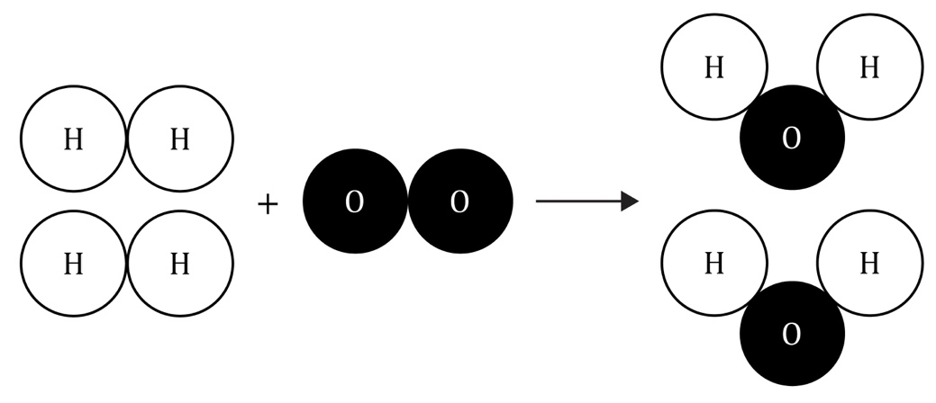

What is the formula for one molecule of hydrogen? For example, the formula for water is H₂O.

Write a balanced symbol equation for the chemical reaction shown in question 2.2.

In terms of conservation of mass, why does the number of hydrogen and oxygen atoms on the left-hand side of the arrow have to be equal to those on the right-hand side?

- Balance this equation:
CH₄ + ___________ O₂ $→$ CO₂ + ___________ H₂O

How much water would you expect to make from 4 g of hydrogen and 32 g of oxygen?

Show your working.

How much water would expect to make from 20 kg of oxygen and 160 kg of hydrogen?

Show your working.

On the Periodic table, oxygen has an atomic (proton) number of 8. How many protons are in one atom of oxygen?

Show your working.

On the Periodic table, oxygen has a relative atomic mass of 16. How many neutrons are in one atom of oxygen?

Show your working.

Quantitative chemistry: feeling confident?
- Use the Periodic table to complete the table.
Element | Symbol | Relative atomic mass
 | H
 | O
 | Cl
 | C
 | N
 | Fe
 | Na
 | Mg
 | Cu
 | S

- Use the relative atomic masses from question 3.1 to calculate the relative formula mass of the compounds in the table. The first one has been done for you.
Formula | Calculation | Relative formula mass
H₂O | (2 × H) + (1 × O)  = (2 × 1) + (1 × 16) | 18
NaCl
CO₂
CH₄
NH₃
CuSO₄
C₆H₁₂O₆
Na₂CO₃
Mg(OH)₂
(NH₄)₂SO₄

Quantitative chemistry: what do I understand?

Think about your answers and confidence level for each mini-topic. Decide whether you understand it well, are unsure or need more help. Tick the appropriate column.
Mini-topic | I understand  this well | I think I understand this | I need more  help
I understand that all substances are made up of atoms and molecules.
I can identify elements and compounds.
I can identify reactants and products in a chemical equation.
I can write simple chemical formulas.
I can understand and use the law of conservation of mass.
I can write simple word equations.
I can write simple balanced symbol equations.
I can calculate the mass of a reactant or product in a chemical reaction given all other reacting masses.
Feeling confident? topics | I understand  this well | I think I understand this | I need more  help
I can use the Periodic table to find the relative atomic masses of named elements.
I can calculate relative formula mass.

