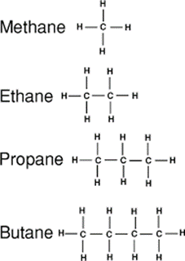
- Here are the first four members of the alkane homologous series.
John and Josie make some statements about these alkanes.

State which statements are true, and which are false.

Write ‘T’ or ‘F’ into the box.
- The alkanes are hydrocarbons.  - In this homologous series, it is always true that the molecular formula of one alkane differs from the next alkane by a CH₃ unit.  - The alkanes in this series are called straight chain hydrocarbons.  - The formula of the alkane having 24 hydrogen atoms is C₁₂H₂₄.  - When an alkane burns, water is always formed.  - It is always true that when an alkane burns, more heat energy is given out on forming new product chemical bonds than is required to break reactant bonds.  - When methane burns, 882 kJ of heat energy is produced per mole. If 1.00 g of methane burns, 14.1 kJ of heat energy is released. [RAM data: C = 12, H = 1] | T  F  F  T  F  T  T

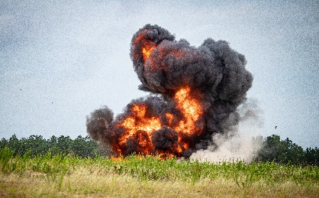
- This shows what happens when rubber tyres are
Source: Adobe Stock
set on fire.

- What type of combustion is taking place?
Give a reason.
Answer: Incomplete combustion.
Carbon is formed.
- State two environmental problems with this type of combustion.
Answer: Breathing problems due to particulate carbon, blackening of buildings, global dimming.

- Some car and lorry engines produce a pollutant called nitrogen dioxide.

- Name the two gases that react together to make nitrogen dioxide.
Answer: Nitrogen and oxygen.
- State the name of the substance that contains these two gases before the engine is used.
Answer: Air.
- Describe how nitrogen dioxide is formed inside an engine.
Answer: Nitrogen reacts with oxygen inside the engine to make nitrogen dioxide.
It can do this because the engine gets very hot when the fuel burns.
- Sulfur is an impurity in fossil fuels. When this substance burns, it can produce a gas that can be very harmful to the environment.
Explain why this gas is harmful.
Write a chemical equation to help you explain your answer.
Answer: Sulfur burns in air (oxygen) to form sulfur dioxide.
Sulfur dioxide dissolves and reacts with water to form sulfurous acid (sulfuric(IV) acid):
H₂O + SO₂ H₂SO₃
Sulfurous acid is a weak acid but when dissolved in water, for example in rain, it forms solutions of a low pH e.g. 3–6 (sometimes lower).
This acid rain can destroy wildlife based in water as well as have a disastrous effect on some life on land, for example, trees.

- Petrol may produce a lot of pollution when it burns.
Hydrogen is seen as a better fuel to use as it does not make any pollution.
- Give the names of two pollutants produced from burning petrol.
Answer: Carbon dioxide, soot, nitrogen dioxide (and other NO_{x} gases).
- Complete the symbol equation to show what happens when hydrogen burns in air:

2H₂ + O₂ 2H₂O
- Use your answer to part b) to explain why hydrogen does not make any pollution when it burns.
Answer: Water is the product of combustion of burning hydrogen, and this is non-polluting and harmless.
- When a hydrocarbon burns in a limited or short-supply of oxygen, a toxic gas may form.
Draw straight lines from the statements on the left to the correct answer on the right.
Answer
Statement

Carbon monoxide
The name of the gas?
Carbon dioxide

CO
The chemical formula of the gas? is..

CO₂

Complete
The type of combustion taking place?

Incomplete

- Explain why the gas in part d) is toxic.
Answer: Carbon monoxide bonds to haemoglobin.
It occupies the sites in the haemoglobin molecule used by oxygen.
The levels of oxygen in the bloodstream decrease, resulting in tissue damage and other serious health consequences.

- State which of these equations show complete and incomplete combustions.
Draw a straight line from the chemical equation to the correct type of combustion.
Chemical equation
Type of combustion
C₃H₈ + 5O₂ 3CO₂ + 4H₂O

C₄H₈ + 4O₂ 4CO + 4H₂O

Complete combustion

2C₁₀H₂₂ + 11O₂ 20C + 22H₂O

Incomplete combustion
2C₄H₁₀ + 13O₂ 8CO₂ + 10H₂O

- This question is about writing chemical equations for combustion reactions.

Complete the equations.
Make sure that each equation is balanced.
- The complete combustion of methane.
CH₄ + 2O₂ CO₂ + 2H₂O
- The incomplete combustion of ethane.
2C₂H₆ + 5O₂ 4CO + 6H₂O
- The complete combustion of hexane.
2C₆H₁₄ + 19O₂ 12CO₂ + 14H₂O
- The incomplete combustion of heptane.
C₇H₁₆ + 11O₂ 7CO₂ + 8H₂O
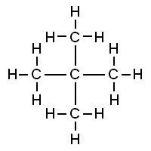
- The complete combustion of the molecule shown.
C₅H₁₂ + 8O₂ 5CO₂ + 6H₂O

- Steph and Nikita set us a puzzle.
They write down the combustion equation below.
2C₈H₁₆ + 24O₂ 16CO₂ + 16H₂O
- What is the formula of the missing straight chain hydrocarbon?
Answer: C₈H₁₆
- State if the missing hydrocarbon is an alkane. Give a reason.
Answer: Not an alkane, as it is a straight chain hydrocarbon, and must therefore have the alkane general formula: C_{n}H_{(2n+2)}, not C_{n}H_{2n}.

