Practical planning: spot the mistakes

Learning objectives
- Identify the mistakes in methods for planned practical experiments.
- Explain why the mistakes you have found would not lead to a valid outcome.
- Select the appropriate equipment needed to carry out a given investigation.
- Plan a method that would lead to a valid outcome.

Introduction

These exam-style questions will check your understanding of experimental skills and strategies. In your answers, you will evaluate the methods described, make suggestions for improvements, select the appropriate apparatus and plan experiments. All of these are fundamental parts of working scientifically. The questions are based on chromatography, making salts and neutralisation.

Questions

Chromatography

A student was investigating the pigments in different leaves (1, 2 and 3). The pigments are insoluble in water but soluble in ethanol.

This is the method they used:
- Leaf 1 was crushed using a pestle and mortar.
- Ethanol was added using a pipette.
- The mixture was filtered.
- Spots of the filtrate were put on to the chromatography paper.
- Steps 1–4 were repeated with leaves 2 and 3.

On the next page, there is a diagram of the apparatus the student used.

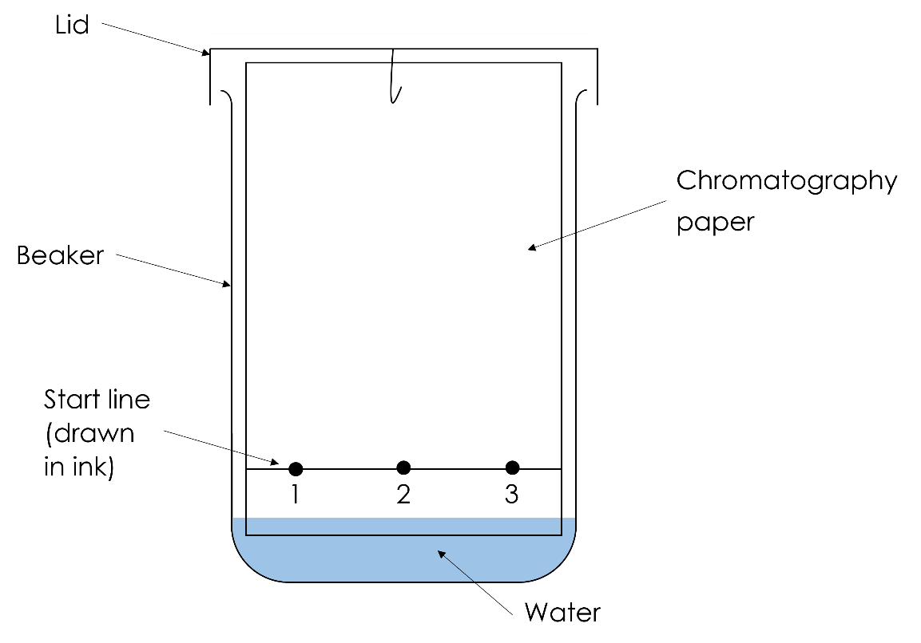

The student made two mistakes when the apparatus was set up.

1.
- Name the mistakes and give one issue caused by each mistake.

__________________________________________________________________________________

__________________________________________________________________________________

__________________________________________________________________________________

__________________________________________________________________________________

__________________________________________________________________________________

__________________________________________________________________________________

__________________________________________________________________________________

__________________________________________________________________________________

__________________________________________________________________________________

__________________________________________________________________________________

(4 marks)

On the next page is a diagram of an investigation into the chromatography of three different inks.

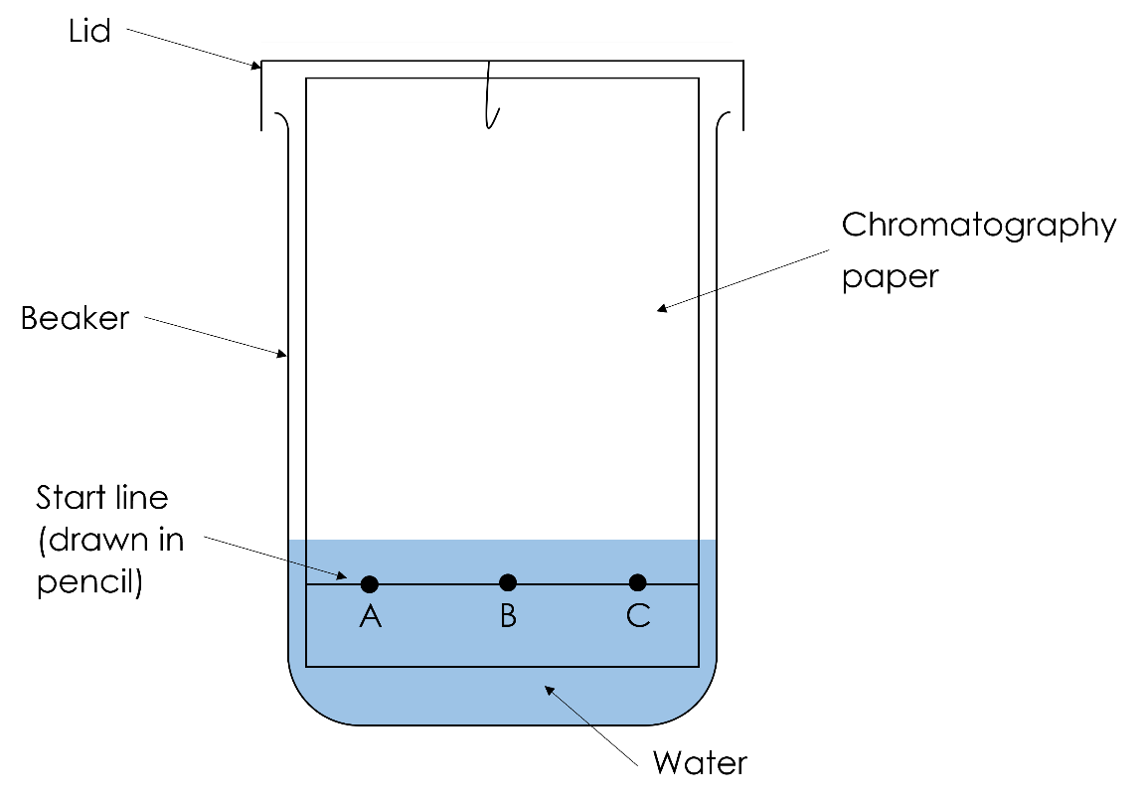
- Name a mistake made when this apparatus was set up and explain what the issue caused by the mistake is.

__________________________________________________________________________________

__________________________________________________________________________________

__________________________________________________________________________________

__________________________________________________________________________________

(2 marks)
- Explain why the start line was drawn in pencil.

__________________________________________________________________________________

__________________________________________________________________________________

(1 mark)

Making salts

A student wanted to make copper sulfate crystals. This is the method they used:
- Measure out 25 cm³ of nitric acid and add it to a beaker.
- Gently warm the acid.
- Add excess calcium oxide and stir.
- Heat the solution in an evaporating basin over a water bath to the crystallisation point.
- Leave the solution on a windowsill to crystallise and pat the crystals dry with filter paper.

The student’s method did not lead to the production of copper sulfate crystals.

2.
- Identify three mistakes the student made.

__________________________________________________________________________________

__________________________________________________________________________________

__________________________________________________________________________________

__________________________________________________________________________________

__________________________________________________________________________________

(3 marks)

The student corrected the mistakes they made. They used the new method (below) and made copper sulfate crystals:
- Measure out 25 cm³ of sulfuric acid and add it to a beaker.
- Gently warm the acid.
- Add excess copper oxide and stir.
- Filter the solution using a funnel and filter paper to remove excess copper oxide.
- Heat the solution in an evaporating basin over a water bath to the crystallisation point.
- Leave the solution on a windowsill to crystallise and pat the crystals dry with filter paper.
- Explain why copper oxide was added in excess.

__________________________________________________________________________________

__________________________________________________________________________________

(1 mark)
- Explain why the acid was gently warmed.

__________________________________________________________________________________

__________________________________________________________________________________

(1 mark)

Neutralisation

A student wants to carry out a titration to find out the volume of potassium hydroxide that reacts with 25.0 cm ³ of sulfuric acid.

3.
- State the apparatus needed.

__________________________________________________________________________________

__________________________________________________________________________________

__________________________________________________________________________________

__________________________________________________________________________________

__________________________________________________________________________________

__________________________________________________________________________________

(7 marks)
- Write a method that would find out the volume of potassium hydroxide that reacts with 25.0 cm ³ of sulfuric acid.

__________________________________________________________________________________

__________________________________________________________________________________

__________________________________________________________________________________

__________________________________________________________________________________

__________________________________________________________________________________

__________________________________________________________________________________

__________________________________________________________________________________

__________________________________________________________________________________

__________________________________________________________________________________

__________________________________________________________________________________

__________________________________________________________________________________

__________________________________________________________________________________

__________________________________________________________________________________

__________________________________________________________________________________

__________________________________________________________________________________

__________________________________________________________________________________

__________________________________________________________________________________

__________________________________________________________________________________

(6 marks)

