Finding food fraud with chromatography, 11–14
Education in Chemistry
July 2018
rsc.li/2JbAXsJ

Worksheet answers

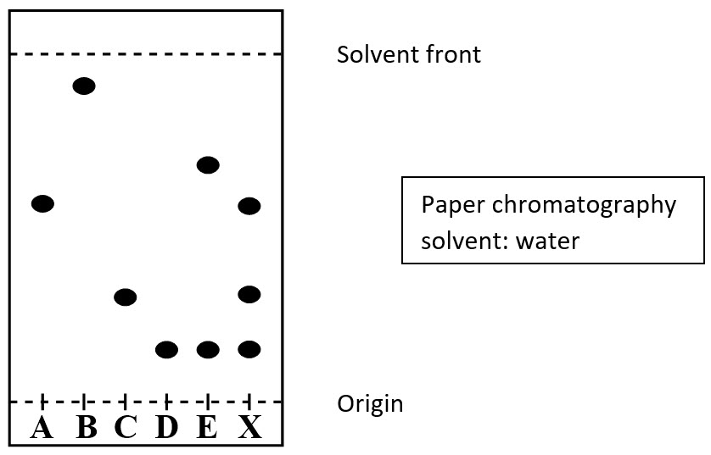

- Which of the natural colours they tested (B–E) are made up of two different colours? Explain your answer.
E is made up of two colours. It has two spots above its starting place in the chromatogram.
- How many colours are in the purple jelly sweet? Which of the other colours (A–E) does the purple colour contain?
Three colours. A, C and D.
- Is the ingredient list on Jellyfish Sweet Co sweet packets accurate? Explain your answer.
No, the ingredients list is not accurate. The purple jelly sweet contains colour A which is synthetic. So, the company cannot claim their jelly sweets contain only natural flavourings.
- One of the students says colour E is present in the purple jelly sweet. This is incorrect. Explain why the student may have come to this conclusion and explain how you can tell E is not in the purple jelly sweet.
E has two spots in its chromatogram and one of these is also seen in sample X. This may have caused the confusion for the student. E is definitely not in the purple jelly sweet as the higher spot from E is not also seen in the sample X.
- What was the mobile phase in the experiment?

Water

- What was the stationary phase?

Paper

- Which of the colours was most soluble in the mobile phase? Explain your answer.
Colour B, it has travelled furthest up the paper (so must be more strongly attracted to the water).
- What did the students use to draw their origin line? Explain their choice.
Pencil. They had to use something that would not dissolve in water. If they had used a pen, the colours of the pen’s ink would have run/separated in the water.

