Experimental skills

Equipment

You have just started in a new research lab and have the following equipment available to you. Choose which piece(s) of equipment you would use for each of the following tasks and name each piece you use. You can assume you have plenty of bungs, tubing and adaptors plus access to a safe source of heat;

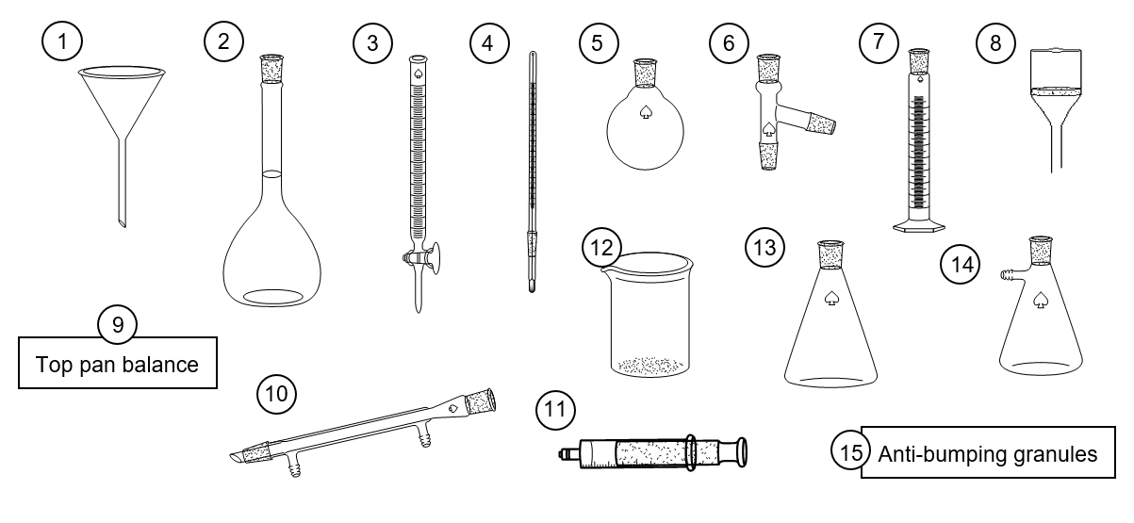
- To measure the volume of carbon dioxide produced by the following reaction;
ethanoic acid + sodium hydrogen carbonate → sodium ethanoate + water + carbon dioxide

- To obtain pure water from a sample of salt water

- To oxidise a sample of propan-1-ol to propanoic acid by heating with an excess of an acidified aqueous solution of sodium dichromate under reflux conditions

- To make up an accurate 0.05 mol dm^{–3} solution of sodium hydroxide

- To recrystallise a sample of paracetamol contaminated with an insoluble solid impurity and collect the solid product

(2 marks for each correct set of equipment correctly named)

Treatment of errors
A student submitted the following report on his recent experiment to determine the concentration of a solution of hydrogen peroxide;

Method
10 cm³ of the hydrogen peroxide was measured using a 100 cm³ measuring cylinder and placed in a 100 cm³ conical flask. A bung and tubing was attached and the other end connected to a 100 cm³ gas syringe. 0.2 g of the MnO₂ catalyst was weighed out. The catalyst was added to the hydrogen peroxide solution and the bung quickly replaced. The total volume of oxygen produced was measured.

Results
Experiment | 1 | 2 | 3
Mass of MnO₂ / g | 0.21 | 0.24 | 0.20
Volume of gas produced / cm³ | 15 | 13 | 13

Analysis
The equation for the reaction is: 2 H₂O₂ → 2 H₂O + O₂
Average volume of gas produced = 13.7 cm³
Assuming room temperature and pressure, no. of moles in 13.7 cm³ of gas = 13.7 cm³ ÷ 24,000 cm³ mol^{–1} = 5.694 x 10⁻⁴ moles
2 moles of H₂O₂ produce 1 mole of O₂ so the no. of moles of H₂O₂ in 10 cm³ = 1.139 x 10^{–3} moles
∴concentration of H₂O₂ solution = 1.139 x 10⁻³ mol ÷ 0.010 dm³ = 0.1139 mol dm^{–3}

- The accuracy of each piece of equipment used is shown below.
- Using the individual equipment errors listed below, calculate the total percentage error for the reaction.
(4 marks)
100 cm³ measuring cylinder ± 0.5 cm³ | 100 cm³ gas syringe ± 0.5 cm³
100 cm³ conical flask ± 5 cm³ | Top pan balance ± 0.005 g
- Suggest how this percentage error could have been reduced using the same equipment.
- mark)

- The teacher wants to give the student some feedback on how he could have improved the accuracy of his experiment. Suggest two pieces of feedback she could give him.
(2 marks)

Comment on the student’s use of significant figures in his analysis. From your comments, correct the student’s final concentration of the hydrogen peroxide.
(3 marks)

Titrations
Titrations are a very accurate way to determine the concentration of an unknown substance by seeing what volume of a second substance of known concentration is needed to react with it.
However titrations are only accurate if completed with care. List 10 things a student must do to ensure that a titration between a 0.1 mol dm^{–3} solution of acid and an unknown concentration of sodium hydroxide using phenolphthalein as indicator is as accurate as possible.
(1 mark for each correct point)

1.
2.
3.
4.
5.
6.
7.
8.
9.
10.

Observation exercises
A student has made the following observations for the reactions described. Unfortunately, the observations are not described accurately enough for the student to get the marks. In each case write a more accurate observation for the reaction that occurred.

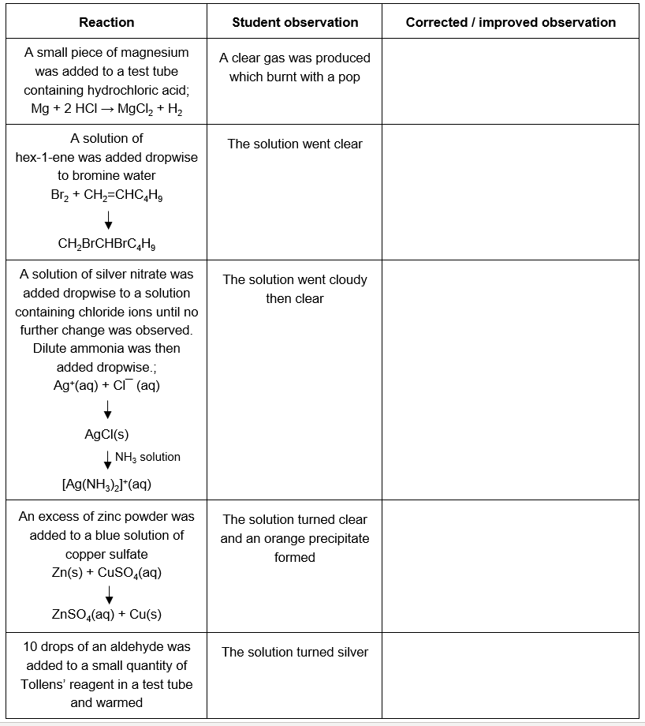

Inferences
Use the student descriptions of some simple test tube reactions to identify each of the salts A to E;
(2 marks for the correct identification of the cation and anion present in each salt)

Salt A
- A lilac flame was produced with the flame test
- A small quantity of the solid was dissolved in water and dilute nitric acid added followed by a few drops of silver nitrate solution. A yellow precipitate formed which could not be dissolved by the addition of concentrated ammonia solution.

Salt B
A small sample of the salt was dissolved in water to make an aqueous solution. Dropwise addition of NaOH(aq) to the aqueous solution produced a green precipitate which slowly turned brown on standing. A separate sample of the aqueous solution was acidified by the addition of hydrochoric acid. On addition of an aqueous solution of barium chloride a white precipitate formed.

Salt C
Addition of concentrated sulfuric acid to a small sample of the solid salt produced steamy fumes and a brown vapour. Carrying out the flame test on a small sample produced a red flame.

Salt D
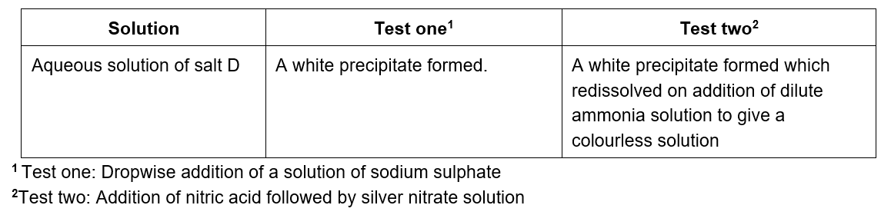

Salt E
A small sample of the salt was dissolved in water to produce a colourless solution. The solution was split between two test tubes.
Addition of sodium hydroxide followed by aluminium powder to the first test tube produced ammonia gas.
Addition of an aqueous solution of potassium iodide to the second test tube yielded a bright yellow precipitate.

Managing risk

Chemistry can be a dangerous occupation but not if you take note of the hazard signs and act accordingly. For each of the experiments below, give two precautions on top of wearing lab specs and a lab coat you could take to minimize the risk. The hazards associated with each of the reactants are shown;
(1 mark for each suitable precaution identified)

Experiment 1
Titrating a 25 cm³ sample of a solution containing Fe²⁺ ions against a solution of KMnO₄
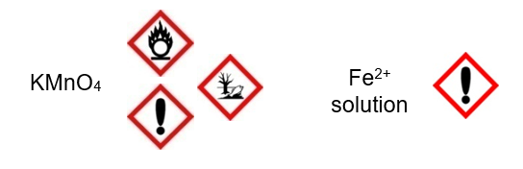

Experiment 2
Dehydrating ethanol to produce ethene by passing ethanol vapour over a hot catalyst of ceramic pot.
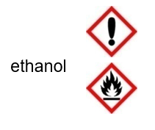

Experiment 3
Investigating the ligand exchange reactions of hexaaquachromium(III) ions by the dropwise addition of ammonia solution to an aqueous solution of chromium sulfate.

Experiment 4
Heating a sample of lead carbonate to investigate the colour changes that occur during the thermal decomposition.
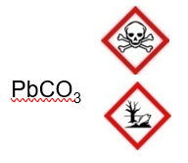

Experiment 5
Investigating the reducing power of bromide ions by the dropwise addition of concentrated sulphuric acid to a small quantity of the solid sodium bromide in a test tube;

2 NaBr + 3 H₂SO₄ → SO₂ + 2 H₂O + Br₂ + 2 NaHSO₄

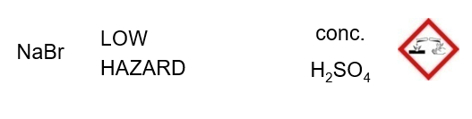

Experimental skills – Answers

Equipment
- no. 13 – conical flask; no. 11 – gas syringe or no. 7 – measuring cylinder
- no. 5 – a round bottomed flask; no. 4 – thermometer; no. 6 – still head; no. 10 – condenser; no. 12 – beaker or no. 13 – a conical flask (as receiver); no. 15 – anti-bumping granules
- no. 5 – a round bottomed flask; no. 10 – condenser; no. 15 – anti-bumping granules
- no. 9 – top pan balance; no. 12 – beaker; no. 1 – funnel; no. 2 – volumetric flask
- no. 13 – conical flask; no. 1 – filter funnel; no. 8 – Büchner funnel; no. 14 – Büchner flask
(In each question; 1 mark for all the correct pieces of equipment identified;
1 mark for all the pieces of equipment chosen being correctly named)

Experimental error
1.
(a) Error from measuring cylinder = ± 0.5 cm³ / 10 cm³ × 100% = 5%
(1 mark)
Error from gas syringe = ± 0.5 cm³ / 13 cm³ × 100% = 3.85%
(2 marks; 1 for calculation and 1 for correct choice of volume)

Total error = 5% + 3.85% = 8.85%
(1 mark)
(b) By using a larger volume of hydrogen peroxide a larger volume of gas would be produced and both of the above errors would be reduced (the denominator in both cases is larger)
(1 mark)
2. Any two from the options below or any other reasonable piece of feedback;

- Record the volume of gas produced to 1 decimal place
- Measure the volume of hydrogen peroxide used more accurately (perhaps using a pipette)
- Adapt the equipment so that the MnO₂ catalyst can be mixed with the hydrogen peroxide in a sealed system hence preventing error from the loss of gas before the bung is fully in place
(2 marks)
3. The volume of gas recorded is only given to 2 significant figures. The student has done the correct thing by carrying through the calculator answer in each step (although perhaps the 4 sig figs shown in some answers is unnecessary), but the final concentration of the hydrogen peroxide should only be given to 2 significant figures i.e. 0.11 mol dm^{–3}.
(2 marks for comments; 1 mark for correct final concentration to 2 sig. fig.)

Titrations
Any 10 from (1 mark for each correct point made);
- Wash the burette with distilled water and then the acid
- Wash the pipette with distilled water and then the sodium hydroxide solution
- Wash the conical flask with just water
- Touch the tip of the pipette on the surface of the liquid to ensure the transfer of the correct quantity of sodium hydroxide
- Ensure no spillage of liquid during the transfer of the sodium hydroxide in the pipette into the conical flask
- Add no more than 5 drops of indicator
- Read the burette to the bottom of the meniscus
- Read the burette to the nearest 0.05 cm³
- Carry out a rough titration to get an approximate titre
- When nearing the equivalence point add the acid a single drop at a time
- Make sure the tip of the burette and the sides of the conical are rinsed with distilled water between addition of each drop
- Swirl the conical to ensure complete mixing of the acid and the sodium hydroxide
Repeat titrations until two concordant results are obtained (within 0.1 cm³)

Observation exercises
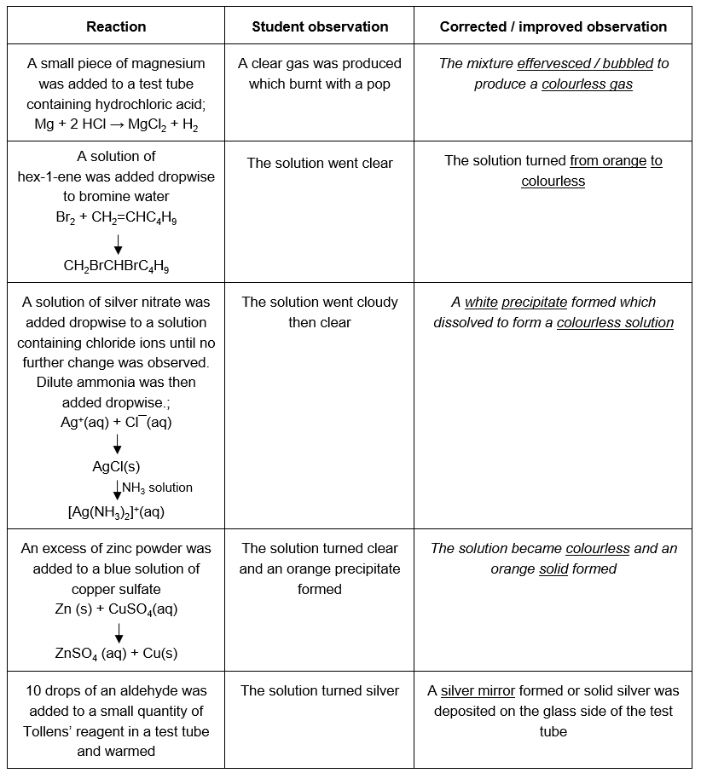
(1 mark for each of the underlined words)

NOTE The students need to make sure they record what they see not what happened e.g. a clear gas was produced is not an observation. The observation is the bubbles. A pop is not an observation but something heard. Other points of note include the fact that a precipitate can only be formed when two liquids react plus that all colour changes should be recorded; not just the final one.

Inferences
Salt A - Potassium or caesium iodide
Salt B - Iron(II) sulphate
Salt C - Lithium or strontium or calcium bromide
Salt D - Barium chloride
Salt E - Lead nitrate
(1 mark for the correct cation; 1 mark for the correct anion in each case)

Managing risk
(1 mark for each correct precaution, either from the answers below or any other reasonable precaution)

Experiment 1
1. Dispose of waste in a separate container
2. Do not mix with flammable substances

Experiment 2
1. Avoid naked flames (especially with the flammable ethene vapours)
2. Do not ingest

Experiment 3
1. Wear gloves or take care not to allow ammonia solution onto skin
2. Do not inhale vapours (use a fumehood or ensure adequate ventilation)
3.Dispose of waste in a separate container

Experiment 4
1. Wear gloves or ensure to wash hands thoroughly after use
2. Dispose of waste in a separate container

Experiment 5
1. Take care with conc. H₂SO₄ – either wear gloves or take extreme care
2. The bromine / SO₂ gases produced in this reaction are the real concern. The reaction needs to be done in a fumehood. Use this as an example to make sure the students are aware of the need to consider the products as well as the reactants when considering risk.

