Biscuit bashing

Biscuit bashing demonstration: A demonstration video can be viewed at rsc.li/3B18KMV
The investigation allows learners to explore the properties of solids by crushing a biscuit into small particles. They will then compare their biscuit crumbs with water to look for similarities and differences between solids and liquids.

Age group: 7–9

Learning objectives
- To understand that some solids are a collection of very small particles which can be poured and take the shape of the container they are poured into.
- To investigate the properties of solids.
Enquiry skills:
- To make predictions, observations and comparisons.
- To use observational skills to compare two materials.

Background science
Learners will have lots of experience of solids but may not know why they are classified as such. They will have experienced ‘pouring’ solids such as sand or sugar, a property that they need to understand as different from pouring a liquid. A solid has a definite shape that remains the same unless a force acts upon it. Some solids are made up of small particles, eg sand. These can be poured and take on the shape of the container. However unlike liquids, when poured, solids form a heap. Each grain is solid but moves over another.
This investigation links well to cooking and food science, as there are many food stuffs which are granular solids, such as flour, salt, sugar, coffee granules etc.
Understanding the properties of solids will also deepen understanding of rocks and soils.

Prior learning
It would be useful for learners to have had experience exploring the properties of a variety of everyday materials, including solids and liquids. This activity is good for developing understanding of granular solids.

Links
You may find it helpful to carry out this investigation on the properties of solids before moving on to the investigation Intriguing ice where the properties of liquids are explored.

Key words and definitions
States of matter – solid, liquid or gas.
Solid – a material that has a fixed volume and holds its shape. Ice, wood and plastic are examples of solids.
Liquid – a material with a fixed volume that can flow and that takes the shape of its container. Water, juice and lava are examples of liquids.
Gas – a material that spreads out in all directions, filling its container. Gases can be compressed (squashed). Oxygen, carbon dioxide and nitrogen are examples of gases.
Particle – a tiny unit of matter.
Teachers may wish to hide the meanings/examples on the PowerPoint slide and discuss the learner’s ideas first.

Equipment list
- 2 digestive biscuits (be aware of individual food requirements, eg gluten free, vegan)
- 1 paper bag and paper tape or 1 resealable plastic bag
- 1 rolling pin (or use hands)
- 2 deep containers, eg yoghurt pots
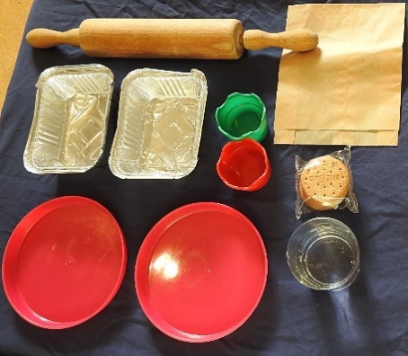
- 2 saucers, Petri dishes or takeaway trays
- 1 small beaker/jug of water
- A selection of differently shaped containers (from the recycling bin)
- 1 results table
- OPTIONAL: magnifying glass or microscope
- OPTIONAL: other powdery solids such as instant/ground coffee, sugar, salt, flour (*be aware of food allergies)
©

Method
Begin by encouraging the learners to think of their own tests to differentiate between liquids and solids. Ask them how they would record their observations.
You can then show them a biscuit and ask them to define its state of matter.
The learners will then carry out a series of simple tests to compare water and biscuit crumbs (a solid made up of particles).

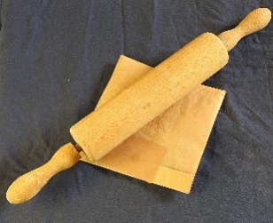
- To make biscuit crumbs
Place the digestive biscuits into the paper bag. Fold the top over and seal with tape.
Use a rolling pin gently to break the biscuits into crumbs. Place the crumbs into the yoghurt pot.

- Testing properties
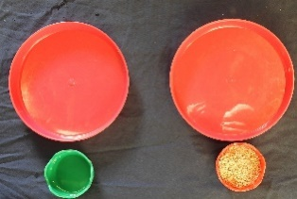
Fill a second yoghurt pot with water in equal quantity to the biscuit crumbs.
- Encourage the learners to look closely at the two materials in the pots and note the similarities and differences. Draw their attention to the crumbs.

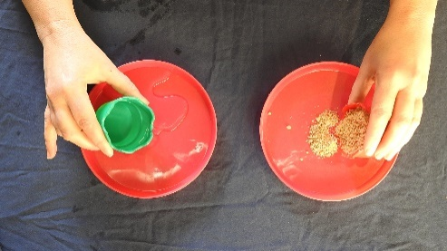
- Pour the water into the tray or saucer, observing how it moves, then repeat with the biscuit crumbs. Ask the learners to look closely at the materials now in the trays. What similarities and differences do they observe here?
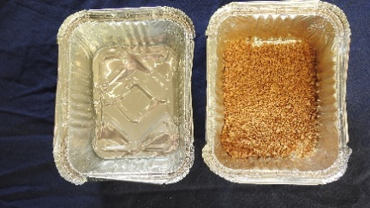
y
- Ask the learners to investigate pouring the water and crumbs into differently shaped containers. What do they notice (does it take the shape of the container)?

OPTIONAL: Learners can use a digital microscope or magnifying glass to observe the particles more closely.
- The learners could then explore a range of other powdery or granular solids, to see if they all have the same properties.

Results table
Learners could be given this table to record their observations either in hard copy or digital format.
Biscuit crumbs | Write notes or make labelled diagrams to record your observations. | Water
 | What can you see? Can you see small pieces?
 | What happens when you tip the container?
 | What happens when you pour the contents onto a saucer?
 | Does it take the shape of the container?

Question prompts
- In what ways are the biscuit crumbs and water similar or different?
The biscuit is a solid material made up of very closely packed grains of cooked biscuit. When you break up the biscuit into very small crumbs these can seem like a liquid because they will take up the shape of a container and can be poured.
- Do you think that we would have the same result if we bashed other biscuits? Would they all have the same size crumbs? How could we find out?
Try crushing different types of biscuits to see if they have the same texture. Biscuits that contain whole grains might not have as fine a texture.
- How could a microscope or a magnifying glass help us?
By using a magnifying glass we can see the shape of the biscuit crumbs better. Try this with different biscuits, eg an oatcake or a rich tea biscuit.
- Can you think of other materials made from lots of small pieces?
Other examples include salt, sand and rice. Make learners aware that they cannot bash all solids to make crumbs. Taking it a step further, on a sub-microscopic scale everything is made up of small atoms that we cannot see with the naked eye. Atoms make up all states of matter and we are also made of atoms.
- Can you think of a small solid, smaller than a biscuit crumb?
Flour for baking, flower pollen and other powdered solids.
- If someone said to you, you can’t pour a solid, what would you say?
If pupils are still unsure why the powdered biscuit hasn’t become ‘liquid’ you could demonstrate that when you pour the crushed biscuit onto the table it would form a pile of crumbs whereas a liquid would spread out.
- When we say that solids keep their shape, what do we really mean?
Draw out that each individual piece keeps its shape; ‘pouring’ is because the pieces move over each other. If you keep crushing the biscuit into finer and finer powder it will still be solid.

FAQs
- Is there any gas in my biscuit?
There are air spaces throughout the digestive biscuits. We can drop water onto the biscuit to see how much it absorbs. This will show that the biscuit is porous because the water runs into the air gaps. Biscuits have an open porous structure to make them easy to eat. If the biscuit were too dense, it would be very hard to chew.

- What would happen if the biscuit and water were mixed together?
Some solids are soluble; they dissolve in liquids so they break up into tiny pieces, so small they can no longer be seen. They are still there! A biscuit is not one single material. Some of the biscuit will be soluble (this is important when we eat it) but some parts may be insoluble (eg fibre), depending on the specific ingredients.

- Are there only three states of matter?
For a long time, it was believed there were only three states of matter. Scientists have now identified seven, including polymeric solids (jelly), plasma and Bose-Einstein condensates.
All images © Royal Society of Chemistry.

