Electrochemical cells microscale

Investigate the thermodynamic feasibility of reactions and apply your knowledge of the reactivity series with this electrochemical cells microscale experiment. Watch a video of the investigation, plus find technician notes and more resources, at rsc.li/3l0g6sR

Equipment (per group)
- 2 x Petri dishes
- 2 x filter paper to fit Petri dish
- 1 x pair of scissors
- 1 x voltmeter (to 2 decimal places) or multimeter set to 2 V
- 2 x electrical leads (red and black preferably)
- 1 x tweezers

- Copper, 1 cm², 5 pieces
- Zinc, 1 cm², 1 piece
- Magnesium ribbon, 1 cm, 1 piece (DANGER: flammable)
- Iron, 1 cm², piece or 1 nail
- Potassium nitrate(v) solution, saturated, 10 cm³
- Copper(II) sulfate(VI) solution, 1.00 mol dm⁻³ (DANGER: harmful, corrosive , irritant)
- Copper(II) sulfate(VI) solution, 0.10 mol dm⁻³ (WARNING: irritant)
- Copper(II) sulfate(VI) solution, 0.01 mol dm⁻³
- Zinc sulfate(VI) solution, 1.00 mol dm⁻³ (DANGER: corrosive)
- Iron(II) sulfate(VI) solution (freshly made), 1.00 mol dm⁻³ (WARNING: irritant)
- Magnesium sulfate(VI) solution, 1.00 mol dm⁻³

- Safety glasses

Safety
Wear eye protection throughout.

Take care when using any hazardous chemicals. Refer to CLEAPSS Student safety sheets SSS034, SSS040, SSS049, SSS038 and SSS081, available from bit.ly/3X8yi5A, for further details.

Take care when handling the pieces of metal as they may have sharp edges.

Method

Part 1 - investigate how different metals affect the potential differences of cells
- Cut the filter paper into a ‘flower shape’ with four ‘petals’ and place it into the Petri dish.
- Use pencil to label each petal of the filter paper with one of the four metals.
- Place a small square of the metal on its labelled segment. Add five drops of the appropriate 1.00 mol dm⁻³ metal ion sulfate solution to the petal with the corresponding piece of metal. Be aware of sharp edges when handling the metals. Take care not to get the solutions on your skin or the electrical equipment.
- Add enough potassium nitrate(v) solution to the centre of the filter paper so it meets the dampened petals.
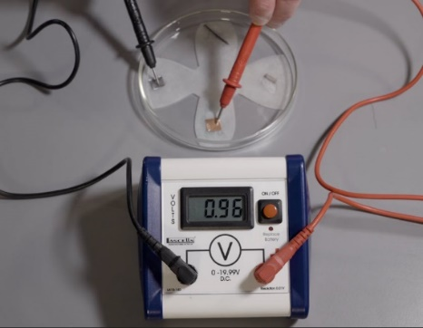
- Connect the leads and switch on the multimeter (DC voltage). Place the positive probe on the copper foil and the negative probe on the zinc. Record the potential difference in a table.

Swap the probes observe what happens to the reading on the voltmeter.

Repeat for the other metal combinations. Record the positive values in a table (see page 3).

Part 2 - investigate how the concentration of solutions affect the potential differences of cells

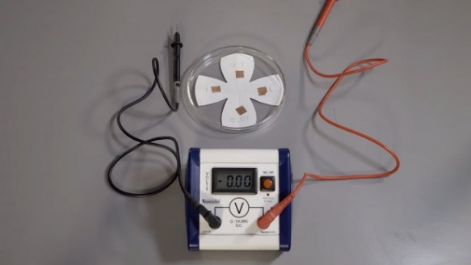
Repeat step 1.

Use pencil to write the concentration of the different copper(II) sulfate(VI) solutions in each of the four petals, making two of them 1.00 mol dm⁻³.

Place a small square of copper in each segment. Add five drops of the appropriate concentration of copper(II) sulfate(VI) solution at the edge of each piece of metal. Be aware of sharp edges when handling the metals. Take care not to get the solutions on your skin or the electrical equipment.

Repeat step 4.

Place the probes on the different concentrations and record the potential differences for all the combinations in a table (see page 3).

Disposal
- Always dispose of chemicals carefully following your teacher’s instructions.
- Place the ‘flower-shaped’ filter paper in the bucket of water provided.
- Do not throw the metal ribbons and strips in the general waste as they can be cleaned and reused.

Printable results tables

Part 1

Half-cell combination | Which metal formed the negative terminal? | Potential difference of the cell (V)
Zn/Cu
Zn/Mg
Fe/Mg
Cu/Fe
Fe/Zn
Cu/Mg

Part 2

Half-cell combination (CuSO₄ / mol dm⁻³) | Which half-cell formed the negative terminal? | Potential difference of the cell (V)
1.00/1.00
1.00/0.10
1.00/0.01
0.10/0.01

