Atoms, molecules and compounds quiz

Learning objectives
- Identify atoms, molecules, elements and compounds using particle diagrams.
- Use particle diagrams to classify a substance as an element or compound and as molecules or atoms.

Introduction

This quiz will help you understand the difference between atoms, elements, molecules and compounds. It will also test your knowledge of the gases in our atmosphere. Write your answers underneath each particle diagram.

Questions
- Label as either an atom or molecule

a. | 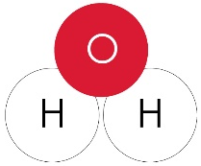  b. | c. | 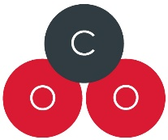  d.
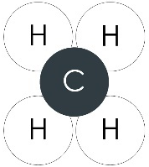  e. | f. | g. | h.
i. | 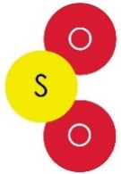  j. | k. | l.

- Label as either an element or non-element

a. | b. | c. | d.
e. | f. | g. | h.
i. | j. | k. | l.

- Label as an element, molecule or both

a. | b. | c. | d.
e. | f. | g. | h.
i. | j. | k. | l.

- Label as either a molecule, compound or both

a. | b. | c. | d.
e. | f. | 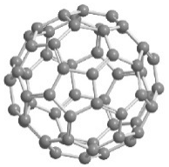  g. | h.
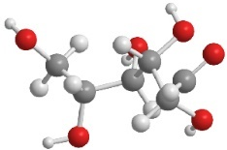  i. | j. | k. | l.

- How much is found in our atmosphere?

a. | b. | c. | d.
e. | f. | g. | h.
i. | j. | k. | l.

