- The diagram shows a fractionating tower used to separate crude oil.
The names of each fraction are missing from the diagram.
Gas
Petrol
Naphtha
Kerosene
Diesel
Lubricating oil
Fuel oil
Bitumen
Distillation Column

Place the correct fraction into the correct box.

Bitumen
Lubricating oil
Naphtha
Petrol
Gas
Kerosene
Diesel
Fuel oil

Source: International bunch / adapted from Shutterstock

- On moving up the fractionating column, there are gradual trends seen in the properties of each fraction.

- Place into the blank spaces in the table the words increase or decrease to show how each of the following changes:
Distillation Column
Property | Increase or decrease?
Boiling point | Answer: Decrease.
Volatility | Answer: Increase.
Viscosity | Answer: Decrease.
Flammability | Answer: Increase.

- Explain the change in boiling point stated in the table.
Use ideas of molecular size in your answer.
Answer: As molecular size increases, boiling point also increases.
Larger molecules have stronger intermolecular forces, and these are harder to overcome when the substance boils.
So the boiling point increases.

- Crude oil – true or false.
The following are statements about the separation of crude oil.
State whether each statement is true or false by writing T or F in the boxes.
- Crude oil is a complicated mixture containing carbohydrates.  - Crude oil is formed when biomass, for example plankton, is compressed and heated over millions of years.  - The process of fractional distillation is used to separate crude oil into its components.  - As we move up a fractionating column, the temperature of the column increases.  - Crude oil is heated before it is pumped into the fractionating column.  - Molecules with higher boiling points move further up the column.  - Crude oil vapour condenses at different heights depending on the boiling point.  - The fractions produced contain molecules of exactly the same boiling point.  - Most of the fractions from crude oil are used as fuels. | F  T  F  F  T  T  T
T
F
- Here are some molecules found in crude oil.
Which one is which?
Write A, B or C in the table below
A
C
B

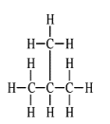
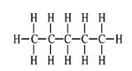
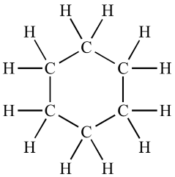

One is a straight chain molecule. | Answer: C.
One is a branched-chain molecule. | Answer: A.
One is a cyclic molecule. | Answer: B.

