Marvellous monosaccharides
Education in Chemistry
September 2019
rsc.li/2YTOmOl
The molecules used in many sustainable materials for bags tend to be carbohydrate based. In this extension activity for students aged 16–18 we explore some of the many structural forms of carbohydrates. This activity introduces some new terminology to students and provides a nice bridge to students who are also studying biology.

Natural monomers
The two sustainable types of bag materials discussed in the article are cotton and starch. These materials are natural polymers and have a common monomer, glucose. So if they have a common monomer why are they so different?
Glucose has the molecular formula C₆H₁₂O₆, this can be drawn as a straight chain structure as shown below. The simplest sugars like glucose are called monosaccharides. These are the monomers of the carbohydrate polymers like starch and cellulose. Two monosaccharides joined together are called a disaccharide, many joined together are called a polysaccharide. The terms sugar or carbohydrate could mean any of these technical terms.
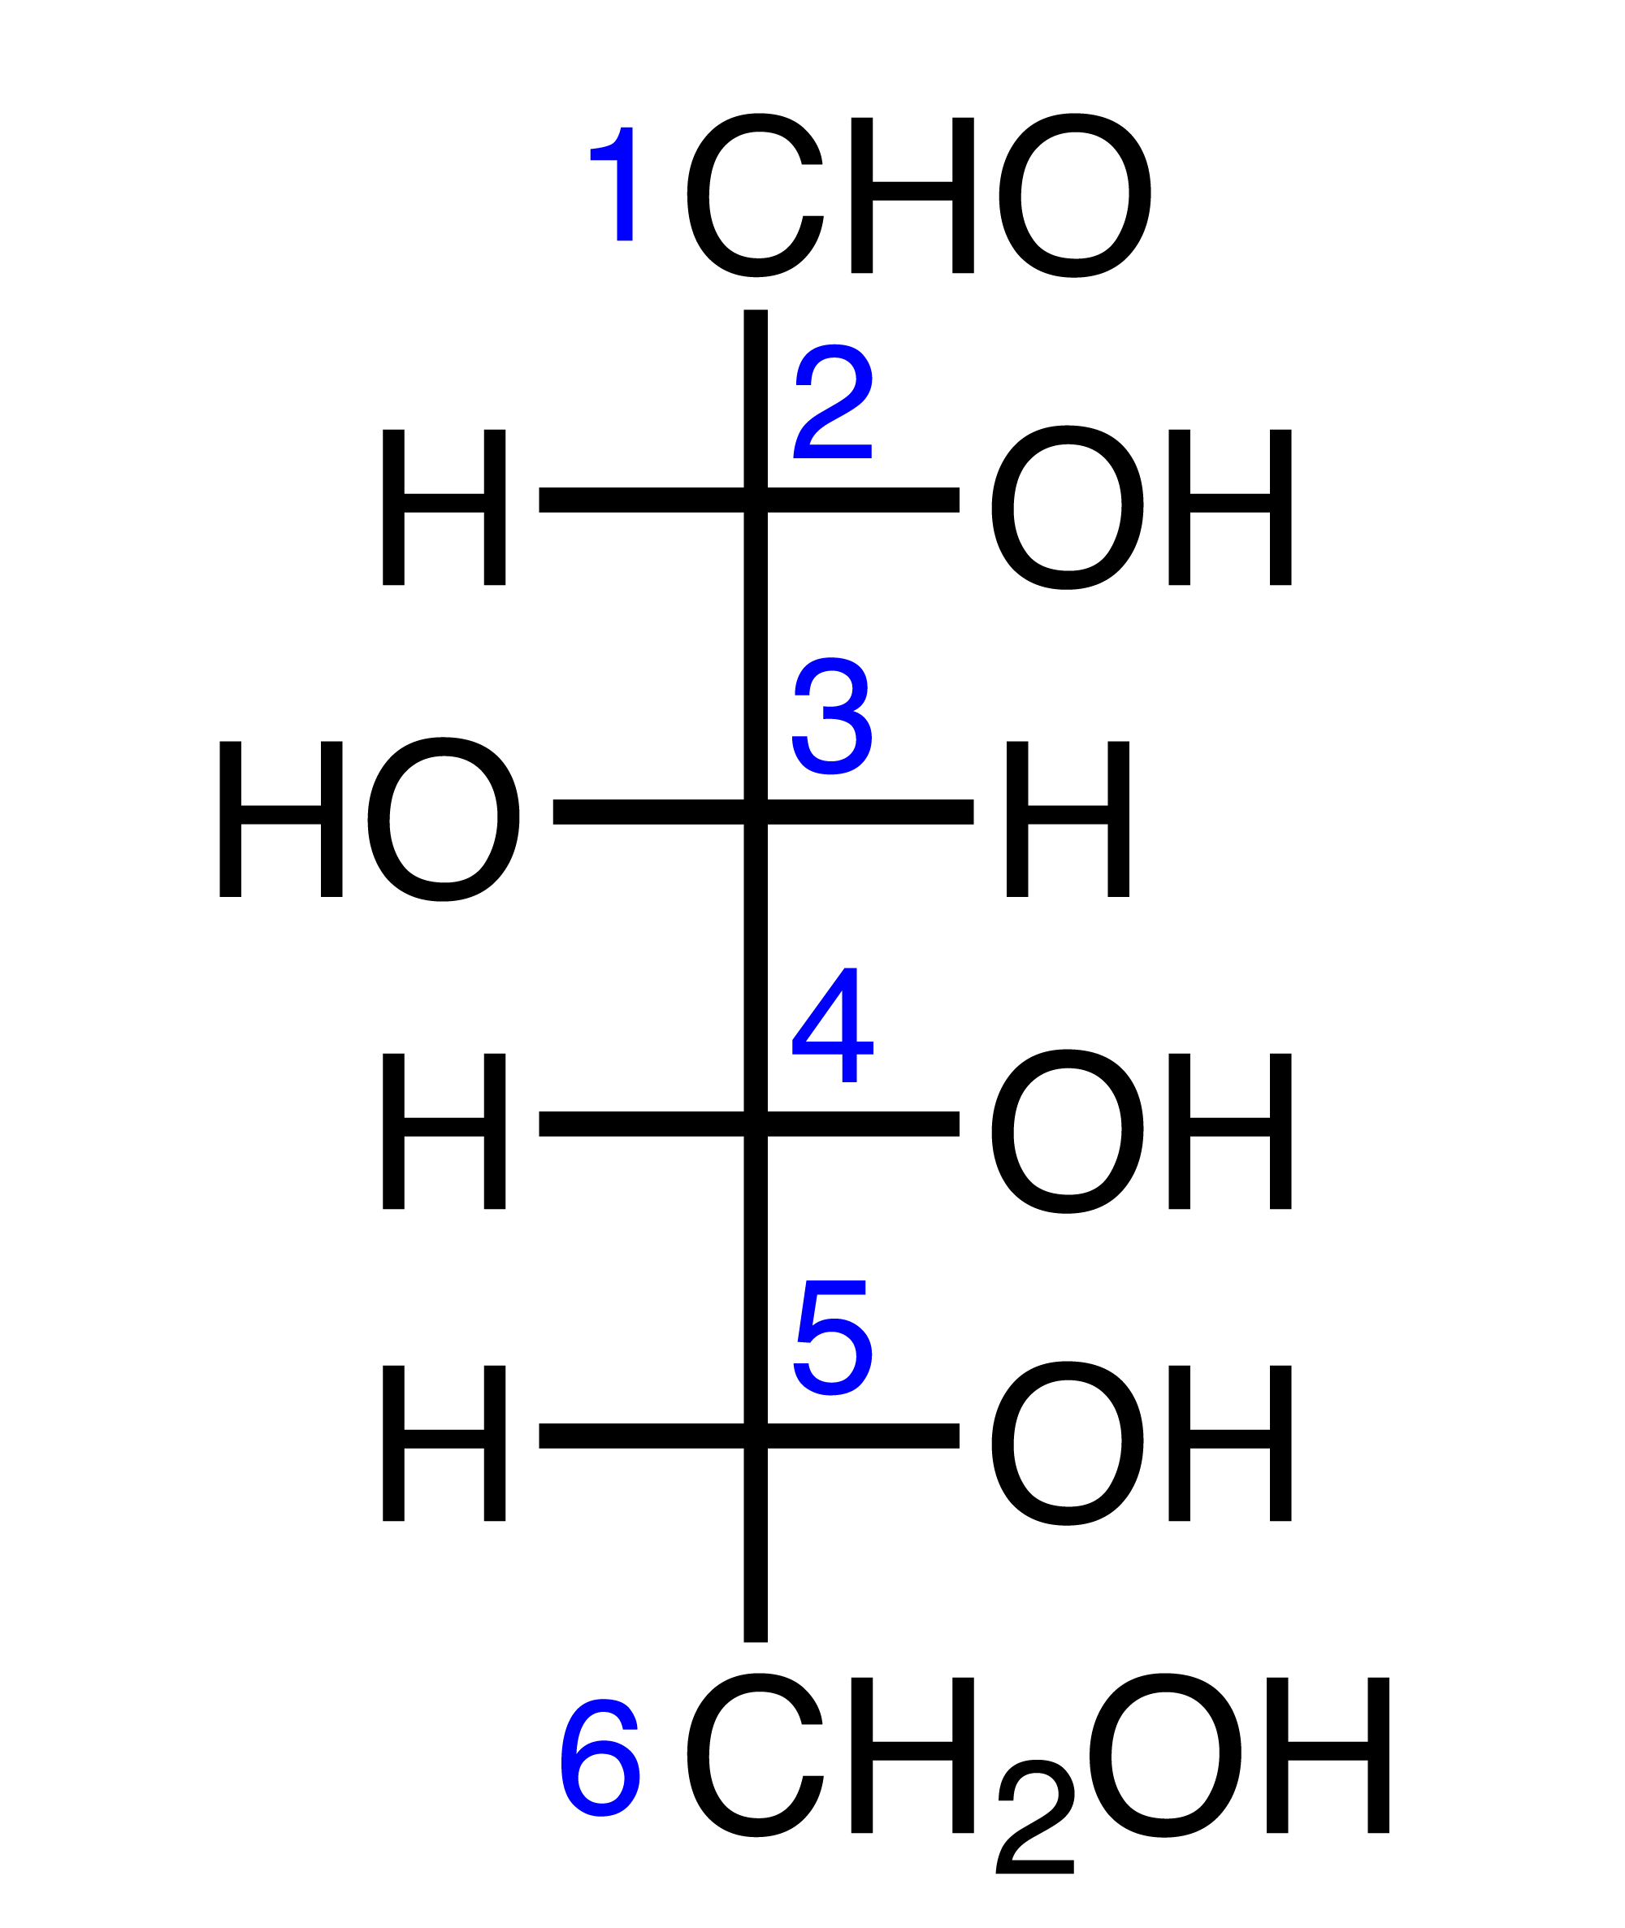
- What is the IUPAC systematic name for glucose as shown in the diagram above?

Monosaccharides exist in equilibrium with the straight chain form and various cyclic forms. This means a variety of structures are possible, which influences the properties of the polymers formed when many monosaccharides monomers are joined together. The forms that are present in cellulose and starch are shown below.
Material | Cotton (cellulose) | Starch
Monomer | β-glucose | α- glucose
Structure (skeletal Haworth form) | 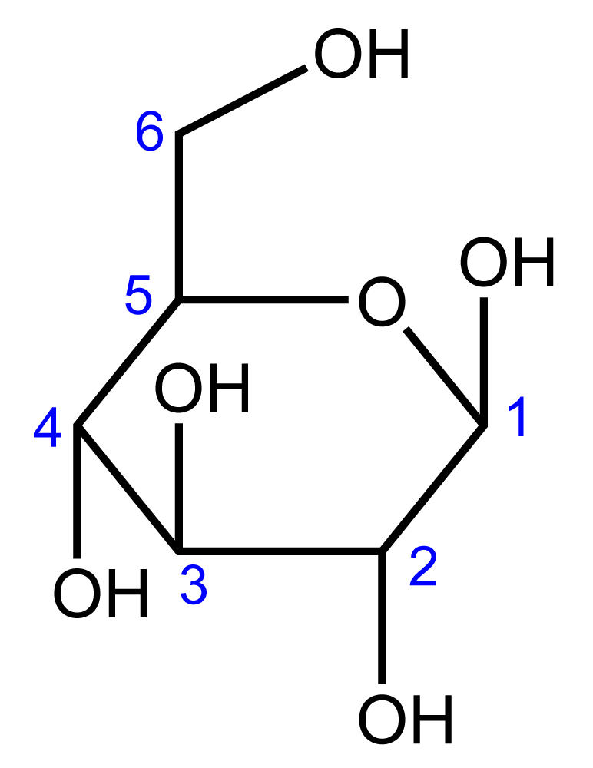 | 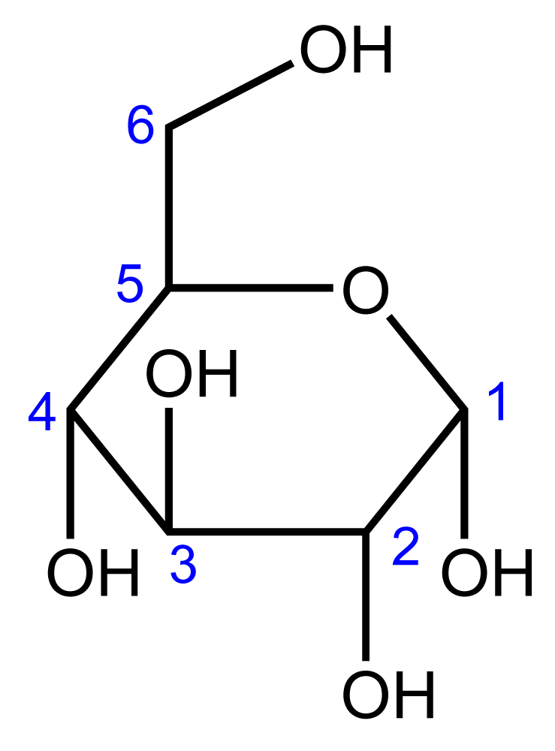

- What is the difference between α- glucose and β-glucose?
In cellulose and starch, the glucose monomers are joined by an ether linkage in between C1 on one molecule and C4 on the next one.
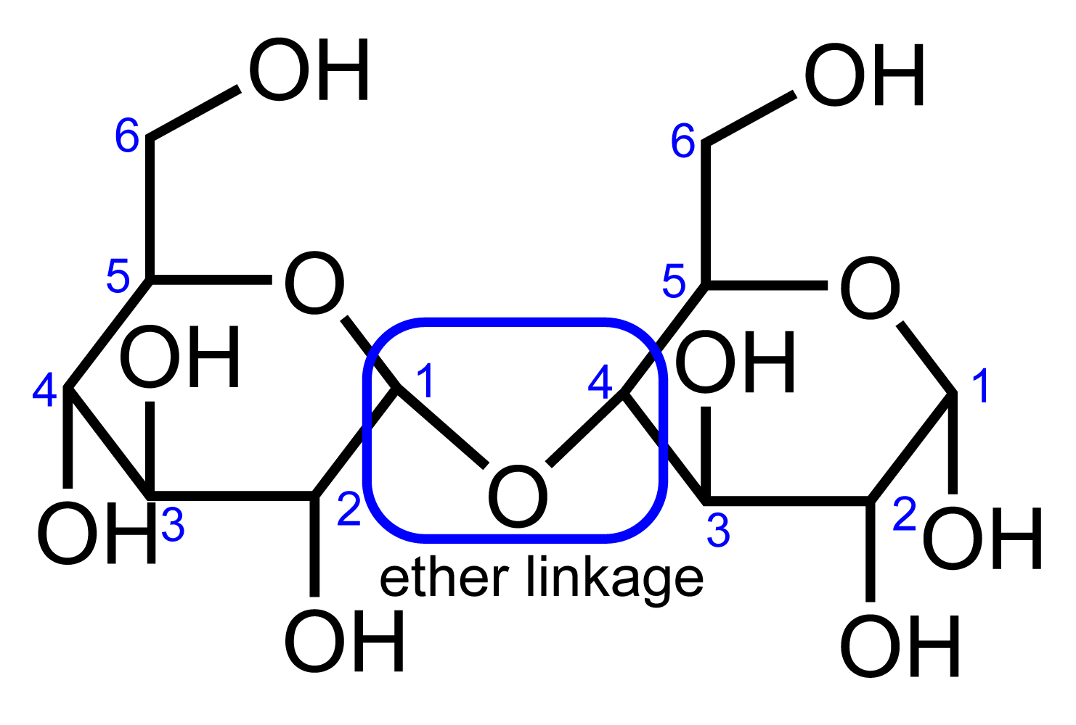
- Draw 4 repeating units of the cellulose and starch polymers.

- Suggest how the differences you noted in question 2 are influencing the polymer structure.
The 6 membered rings we drew above make up the largest proportion of glucose molecules in the equilibrium. To form these structures the oxygen of the OH on C5 attacks the carbon atom of the aldehyde at C1 to form a ring containing oxygen. These ring types are called the pyranose forms. This name comes from their similarity to a ring structure called pyran. Pyran is a heterocycle, a ring that contains an atom other than carbon.
An even more similar structure to our pyranose sugars is tetrahydropyran, this is a saturated form of pyran.
- Complete the table to show the skeletal structure of tetrahydropyran.
Pyran | Tetrahydropyran
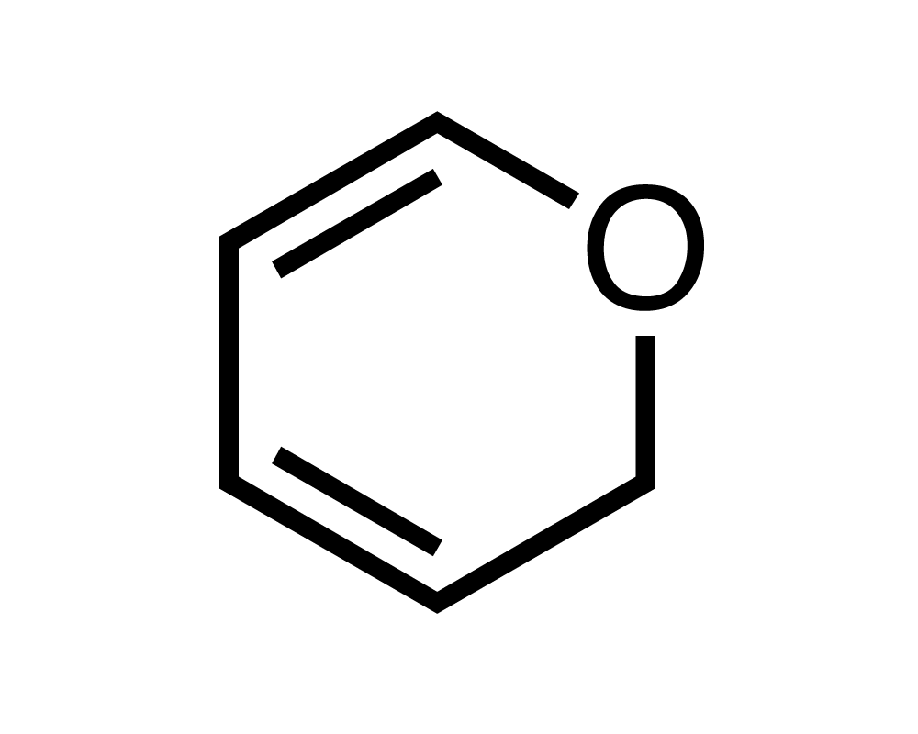

Monosaccharides can also form 5 membered rings, called furanose forms. This name comes from their similarity to the heterocycle furan. An even more similar structure to our furanose sugars is tetrahydrofuran. This is a saturated form of furan.
- Complete the table to show the skeletal structure of tetrahydropyran.
Furan | Tetrahydrofuran
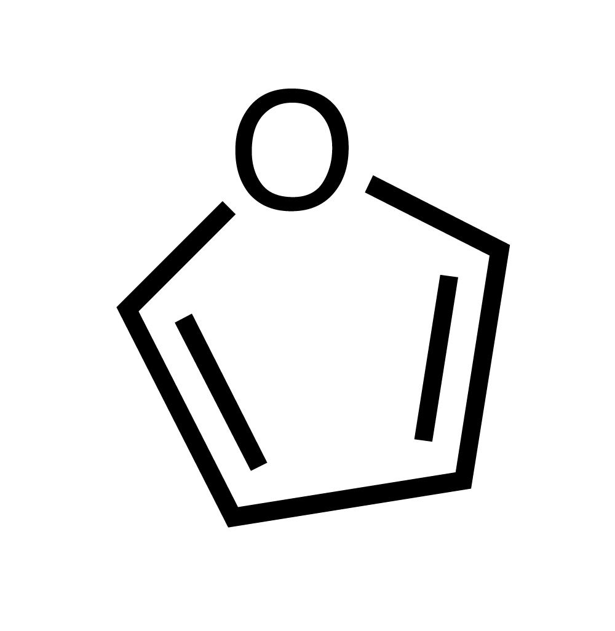

To make the furanose form, the O of the OH at C4 attacks the carbon atom of the aldehyde at C1 to form the ring.
- Draw the two possible furanose structures of glucose (hint: look at the 2 pyranose forms and apply the difference to the form you are trying to create)

