Acid-base indicators

Learning objectives
- To understand that indicators are weak acids in which the colour of the aqueous solution of the acid is distinctly different from that of its conjugate base.
- To know that the pH range over which a colour change occurs can be estimated by pH = -pK_{In} ± 1.
- To be able to sketch the pH curves for different acid-base titrations and suggest suitable indicators based on data given.

Introduction

You will need to apply your understanding of equilibria and acid-base chemistry to answer some questions about indicators.

Questions
- Phenolphthalein and methyl orange are weak acid indicators. When dissolved in water they dissociate slightly to form the conjugate base. For each of the equilibria:
- identify the weak acid and the conjugate base;
- on the structure of the weak acid, circle the proton that is released during dissociation.

phenolphthalein:

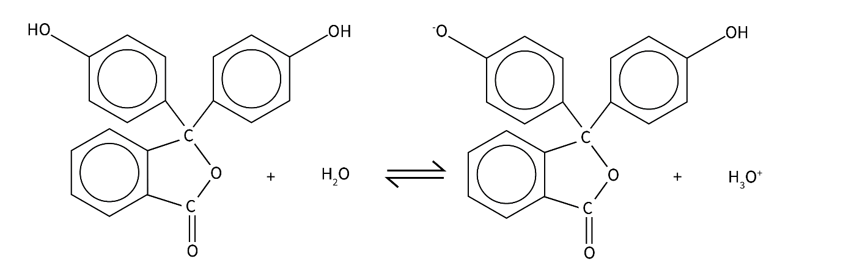

methyl orange:

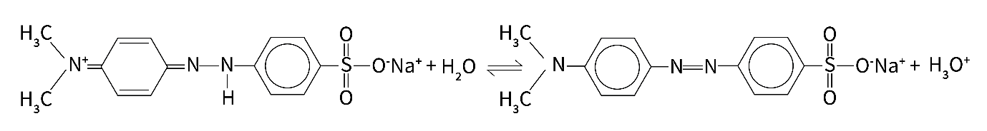

- Phenol red is another weak acid indicator. When dissolved in water the following equilibrium is established.

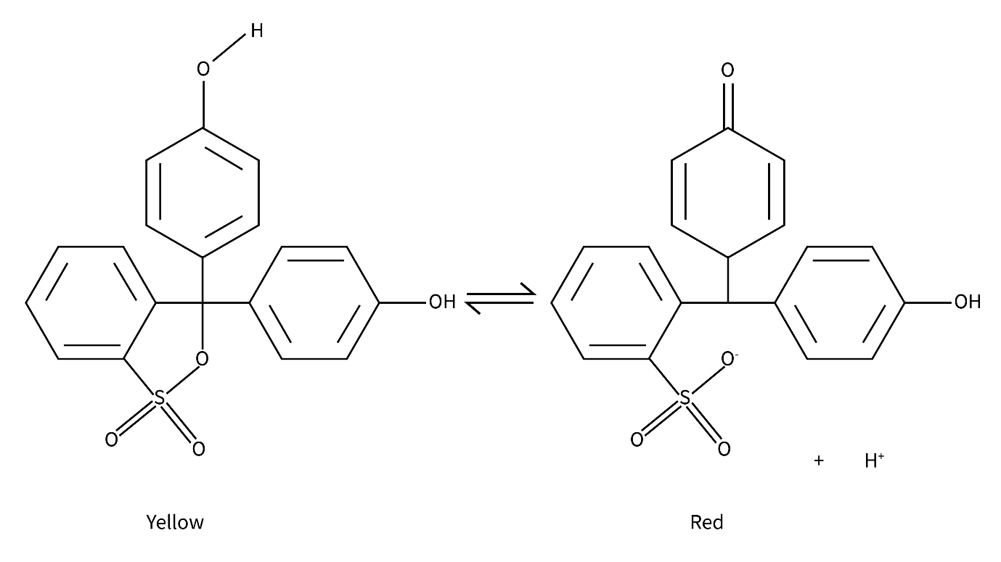

- Explain why phenol red turns red when you add it to an alkaline solution.
- Explain why phenol red turns yellow when you add it to an acidic solution.
- The K_{In} for this equilibrium is 1.26 × 10⁻⁸ mol dm⁻³. Estimate the pH range over which phenol red changes colour.

- The names of different acid-base indicators and the range over which they change colour is given in the table below.

Indicator | Colour in acidic solution | Colour in basic solution | pH range
Methyl orange | red | yellow | 3.1–4.4
Phenolphthalein | colourless | pink | 8.3–10.0
4-Nitrophenol | colourless | yellow | 5.6–7.0

Sketch pH curves for each of the titrations below and choose a suitable indicator for the titration from those listed in the table
- Addition of ammonia solution to hydrochloric acid.
- Addition of ethanoic acid to sodium hydroxide.

