Structure of the atom

This resource is part of the Structure strip series of resources, designed to support literacy in science teaching. Find more structure strips on a range of chemistry topics at: rsc.li/49W5zXh

Learning objectives
- Describe the current accepted model of the atom.
- Determine the number of subatomic particles in a neutral atom.
- Recall the properties of each subatomic particle.

Introduction

Atomic structure is one of the most important topics in chemistry. Lots of other topics depend on understanding the structure of the atom and the properties of the subatomic particles.

How to use structure strips

Structure strips are a type of scaffolding you can use to support learners to retrieve information independently. Use them to take an overview at the start of the topic, to activate prior knowledge, or to summarise learning at the end of a teaching topic.

Structure strips have sections containing prompts, sized to suggest the amount that learners must write. Learners glue the strips into the margin of an exercise book and write their answers next to the sections, in full sentences. When learners have finished using the structure strip, they should have an A4 page set of notes and examples.

Scaffolding

To further support learners to answer the questions you can include a list of keywords or add prompts to the structure strip. As learners grow in confidence, they may be able to attempt the follow-up question first and then use the structure strip to improve or self-assess their answer.

Metacognition

This activity supports learners to develop their metacognitive skills in three key areas.
- Planning: the strips provide scaffolding to plan the written response. Learners will decide where to gather information from (textbooks, own notes, revision websites). Ask learners: is the source of information you are using reliable?
- Monitoring: learners are prompted by the questions in the structure strip and can check their answer against the prompts. Ask learners: have you covered all of the questions in the space provided? Do you need to change anything to complete the task?
- Evaluation: learners can self-assess or ask a peer to check their work against the answers. Ask learners: did you achieve what you meant to achieve? What might you do differently another time?

Follow-up question

Learners should answer this question after completing the structure strip. The structure strip activates the required knowledge which learners can then apply to the question.

Explain, with reference to subatomic particles, why an atom of potassium has an overall neutral charge.

Answers

Find suggested answers for the structure strip activity on page three.

Answer to follow-up question

Potassium has the atomic number 19. It has 19 positively charged protons and 19 negatively charged electrons. Therefore, the charges of the subatomic particles cancel out and the overall charge on the atom is neutral.

Structure strip  Atomic structure | Suggested answer
Define the term atom. | Atoms are the smallest possible unit of an element that can exist.
Draw a labelled diagram of the current accepted model of the atom. | 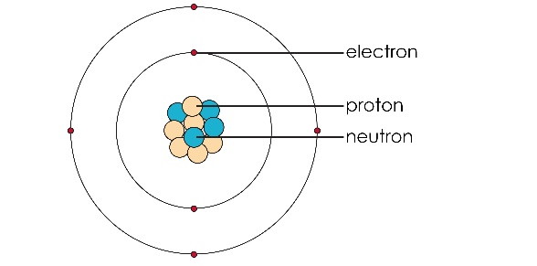
Draw a table to compare the three subatomic particles, their relative masses and charges and their location in the atomic model. | Property Proton Neutron Electron  Relative mass 1 1 Negligible or 1/1840  Relative charge +1 0 -1  Location Nucleus Nucleus In shells orbiting the nucleus
Find oxygen on the periodic table.  Explain how to determine the number of:  - Protons  - Electrons  - Neutrons | 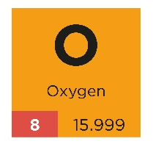  The number of protons is the same as the atomic number (sometimes called proton number) which is always the smaller number on the symbol. For oxygen this is 8.  The number of electrons, for a neutral atom, is the same as the number of protons.  The number of neutrons is worked out by subtracting the atomic number from the mass number. So, for oxygen 16 - 8 = 8 neutrons.
With reference to their atomic structure, describe the similarities and differences between atoms of the same element. | Atoms of the same element always have the same number of protons. The number of protons gives the atom its identity. Atoms might not have the same number of neutrons as all elements have isotopes, different forms of the same atom with the same number of protons but different numbers of neutrons and hence different mass numbers.  Neutral atoms of the same element have the same number of electrons, but electrons can be gained or lost in forming ions.
With reference to their atomic structure, describe the similarities and differences between atoms of different elements. | Atoms of different elements do not have the same number of protons. They may have the same number of neutrons, eg fluorine has 10 neutrons and neon also has 10 neutrons. Atoms can have the same number of electrons due to the formation of ions.

