Testing the strength of natural polymers – teacher and technician notes
Education in Chemistry
July 2017
rsc.li/EiC417-medical-plastics
This experiment accompanies the above article ‘Body, heal thyself’

Apparatus
- Clamp and stand
- Pencil
- Hair and wig samples
- Slotted masses
- Plasticine
- Access to a balance
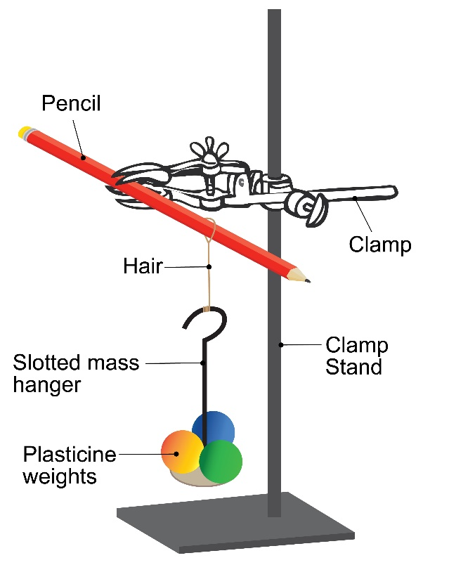

Sample results

Sample | Colour | Human/Synthetic | Dyed/Undyed | Mass added to break (g)
1 | Black | Human | Undyed | 90
2 | Red | Human | Dyed | 168
3 | Brown | Human | Dyed | 149
4 | Brown | Human | Undyed | 95
5 | Blonde | Human | Dyed | 139
Hairpiece | Brown | Synthetic | Dyed | 110

