Bonding: knowledge check
- Use the words to complete the sentences:

covalent bonding ionic bonding metallic bonding
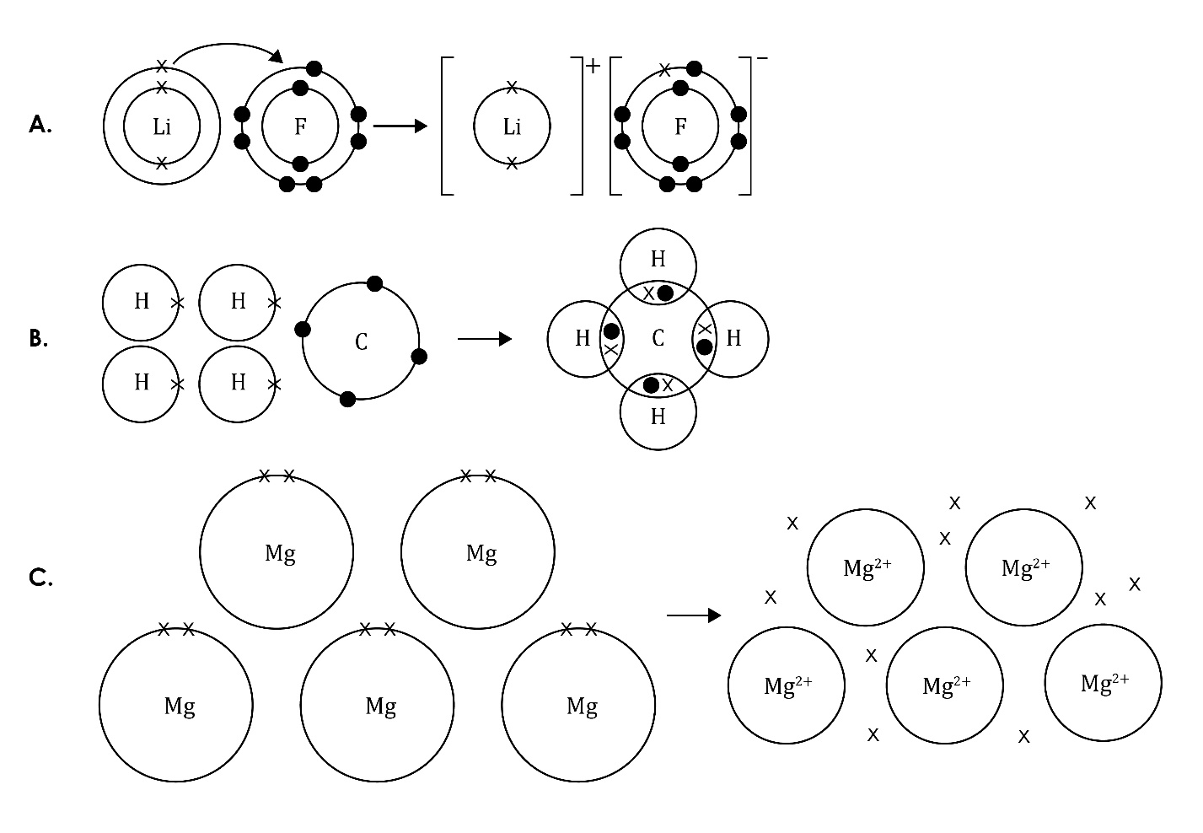
  - The type of bonding in figure A is ______________________________________.
  - The type of bonding in figure B is ______________________________________.
  - The type of bonding in figure C is ______________________________________.

- Use the words to complete the sentences.

electrostatic forces ionic negatively

non-metal transferred

_____________________________________ bonding – this bond is formed when electrons are _____________________________________ from a metal atom to a _____________________________________ atom, forming positively charged ions and _____________________________________ charged ions. Strong _____________________________________ attract the oppositely charged ions to each other.
- Use the words to complete the sentences. You can use words more than once.

covalent electron electrons

outer non-metal

_____________________________________ bonding – this bonding occurs between _____________________________________ atoms. In a single covalent bond, a pair of _____________________________________ is shared between two atoms.
These shared electrons are found in the _____________________________________ shells of the atoms. Each atom contributes one _____________________________________ to the shared pair of electrons.

- Use the words to complete the sentences. You can use words more than once.

electrons electrostatic forces ions metallic

_____________________________________ bonding – the electrons leave the outer shells of metal atoms, forming positive metal ions and a ‘sea’ of delocalised _____________________________________ that are free to move. This bond is the result of the strong _____________________________________ of attraction between the positive metal _____________________________________ and the negative delocalised _____________________________________.

Bonding: test myself

Use the words to complete the sentences. You can use the words more than once.
- What types of elements are involved in the following bonds?

metals and non-metals metals only non-metals only
  - ionic bonding _________________________________________________________.
  - covalent bonding _____________________________________________________.
  - metallic bonding ______________________________________________________.

- In which type of bonding are electrons shared?

covalent ionic metallic

Electrons are shared in ___________________________ bonding.

- What does the curved arrow represent in this diagram?

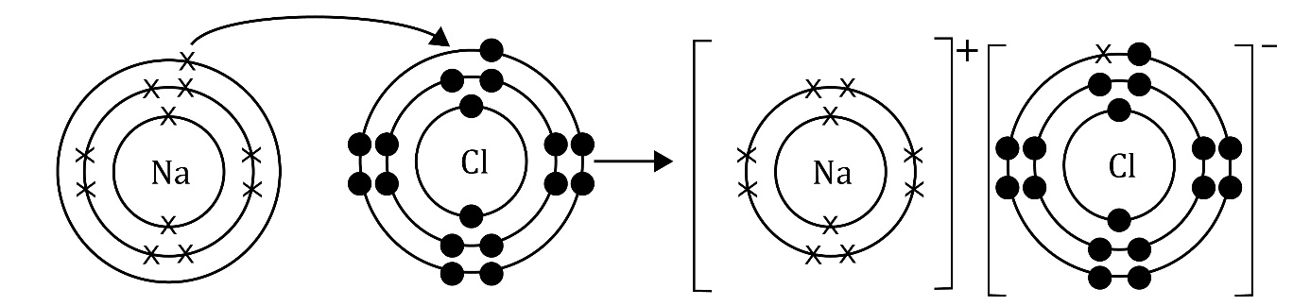

atom electron ion shared transferred

The arrow represents an ___________________________ being ___________________________ from one atom to another.
- What type of forces hold the particles together in an ionic bond?

covalent forces electrostatic forces ionic forces

_____________________________________ of attraction hold the particles together in an ionic bond.

- What does ‘delocalised’ mean?

allowed easy free produced

Delocalised means that the electrons are ___________________________ to move around.
- What are the charged particles called in an ionic compound?

electrons ions atoms protons

The charged particles in an ionic compound are called ___________________________.
- What type of bonds do you find in a compound?

covalent electronic ionic metallic

The bonds in a compound can be either ___________________________ or ___________________________.
- Why are metals good conductors of electricity?

delocalised electrons ions metallic move

Metals are good conductors of electricity because they contain ___________________________ ___________________________ that are free to ___________________________ and carry the charge.

- How do ionic compounds conduct electricity when solid, liquid and in solution?
Explain your answer.

gas ions liquid move

solid solution

Ionic compounds cannot conduct electricity when they are in the ___________________________ state because the ions are not free to move.
They can conduct electricity when they are in a ___________________________
or when they are ___________________________ because the ___________________________ can ___________________________ and carry the charge.
- Why are most covalent substances non-conductors of electricity?

atoms charge charged

electrons ions

Most covalent compounds do not conduct electricity because they do not have _____________________________ particles (___________________________
or ___________________________) that can move and carry the ___________________________.

Bonding: feeling confident?

For questions 3.1 and 3.2, complete the bonding diagrams.
- The reaction between sodium and fluorine.
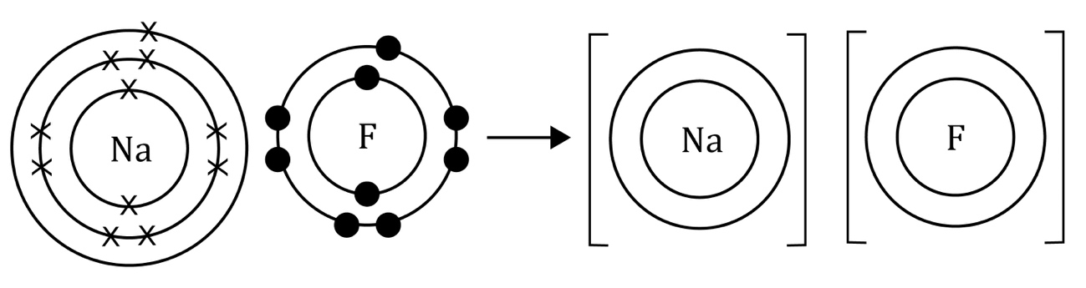
- The reaction between hydrogen and chlorine.
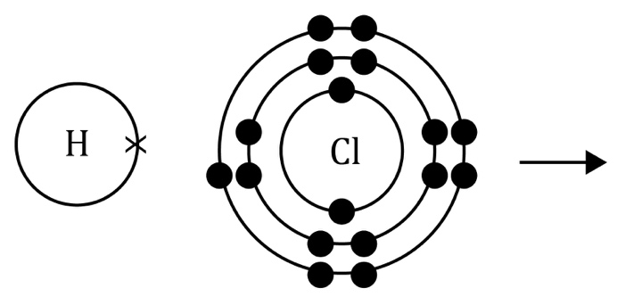
- Add electrons to the diagram to show the metallic bonding in zinc.

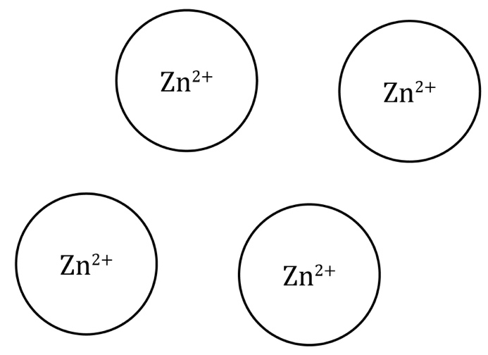

Bonding: what do I understand?

Think about your answers and confidence level for each mini-topic. Decide whether you understand it well, are unsure or need more help. Tick the appropriate column.
Mini-topic | I understand  this well | I think I understand this | I need more  help
I can identify ionic, covalent and metallic bonds from diagrams.
I know that there are ions in ionic bonds.
I know about electrostatic forces in ionic bonds.
I know that electrons are shared in covalent bonds.
I know that there are positive metal ions and negative delocalised electrons in metallic bonds.
I know the types of elements involved in:
- ionic bonds
- covalent bonds
- metallic bonds.
I can explain why metals conduct electricity.
I can explain the conditions required for ionic compounds to conduct electricity.
I can explain why covalent substances do not conduct electricity.
Feeling confident? topics | I understand  this well | I think I understand this | I need more  help
I can draw diagrams to represent ionic and covalent bonds.

