Born–Haber cycles

This resource accompanies the infographic poster Mastering the Born–Haber cycle in Education in Chemistry which can be viewed at: https://rsc.li/3gZ9NHX

Learning objectives
- Construct Born–Haber cycles involving singly and doubly charged cations and anions.
- Compare the relative sizes of the enthalpy changes involved in different Born–Haber cycles.
- Explain the relative magnitudes of enthalpy changes involving transferring electrons from and to atoms and ions.
- Calculate an unknown enthalpy change using Hess’s Law, given suitable data about the other enthalpy changes in a Born–Haber cycle.

The resource contains a set of cut-out arrows drawn to scale to represent the component enthalpy changes that make up Born–Haber cycles for the formation of NaCl(s), MgCl₂(s), Na₂O(s) and MgO(s) from their elements. The set allows students to easily arrange the enthalpy changes of the different components as a hands-on activity to help them become familiar with the different cycles. They will need to place the arrows pointing up or down depending on whether the given enthalpy change is exothermic or endothermic, allowing them to think about the energy transfers associated with each component.

This activity can be done individually, but works well with students working in small groups or pairs to promote learning through trial, error and discussion.

Instructions

Materials
- Three sheets of A4, plus one sheet of A3 stiff paper or card.
- Access to a laminator.
- Clear sticky tape.
- Plastic ‘polywallet’ or similar to store the sets of cards.

Preparation
- Print out the three A4 sheets, plus the one A3 sheet in the separate toolkit on card. The first A4 sheet contains all the components needed for NaCl. The other three cycles are made by adding the cards from the other two A4 sheets and the A3 sheet. Make sure that the printer does not rescale the pages to keep the lengths correct.

- Cut out the individual rectangular cards, taking care not to lose any small pieces. If a laminator is available, you can use this to make the cards more durable. The two halves of the large lattice enthalpies on the A3 sheet will need joining with clear sticky tape to form a hinge so they can be easily folded.

- Sort and store the cards in a plastic wallet. The cards are shaded in colours to help with sorting. If a colour printer is not available, use coloured stickers.

Suggested activity and teaching points
- Introduce Born–Haber cycles by first reviewing the enthalpy level diagram for the formation of a simple covalent compound. Remind students of the need for bond breaking (endothermic), followed by bond making (exothermic).
- Show students the equations for the enthalpy changes involved in Born–Haber cycles: enthalpy of atomisation, ionisation enthalpy, electron affinity and lattice enthalpy, distinguishing bond breaking/making from electron transfer processes.
- Give each group the set of cards needed to make NaCl. Allow them to try to construct the cycle, giving hints if necessary.
- Review the completed cycle for NaCl. Note that cards showing the formulas of the intermediate atoms and ions have not been included in the kit to reduce the number of small pieces of card. However students could be encouraged to add them on paper once they have completed the cycle.
- Before they move on, highlight the following features of the NaCl cycle.
- Show how the value of the enthalpy change for any of the individual components can be calculated if the others are known. The cards give a helpful visual picture of the addition and subtraction needed.
- Show how the cycle can be used to compare the relative contribution of the different components to give the overall ΔH_{f} of the ionic solid.
- Able students might also benefit by reflecting on the statement that ‘sodium atoms want to lose their outer electron’, which is a common misconception arising from the simple pre-16 models used for bonding (see question 5 on the student sheet).
- Once the groups are familiar with the NaCl cycle, they can go on to attempt any or all of MgCl₂, Na₂O and MgO. Place the additional cards needed in separate pots around the room, so students have to think about what they need. These will introduce the additional features of the more complex cycles.
- The second ionisation enthalpy for doubly charged metal ions.
- The need to double the atomisation and electron affinity/first ionisation enthalpy for the singly charged ions combining with doubly charged ions.
- The large endothermic second electron affinity for doubly charged non-metal anions.

The very large arrows needed for the lattice enthalpies in these cycles are quite cumbersome but dramatically illustrate the effect of ion charge on the strength of the ionic bonding in the lattice.

Answers

Part 1: Born–Haber cycle for NaCl
- (a) $Na\left(s\right)→Na(g)$
- ½${Cl}_{2}(g) → Cl(g)$
- ${Na}^{+}(g)+ {Cl}^{-}(g) →NaCl(s)$
- (a) Metallic bonding

(b) Covalent bonding

(c) Ionic bonding

- Both enthalpy changes involve breaking the Cl-Cl covalent bond in the gaseous state to form gaseous atoms. Enthalpy of atomisation is defined as the energy needed to form one mole of gaseous atoms, whereas bond enthalpy is defined as the energy need to break one mole of the covalent bond, which will form two moles of gaseous atoms.

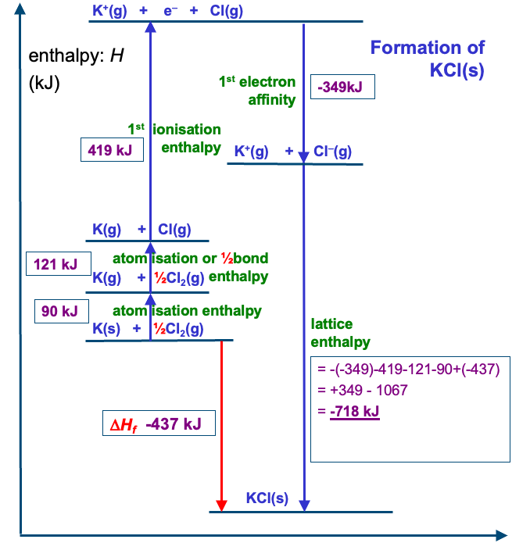
- Both ions have the same overall charge of 1+, but the potassium ion has a larger radius than the sodium ion. This gives the potassium ion a lower charge density, reducing the attraction for the negative ions in the lattice.
- This question is designed to elicit a fruitful discussion with students that will reveal their thinking, rather than require one particular response. Statements such as this result from a pre-16 study of bonding where students often have the idea that atoms bond in order to gain a stable full outer shell. The Born–Haber cycle shows that the formation of an ionic compound is feasible because of the large amount of energy transferred to the surroundings as the ionic lattice forms (enough to outweigh any loss of entropy due to the formation of an ordered solid lattice from the elements). The statement in the question is also an example of anthropomorphism, as the inanimate atoms are described as ‘wanting’ to do something, which is a human characteristic.

Part 2: Born–Haber cycles for MgCl₂, Na₂O and MgO
- After removal of the first electron, the magnesium has an overall charge of 1+, making it harder to remove an electron than from the neutral magnesium atom. Also, the ${Mg}^{+}$ ion has a smaller ionic radius than the atomic radius of a magnesium atom. This means that the outer electron is now closer to the nucleus, so more strongly attracted.
- The second electron is added to the $O^{-}(g)$ ion, so it requires energy to work against the repulsion between the negative ion and the incoming electron.
- The 2+ charge on the magnesium ion results in a significantly stronger attraction for the chloride ions in the lattice than with the 1+ sodium ions. Therefore much more energy is transferred to the surroundings as the lattice forms from the gaseous ions.

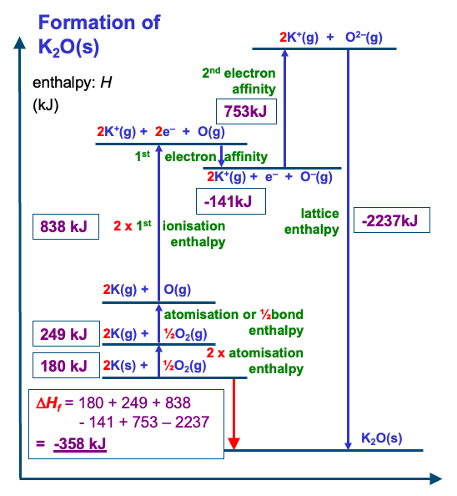

Data used in the cycles

The values for some of the standard enthalpy changes involved in Born–Haber cycles varies between different data books. Below is a summary of the values used in this resource, which may differ slightly from those seen in textbooks or exam questions.
 | ΔHº / kJ mol⁻¹
Enthalpy change | Sodium | Magnesium | Chlorine | Oxygen
Atomisation enthalpy | + 107 | + 148 | + 121 | + 249
First ionisation enthalpy | + 496 | + 738
Second ionisation enthalpy |  | + 1451
First electron affinity |  |  | - 349 | - 141
Second electron affinity |  |  |  | + 753

 | ΔHº / kJ mol⁻¹
Enthalpy change | Sodium chloride | Magnesium chloride | Sodium  oxide | Magnesium oxide
Lattice enthalpy | - 790 | - 2524 | - 2528 | - 3791
Enthalpy change of formation | - 415 | - 643 | - 461 | - 593

Completed cycles

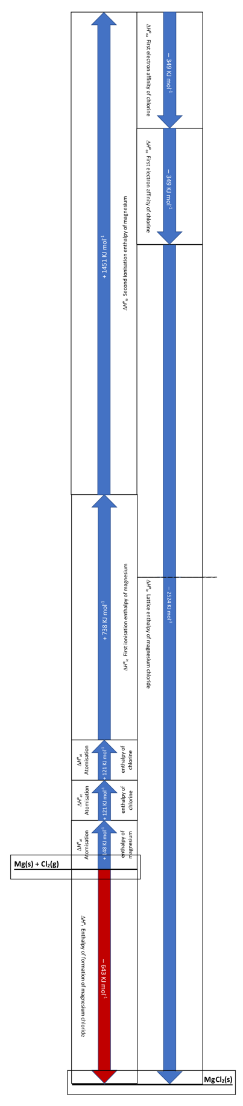
Below are diagrams to show how the cards in the toolkit can be arranged to form the four Born–Haber cycles.

Note that the atomisation and ionisation enthalpy changes can be validly arranged in a number of different orders, as long as the atomisation enthalpy for the metal is before the first ionisation enthalpy.
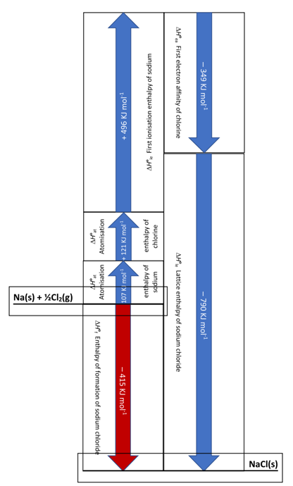

MgCl₂

NaCl

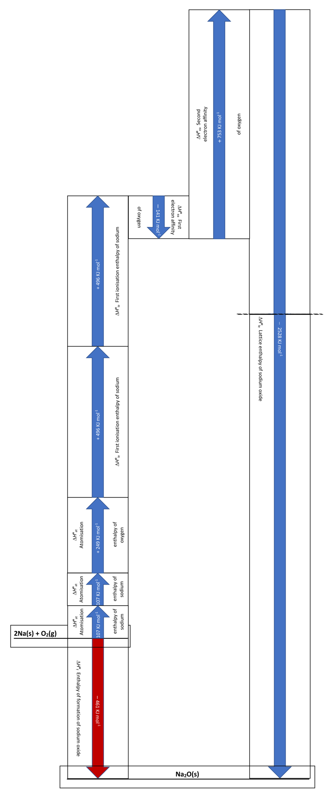
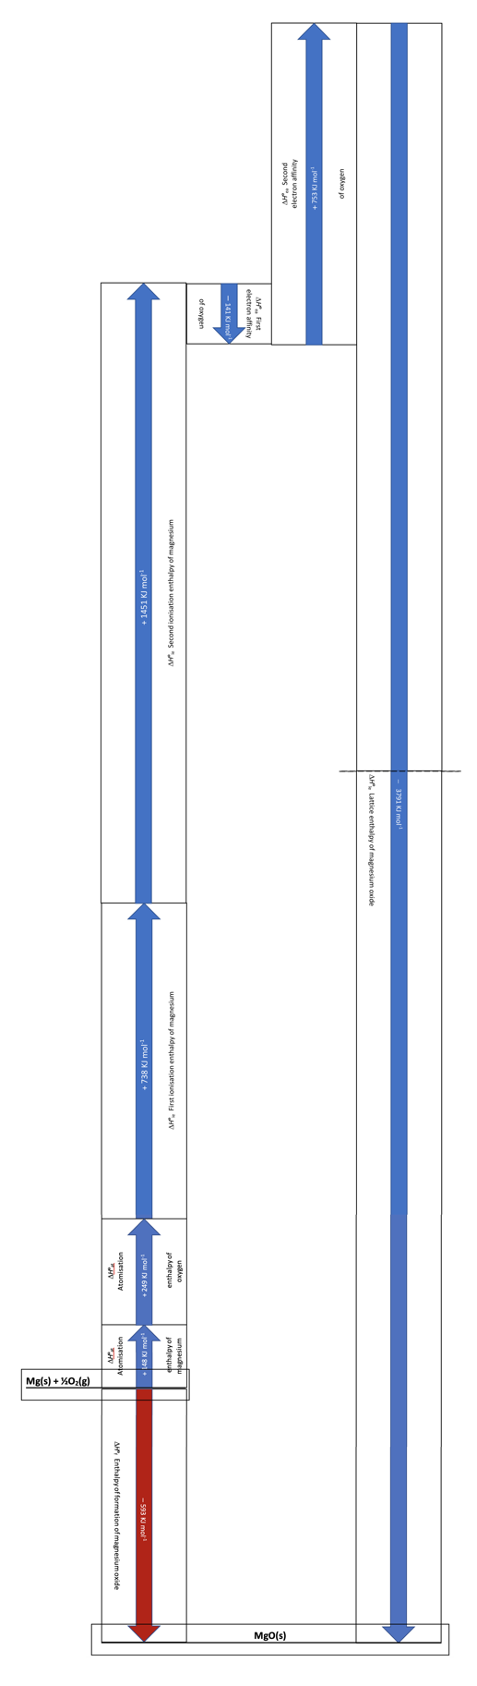

MgO

Na₂O

