- A teacher shows a class an experiment in which liquid paraffin is cracked.
Watch the video at https://youtu.be/ZYyKUePdC2Y

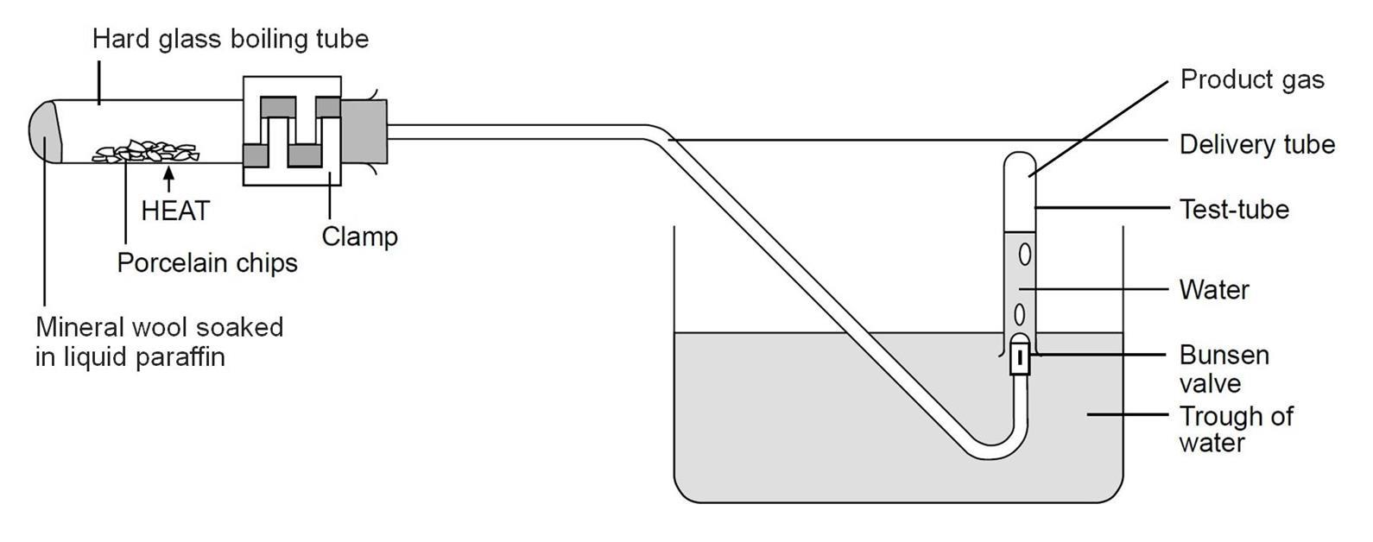
Here is a diagram of the equipment used.
Source: Royal Society of Chemistry

- Porcelain chips are used because they catalyse the reaction.
What is the meaning of the word ‘catalyse’?

- Using the diagram, what evidence is there that smaller molecules are made in the experiment?
Explain your answer.

- Using the diagram, describe how you think the experiment works.

- What evidence is there from the diagram that the product gas is insoluble in water?

- Suggest why a special valve called a Bunsen valve is used in the experiment.

Paraffin is a mixture of large hydrocarbon molecules.
The structure of one of these molecules, called dodecane, is shown below.
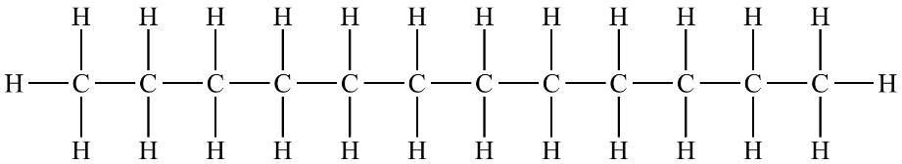

- State the molecular formula of dodecane.

Dodecane is a member of a homologous series.
- Give two characteristics of molecules in a homologous series.

- To which homologous series does dodecane below?

- What is the general formula of the homologous series in part h)?

- Which of these molecules do not belong to the same homologous series as dodecane?
Write ‘Yes’ or ‘No’ into the right-hand column in the table.
Molecular formula of substance | The same homologous series as dodecane (‘Yes’ or ‘No’)
C₈H₁₆
C₁₃H₂₈
C₅H₁₂
C₂₃H₄₆
C₅₀H₁₀₂

- Dodecane may be cracked to form smaller alkanes and alkenes.
Write a symbol equation to show dodecane being cracked to form ethene as one of the products, together with a different product.

- Complete the symbol equations for the following cracking processes.

- C₆H₁₄ + C₂H₄

- C₁₆H₃₄ + 2C₂H₄

- C₂₀H₄₂ C₁₃H₂₈ + 2 + C₃H₆
- State a use for the products formed from a cracking reaction.
Smaller alkanes
Alkenes

The molecule shown below can form from a cracking reaction.

- What is the name of this molecule?

- State whether this molecule is saturated or unsaturated.
Give a reason for your answer.

