Super-slimmed smartphones
Education in Chemistry
September 2018
rsc.li/2vVc3Vi
Adam Boxer

These teaching ideas accompany the article Super-slimmed smartphones. Download this article and all these teaching ideas and the worksheet from: rsc.li/2vVc3Vi
Batteries are a notoriously tricky part of the chemistry curriculum. Now part of more 14–16 chemistry courses, they are also studied at 16–18 within electrochemistry. Students can make links from this topic to many different areas of their course – understanding batteries needs knowledge of ions and reactivity, as well as areas from physics like current and potential difference. This article discusses a practical application of batteries. You could use it in class to discuss surface area and life cycle assessments, as well as the chemistry of batteries.

Could you design better smartphones?
Worksheet, ages 14-16
Download this worksheet from the Education in Chemistry website that students must complete using their own knowledge and information in this article. It’ll get students thinking about the science behind good phone design and applying their knowledge from other areas of their science lessons. You will also find a teacher guide with answers.
Chemists are at the cutting edge of product design and manufacture. Read the article Super-slimmed smartphones (rsc.li/2vVc3Vi) about how some chemists are developing a new type of battery that could also serve as a phone screen, then answer the questions below using the article and your own knowledge.
- Explain in terms phone design why having a two-in-one battery and screen is an advantage.
It enables phones to be smaller.
The best answers will discuss how size is an important threshold point in device design. Scientists know size is a hindrance with clear implications, but are currently struggling to solve it. It may be worth discussing ergonomics and why smaller devices might be preferable to consumers.
- Below is a schematic diagram of a conventional (normal) phone screen. Use the article to write labels to the diagram. 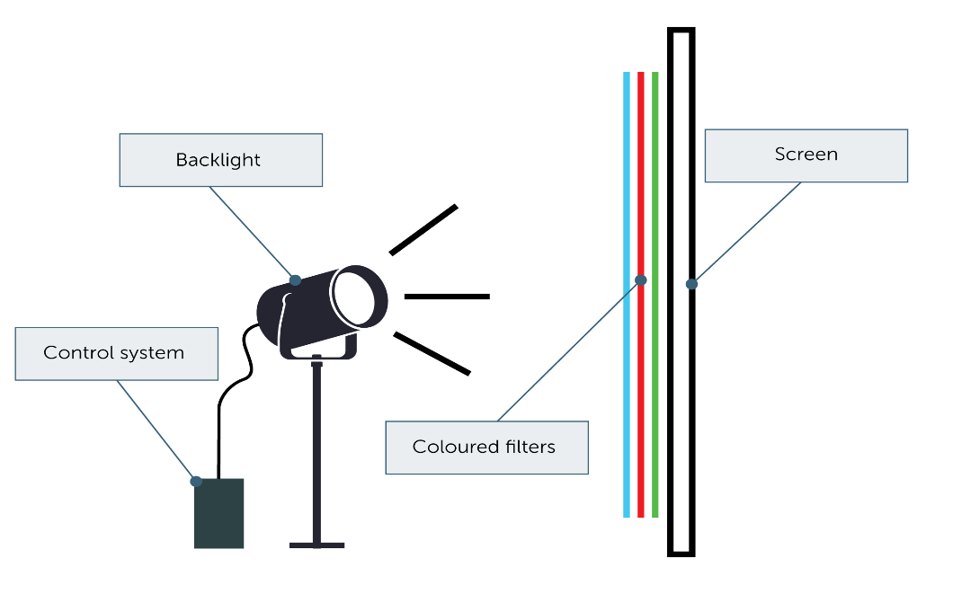
- Phone screens need to be tough, transparent, unreactive and conductors of electricity.
Answer these questions about the properties of solid potassium chloride.
- Is potassium chloride tough or brittle? Brittle
- Is potassium chloride transparent? No
- What might happen if potassium chloride is put into water? It dissolves
- Does solid potassium chloride conduct electricity? No
Do you think potassium chloride would be an appropriate material to use for phone screens? Explain your answer.
No. It would break too easily, it would be too difficult to see through, it might dissolve in the rain and it wouldn’t conduct electricity.
For high achieving students, you could rewrite this question as ‘Explain why using an ionic compound like potassium chloride would be inappropriate for phone screens’ for additional challenge.
- Phone screens need to be tough, transparent, unreactive and conductors of electricity.
- Potassium chloride does not suit the criteria.
- Potassium chloride has a giant ionic lattice structure.
  - It will be brittle and would mechanically wear.
  - Most giant ionic substances are not transparent.
  - While giant ionic lattices could be relatively unreactive, many tend to be soluble, which would be a problem.
  - Giant ionic lattices do not conduct electricity when solid.

- Some scientists have tried to make phone screens by attaching a layer of graphene to a transparent material.
Suggest why graphene could be an appropriate material for phone screens. In your answer, refer to the structure and bonding in graphene.
Graphene is just one atom thick, so negligibly contributes to overall size or mass of the phone. It is a very strong material due to strong covalent bonds between carbon atoms. It is also an excellent conductor of electricity.
- The screen-battery anode and cathode have a ‘hair comb’ shape.
Suggest why the scientists chose a ‘hair comb’ shape instead of the shape shown below for the anode and cathode. 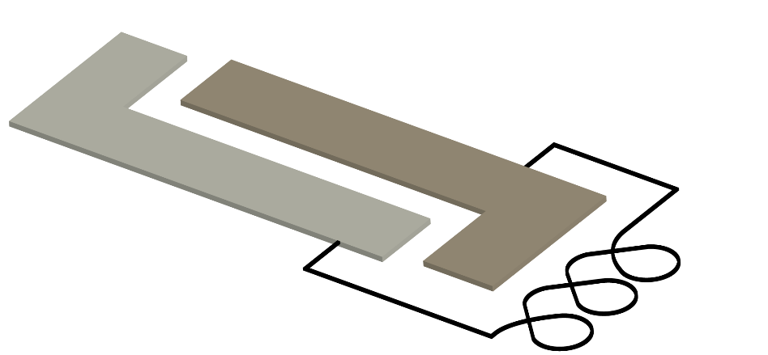
The hair comb structure has a much larger surface area, allowing for increased frequency of collisions between particles from the electrolyte with the electrodes. This increases the rate of reaction and therefore the rate of electrical energy the battery supplies.

- Explain why a chemical cell with one electrode made of magnesium and another made of copper will produce a larger potential difference than a cell where one electrode is zinc and the other is copper.
Potential difference depends on the difference in reactivity between metals involved. The difference in reactivity between Mg and Cu is larger than between Zn and Cu.
- Read the section of the article Super-slimmed smartphones under the subheading ‘A touch of quantum glow’.
List the properties and components the new screen-battery has that are different to conventional batteries.

- Flat
- Transparent electrolyte
- Contains quantum dots
- Electrolyte that glows under UV conditions

- Read the last paragraph of Super-slimmed smartphones. Environment-poisoning is where harmful chemicals in everyday products end up in the ecosystem. Explain why this should be considered as part of a device’s design and life cycle assessment.
Life cycle assessment needs to take into account the manufacture, lifetime use and disposal of a device. In the disposal step, the wider environment and ecosystem must be considered. If disposal will cause leaking of harmful chemicals then effort to counteract it will be needed. This contributes to the overall ‘cost’ of the device to society and the planet.

More recommended resources
- In this practical, students construct a simple chemical cell.
- I ask students to compare and contrast the microscale method for making a chemical cell with a more traditional one and evaluate for effectivity and efficiency. The microscale version is also suitable as an A-level required practical.
- This article has lots of information about the first battery, the voltaic pile, as well as ideas for other activities.
- Here’s another really simple method to build a voltaic pile battery at home or in school.

