Teaching rates of reaction post-16: next steps
Education in Chemistry
September 2021
rsc.li/3jV0WVq
These steps follow those from the graphical representations in the Teacher checklist, which accompanied the first Teaching rates of reaction post-16 article (rsc.li/3yLp1nU).

Introducing the rate equation
Students should be familiar with transforming a relationship that shows a proportional relationship into an equation by including a constant of proportionality.
Rate ∝ [x]^{n} becomes Rate = k[x]^{n}
Where k is the rate constant. This is only a constant when the temperature remains the same or when a catalyst doesn’t affect the rate.

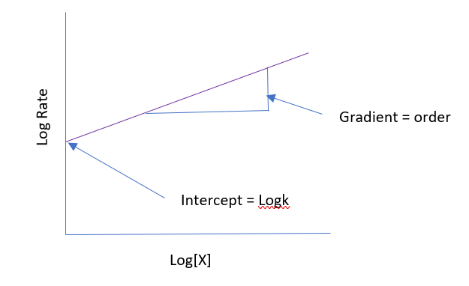
Calculating the rate constant
Now take Log₁₀
Log rate = logk + nlog[x]
This equation form can be compared to y = mx + c
Log rate | = | logk | + | nlog[x]
y | = | c | + | mx
So, plotting log[x] against log rate allows the gradient n (order) to be calculated. The intercept is logk which is important for calculating the Ea.

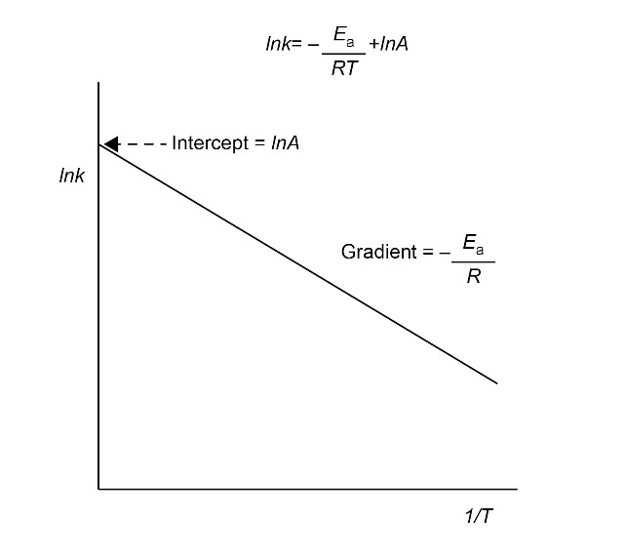
Calculating the activation energy (E_{a})
Applying the Arrhenius equation
k = Ae^{-Ea/RT}
Take natural logarithms and plot lnk versus 1/T

