Analysis of aspirin on a microscale – teacher notes

In this experiment students measure the amount of free 2-hydroxybenzoic acid (salicylic acid) in 2-ethanoyloxybenzenecarboxylic acid (aspirin) tablets.

2-hydroxybenzoic acid (salicylic acid), being a substituted phenol, reacts with Fe³⁺ ions to produce a purple colour. The colour is matched against that produced by a set of standard solutions of 2- hydroxybenzoic acid (salicylic acid) in a well-plate.

Topic

Organic chemistry, chemical analysis

Timing

20 minutes

Equipment

Apparatus

- Eye protection
- 24-well plate
- Beaker, 100 cm³
- Cotton wool
- Plastic pipette (standard form, eg Aldrich ref: Z13, 500-3)
- Plastic pipettes (fine tip, eg Aldrich ref: Z13, 503-8), x2
- Sheet for microscale filtration technique (see note 4 below)

Chemicals

Solutions should be contained in plastic pipettes (fine tip) – see the accompanying guidance on apparatus and techniques for microscale chemistry (https://rsc.li/2PRZ8Bu).

- Various 2-ethanoyloxybenzenecarboxylic acid (aspirin) tablets
- Iron(III) nitrate solution, 0.1 mol dm^{–3}
- 2-hydroxybenzoic acid (salicylic acid) (working) solution
- Deionised water

Health, safety and technical notes

- Read our standard health and safety guidance (https://rsc.li/3uqIGaz).
- Wear eye protection throughout.
- Advise students not to ingest the aspirin tablets.
- See our guidance on apparatus and techniques for microscale chemistry (https://rsc.li/2PRZ8Bu) for microscale filtration instructions.
- Iron(III) nitrate, Fe(NO₃)₃.9H₂O(aq), 0.1 mol dm^{–3} is of low hazard. See CLEAPSS Hazcard HC055C and CLEAPSS Recipe Book RB052.
- 2-hydroxybenzoic acid (salicylic acid) solution (0.1% w/v) is of low hazard. See CLEAPSS Hazcard HC052.
- Ethanol/water mixture (1:1) is FLAMMABLE. See CLEAPSS Hazcard HC040A and CLEAPSS Recipe Book RB002.

Preparing a stock salicylic acid solution (0.1% w/v)

Dissolve 0.100 g of 2-hydroxybenzoic acid (salicylic acid) in approximately 20 cm³ of a 1:1 mixture of ethanol and deionised water in a 100 cm³ beaker. Make up to 100 cm³ in a volumetric flask.

Preparing a working salicylic acid solution

To produce a working solution (0.0025 g 2-hydroxybenzoic acid (salicylic acid) / 25 cm³), dilute 2.5 cm³ of the stock solution to 25 cm³ in a volumetric flask with a 1:1 ethanol–water mixture.

Teaching notes and expected observations

The set of standard solutions should give a range of intensities of a bluish colour. Students should be careful to add the correct number of drops as indicated. The experiment works best with old tablets containing some free 2-hydroxybenzoic acid (salicylic acid). New tablets with minimal free acid do not give any blue coloration but merely the colour of iron(III) in solution (yellow) so they do not fit into the range of standards.

The equation by which 2-hydroxybenzoic acid (salicylic acid) is formed is:

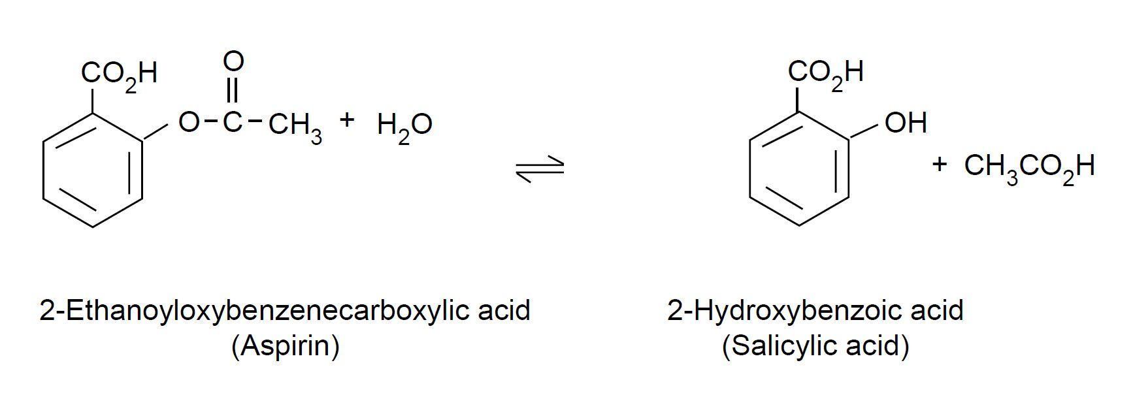
This experiment gives students an opportunity to consider the practical effect of equilibrium. Old 2-ethanoyloxybenzenecarboxylic acid (aspirin) tablets, which may have become damp with time, will contain more free 2-hydroxybenzoic acid (salicylic acid) because the presence of water causes the position of equilibrium to be shifted to the right in the above equation.

Reference
This experiment is based on a similar procedure given in the publication G. Rayner- Canham and A. Slater, Microscale chemistry – laboratory manual. Don Mills, Ontario: Addison-Wesley, 1994.

