Covalent bonding

This resource is part of the Structure strip series of resources, designed to support literacy in science teaching. More resources in this series can be found at: rsc.li/3TeI4DI

Learning objectives
- Define the term covalent bond.
- Recognise, use and interpret different types of diagrams of covalent bonding in small molecules.
- State the limitations of covalent bonding diagrams.

Introduction

Covalent bonding occurs when electrons are shared. Lots of different substances have covalent bonding and covalent bonding can be represented using different types of diagrams. In this activity, learners will gain an understanding of these diagrams and their limitations.

How to use structure strips

Structure strips are a type of scaffolding you can use to support learners to retrieve information independently. Use them to take an overview at the start of the topic, to activate prior knowledge, or to summarise learning at the end of a teaching topic.

Structure strips have sections containing prompts which are sized to suggest the amount that learners must write. Learners glue the strips into the margin of an exercise book and write their answers next to the sections, in full sentences. When learners have finished using the structure strip, they should have an A4 page set of notes and examples.

Scaffolding

To further support learners to answer the questions you can include a list of keywords or add prompts to the structure strip.

As learners grow in confidence, they may be able to answer the question without the structure strip or attempt the question first and then use the structure strip to improve or self-assess their answer.

Metacognition

This activity supports learners to develop their metacognitive skills in three key areas.
- Planning: the strips provide scaffolding to plan the written response. Learners will decide where to gather information from (textbooks, own notes, revision websites). Ask learners: is the source of information you are using reliable?
- Monitoring: learners are prompted by the questions in the structure strip and can check their answer against the prompts. Ask learners: have you covered all of the questions in the space provided? Do you need to change anything to complete the task?
- Evaluation: learners can self-assess or ask a peer to check their work against the answers. Ask learners: did you achieve what you meant to achieve? What might you do differently another time?

Follow-up question

Learners should answer this question after they have attempted the structure strip. The structure strip activates the required knowledge which learners can then apply to the question.

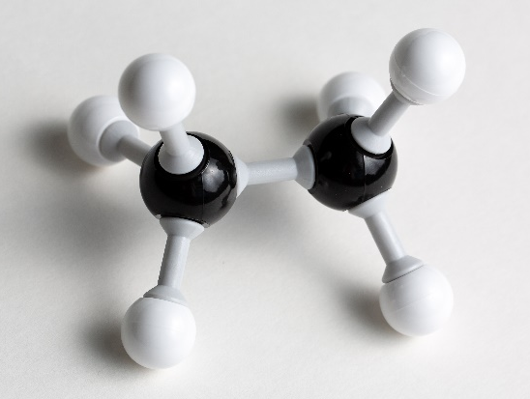

The photograph shows a small molecule built using Molymods®.

Give the formula of the molecule and draw the molecule as:
- A dot and cross diagram
- A ball and stick diagram
- A structural or skeletal formula

Keywords

Covalent, bonding, limitation, molecule, polymer.

Answers

Suggested answers for the structure strip activity are given in the frame on page four of this document.

Answers to follow-up question:

The formula for ethane is $C_{2}H_{6}.$ (check learners have the numbers as subscripts)
- Dot and cross diagram:
- Ball and stick diagram

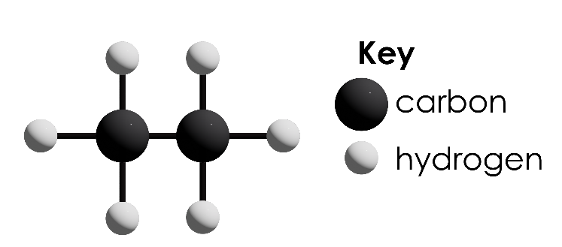
- Structural or skeletal formula
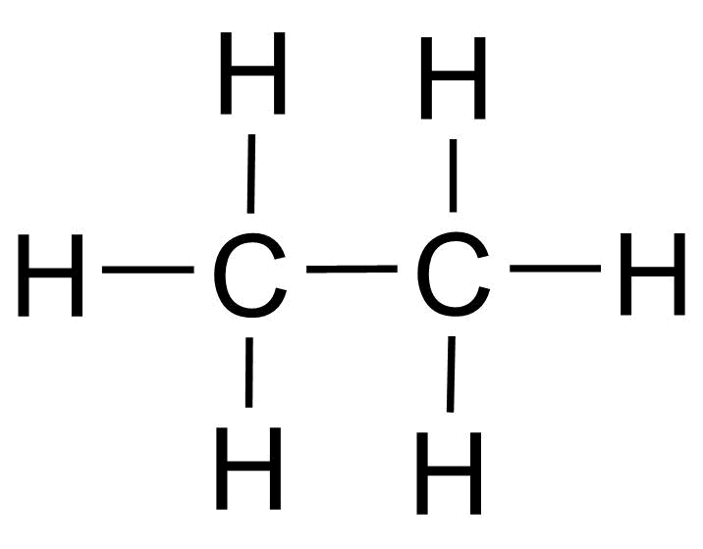

Structure strip  Covalent bonding | Example answer
How are covalent bonds formed? | Covalent bonds are formed when electrons are shared between atoms.
Covalent bonds can be found in small molecules, large molecules, and giant covalent structures. Give examples of each. | - Small molecules: hydrogen, H₂, water, H₂O, ammonia, NH₃  - Large molecules: polymers e.g. poly(ethene)  - Giant covalent structures: carbon (graphite), carbon (diamond), silicon dioxide, SiO₂.
Covalent bonds can be represented in different diagrams, including dot and cross diagrams.  Explain how you would go about drawing a dot and cross diagram of the covalent bonding in ammonia.  Fully explain each decision in your diagram construction. | - Recall the formula for ammonia or look it up. Ammonia is NH₃.  - Determine how many electrons are in the outer shells of the atoms. There are 5 in the outer shell of nitrogen and 1 in the outer shell of hydrogen.  - Decide which atom is at the centre of the molecule, since H can only form one bond, this is N.  - Draw a circle for the nitrogen atom and three circles overlapping it (but not overlapping each other) for the hydrogen.  - Now add the electrons using dots and crosses. One dot in each overlap from the hydrogen atoms. These are single bonds. Now add the 5 electrons for the nitrogen using crosses, one in each of the overlaps and the two ‘spare’ electrons are placed on the outer shell of the N atom. This is a lone pair.
Water is a simple covalent structure.  Draw water in each of these forms:  - Ball and stick model  - Dot and cross diagram  - Skeletal formula. | 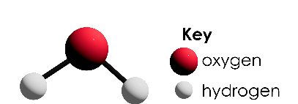  - Ball and stick model  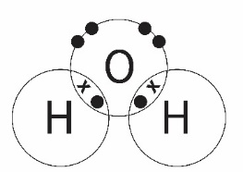  - Dot and cross diagram  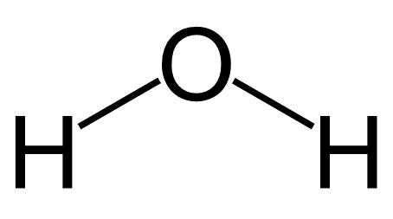  - Skeletal formula
Give the limitations of using models to represent covalent molecules. | - 2D models do not represent the correct shape of molecules.  - Models do not represent the relative size of atoms.  - Models do not represent the movement of electrons.  - Stick models do not represent the number of electrons.  - Stick models place the atoms far apart from each other.

