Spacing guide
Education in Chemistry
September 2019
rsc.li/2NqeJTm

Sept | 30
Oct | 31
Nov | 30
Dec | 31
Jan | 31
Feb | 28
Mar | 31
Apr | 30
May | 30

Topic

Finished on .

days to exam – day gap until revisit.

Spacing lesson/lag homework on________

Example
You finish a topic on bonding, structure and the properties of matter on 12 November. The exam is on 28 May.
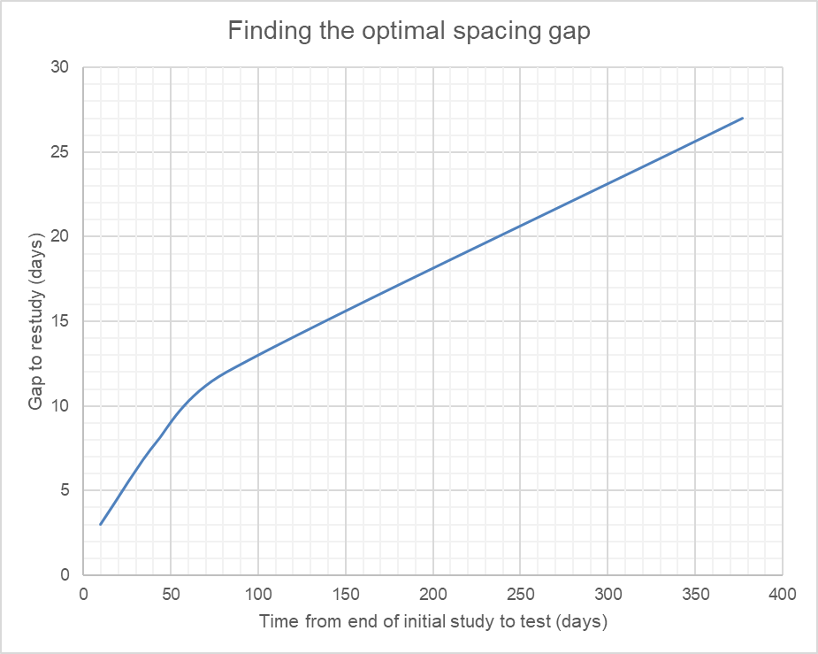
Sept | 30
Oct | 31
Nov | 30 (18)
Dec | 31
Jan | 31
Feb | 28
Mar | 31
Apr | 30
May | 30 (28)
197
Topic Bonding, structure and the properties of matter
Finished on 12 November

197 days to exam – 18 day gap until revisit

Spacing lesson/lag homework on 30 November

