Testing the strength of natural polymers
Education in Chemistry
July 2017
rsc.li/EiC417-medical-plastics
This experiment accompanies the above article ‘Body, heal thyself’

Aim
Hair contains a natural polymer called keratin. In this experiment we will compare the strength of single strands of hair with single strands of synthetic hair from a wig or hairpiece.

Apparatus
- Clamp and stand
- Pencil
- Hair and wig samples
- Slotted masses
- Plasticine
- Access to a balance
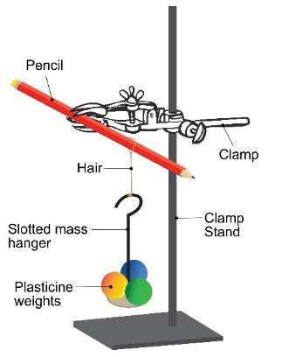

Method
- Set up a clamp stand and clamp a pencil horizontally as shown in the diagram.
- Prepare 10 pieces of plasticine to use as weights; each should be the size of a large marble.
- Tie a knot in your hair sample and hang the loop over the pencil. Record the sample name, colour and whether it is human or synthetic, dyed or undyed in your table.
- Hang the first slotted mass off the loop of hair.
- Now add pieces of plasticine to the mass, one at a time. Do this until the hair breaks.
- Weigh your masses and plasticine on the balance and record the result in your table.
- Repeat this for all the hair samples.

Results
Sample | Colour | Human/Synthetic | Dyed/Undyed | Mass added to break (g)
1
2
3
4
5
6

Conclusion
Write a conclusion for your experiment. A really good conclusion also uses quotes from the results to support its claims.

Questions
- Why can this data not be presented in graphical form?
- Why does the size of the hair loop not matter? (Clue: think about the stress point on the hair)
- Is there any correlation between hair colour or hair dye and strength?
- Are you able to make a clear conclusion about the strength of the natural polymer in hair and the synthetic hair? Explain your answer.

