- This question is about some of the reactions of ethene, C₂H₄.
Complete the spider diagram by drawing the structures of the products formed.

Bromine, Br₂

Hydrogen with a nickel catalyst at 150°C

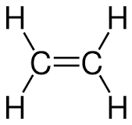

Chlorine, Cl₂

Steam, 300°C, 60 atm, phosphoric acid catalyst

- Cover up your answers to question 1.
Write the reagents and conditions needed for the reactions by writing answers on the arrows. This time, propene is used instead of ethene.

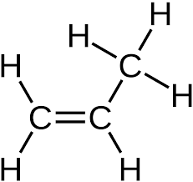
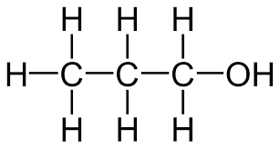
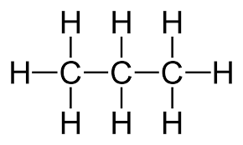

- This question is about reactions of ethanol, C₂H₅OH.
Complete the spider diagram by drawing the structures of the products formed.

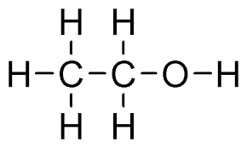
Oxidising agent e.g. acidified potassium manganate(VII) or sodium dichromate(VII)
Combustion, O₂
Sodium metal
Ethanoic acid and an acid catalyst

Concentrated sulfuric acid or phosphoric acid

- Cover up your answers to question 3.
Write the reagents and conditions needed for the reactions below by writing answers on the arrows.
This time, propan-1-ol is used instead of ethanol.
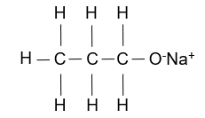
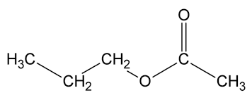
Carbon dioxide
and water

