Spot the entropy errors

Learning objectives
- Identify misconceptions in entropy question responses.
- Explain why changes in entropy occur.
- Understand why some reactions are not feasible under standard conditions.

What to do

A group of learners have answered some entropy questions. Unfortunately, they are not entirely correct.

Read through the questions and the learner answers provided.

For each question:
- Identify the mistake or mistakes in the student answer. These may include:
  - incorrect terminology
  - inaccuracies in calculations
  - incorrect explanations
  - incomplete explanations.
- Explain the identified mistake(s)
- Write out the correct answer.

Questions
- The reaction between the solids hydrated barium hydroxide and ammonium chloride is endothermic.

The symbol equation for the reaction is:

$$Ba{(OH)}_{2}.8H_{2}O\left(s\right) +2NH_{4}Cl\left(s\right)→ Ba{Cl}_{2}\left(s\right)+10H_{2}O\left(l\right)+2NH_{3}(g)$$

- Predict the sign of the standard entropy change of the system (${ΔS}_{system}$) for this reaction and give two reasons to justify your prediction.

Learner answer:

${ΔS}_{system}$is positive because the number of molecules of products is greater than the number of molecules of reactants. Two moles of solids go to one mole of solid.

Table of thermodynamic data
Compound | $${{ ΔH}_{f}}^{°}(kJ {mol}^{-1})$$ | $$ΔS^{°}(J {K^{-1} mol}^{-1})$$
Ba(OH)₂.8H₂O(s) | –3345 | 427
NH₄Cl(s) | –314 | 95
NH₃(g) | –46 | 192
H₂O(l) | –286 | 70
BaCl₂(s) | –859 | 124
BaCl₂.2H₂O(s) | –1460 | 203

- Use the data in the table to calculate the standard entropy change of the system. Give a sign and unit with your answer.

Learner answer:

$$ΣS° \left(products\right)=\left(2×192\right)+\left(10×70\right)+124$$

$$=\left(+\right)1208 kJ K^{-1}{mol}^{-1}$$

$$ΣS° \left(reactants\right)=427+(2×95)$$

$$=\left(+\right)617 kJ K^{-1}{mol}^{-1}$$

$${ ΔS°}_{system}=617-1208$$

$$=-591 kJ K^{-1}{mol}^{-1}$$

- Use the data in the table to calculate the standard entropy change of the surroundings at 298 $K.$ Give a sign and unit with your answer.

Learner answer:

$${ ΔS°}_{surroundings}=-\frac{ΔH}{T}$$

$$ΣΔH° \left(products\right)= -859+(10×-286)+\left(2×-46\right)$$

$$=-3811 kJ {mol}^{-1}$$

$$ΣΔH° \left(reactants\right)=-3345+(2×-314)$$

$$=-3973 kJ {mol}^{-1}$$

$${ ΔH°}_{reaction}=- 3811-(-3973)$$

$$=\left(+\right)162 kJ {mol}^{-1}$$

$${ ΔS°}_{surroundings}=-\frac{162}{298}$$

$$=\left(+\right)0.543 kJ {mol}^{-1}$$

- Describe what happens to the bromine gas when the cover between the gas jars is removed. Explain the change in terms of entropy.

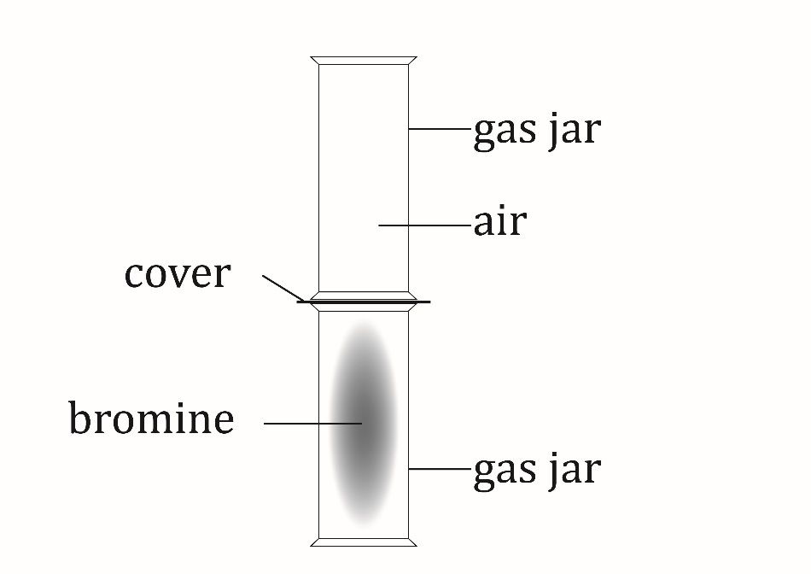

Learner answer:

It spreads out and diffuses filling the gas jar. This is because the surrounding volume has increased and the particles start colliding together. The entropy has stayed the same because it is still a gas.

- Describe how the entropy changes when one mole of solid sodium chloride dissolves in water. Include an equation in your explanation.

Learner answer:

The entropy increases because the lattice is broken down and so the sodium chloride becomes more random.
$$NaCl+aq → {Na}^{+}+ {Cl}^{-}$$

- Complete the sketch graph of entropy against temperature for potassium chloride to illustrate the entropy changes as temperature increases, and the potassium chloride changes state. Label any significant changes on the graph. The vertical axis does not have to be to scale.

The melting point of potassium chloride is 770$°C$ and the boiling point is 1420$°C$.

Learner answer:

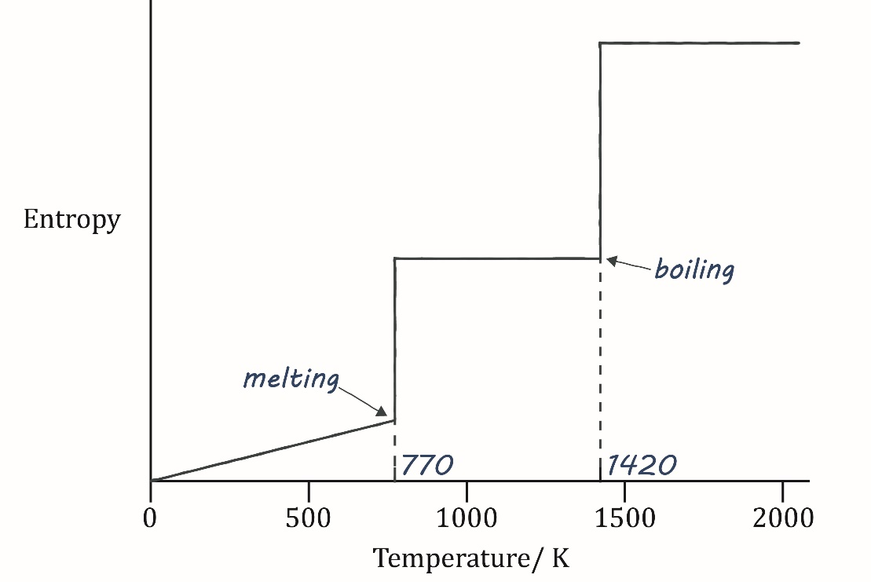

- When zinc carbonate is heated, it decomposes. The symbol equation for the reaction is:
$$ZnCO_{3}\left(s\right)→ ZnO\left(s\right)+ {CO}_{2}(g)$$

 | $$ZnCO_{3}(s)$$ | $$ZnO(s)$$ | $$CO_{2}(g)$$
$${{ ΔH}_{f}}^{° }(kJ {mol}^{-1})$$ | –812 | –348 | –394
$${ΔS}^{° }(J K^{-1} {mol}^{-1})$$ | 83 | 44 | 214

- Calculate $ΔH°$, $ΔS°$ and $ΔG°$ for this reaction at 298 $K$. Give signs and units with your answers.

Learner answer:

$$ΣΔH° \left(products\right)=-348+(-394)$$

$$=-742 kJ {mol}^{-1}$$

$$ΣΔH° \left(reactants\right)=-812 kJ {mol}^{-1}$$

$${ΔH°}_{reaction}=-742-(-812)$$

$$=\left(+\right)70 kJ {mol}^{-1}$$

$${ΔS°}_{total}= {ΔS°}_{system}+ {ΔS°}_{surroundings}$$

$$ΣΔS° \left(products\right)=44+214$$
$$=258 J {K^{-1} mol}^{-1}$$
$$ΣΔS° \left(reactants\right)=83 J {K^{-1} mol}^{-1}$$
$${ ΔS°}_{system}=258 –83$$
$$=(+)175 J K^{-1} {mol}^{-1}$$

$${ ΔS°}_{surroundings}=-\frac{ΔH}{T}$$
$$=-\frac{70,000}{298}$$
$$=234.9 J K^{-1} {mol}^{-1}$$

$${ΔS°}_{total}=175+ 234.9$$
$$=(+)409.9 J K^{-1} {mol}^{-1}$$

$$ΔG°=ΔH°-TΔS°$$
$$=70,000-\left(298×409.9\right)$$
$$=(+)52,150.2$$
$$=(+)52.2 kJ {mol}^{-1}$$

- State whether the reaction is feasible or not at 298 $K$. Suggest a reason for your answer.

Learner answer:

Yes, because $ΔG° is positive.$

- Calculate the minimum temperature at which the decomposition of $ZnCO_{3 }$is feasible.

Learner answer:
$$ΔG°=ΔH°-TΔS°$$
$$TΔS°=ΔH°-ΔG°$$
$$T=\frac{ΔH°}{ΔS°}$$
$$=\frac{70,000}{175}$$
$$=400℃$$

