Qualitative tests for organic functional groups: supporting resources

This resource supports the practical video Qualitative tests for organic functional groups, available here: https://rsc.li/3hmgvVM

Contents

Teacher notes
How to use this video . . . . . . . . . . . . . . . . . . . . . . . . . . . . . . . . . . . . . . . . . . . . . . . . . . . . . . 2
Notes on running the practical experiments . . . . . . . . . . . . . . . . . . . . . . . . . . . . . . . . . . . . . . . . 2
Prior knowledge . . . . . . . . . . . . . . . . . . . . . . . . . . . . . . . . . . . . . . . . . . . . . . . . . . . . . . . . . 3
Common misconceptions . . . . . . . . . . . . . . . . . . . . . . . . . . . . . . . . . . . . . . . . . . . . . . . . . . . . 3
Intended outcomes video . . . . . . . . . . . . . . . . . . . . . . . . . . . . . . . . . . . . . . . . . . . . . . . . . . . 4
How to use the additional resources . . . . . . . . . . . . . . . . . . . . . . . . . . . . . . . . . . . . . . . . . . . . . 5

Additional resources
Pause-and-think questions: teacher version . . . . . . . . . . . . . . . . . . . . . . . . . . . . . . . . . . . . . . . . 6
Pause-and-think questions: student version . . . . . . . . . . . . . . . . . . . . . . . . . . . . . . . . . . . . . . . . 9
Follow-up worksheet . . . . . . . . . . . . . . . . . . . . . . . . . . . . . . . . . . . . . . . . . . . . . . . . . . . . . . 10
Follow-up worksheets: answers . . . . . . . . . . . . . . . . . . . . . . . . . . . . . . . . . . . . . . . . . . . . . . . . 13
Printable results table . . . . . . . . . . . . . . . . . . . . . . . . . . . . . . . . . . . . . . . . . . . . . . . . . . . . . 14

Teacher notes
This resource supports the practical video Qualitative tests for organic functional groups, available at: rsc.li/3hmgvVM

The value of experiencing live practical work cannot be overstated. Numerous studies provide evidence of its value in terms of learner engagement, understanding, results and the likelihood of continuing to study chemistry or work in a related field. This video can be used to complement live practical work, as well as help learners to understand the methods, equipment and skills when they cannot access the lab.

How to use this video
The video and additional resources are designed to be used flexibly, but some suggestions follow.

Flipped learning
Learners view the video ahead of the live practical lesson to help it run more smoothly and keep objectives in focus. This may also help build confidence for some learners and improve their outcomes in the lesson. Use questions from the pause-and-think set provided as part of the preparation task.

Consolidation and revision
Learners view the video after the practical – this may be directly after the lesson or learners can return to it as part of their revision for examinations.

Revisiting a practical with a different focus
A practical experiment can support many learning outcomes. Focusing on just one or two of those in a lesson will help ensure that the aims are achieved. The video could be used to revisit the experiment with a different focus.

Home learning
Whether it is remote teaching, homework, or individual learner absence, the video provides an opportunity to engage with a practical experiment and the associated skills when learners are not in the lab.

Other tips
- Provide your own commentary
Mute the voice over and provide your own commentary. This will allow you to better engage with learners and adapt to the needs and objectives of your lesson.
- Use questions
A set of pause-and-think questions are provided in two formats, one for teacher-led questions and discussion and a student worksheet which can be used independently by learners. Select from these or create your own questions to help engage learners and target specific aims.

Notes on running the practical experiment
Technician notes including the equipment list and safety notes are available as a separate document here: rsc.li/3hmgvVM. If you are planning to carry out the practical, you will need to carry out your own risk assessment.

Qualitative tests of organic functional groups appear in all 16–18 courses in the UK. Not all tests will be on all specifications; this video aims to cover quite a comprehensive list. When running the experiment, a reduced or adapted list of samples, relevant to your own course, may be more suitable. The six samples in this investigation include the following organic functional groups:
- alkene
- aldehyde
- ketone
- alcohol
- carboxylic acid
- haloalkane
Crucially, the video demonstrates the importance of learners using the tests for identification of unknown substances; it is not enough to just be able to recall how to carry out each test. Therefore, provide a context in which learners can plan a sequence of tests – the less the better! – to match a set of unlabelled organic compounds to a list. This experiment requires a solid understanding of the tests and a logical approach to deduce the identities through positive/negative results and a process of elimination.

Instructions for learners
A student sheet with instructions for carrying out the experiment is available here: rsc.li/3hmgvVM

Results tables
A printable and editable table for learners to plan and record their own investigation is provided in this booklet.

Further practical activities
There is overlap with chemical tests for inorganic compounds in this experiment, with the identification of haloalkane and metal halide precipitates. Inorganic chemical tests provides suggestions for practical activities and links.

Prior knowledge
In order for learners to correctly analyse and identify the components of an unknown molecule/mixture they need to have a good working knowledge and understanding of the different functional groups that could be present. They should be able to:
- Identify aldehydes, ketones, alcohols, carboxylic acids, alkenes and haloalkanes.
- Name and draw different organic compounds that include the complete range of functional groups and 1⁰, 2⁰ and 3⁰ alcohols.

Learners should be able to describe:
- The oxidation of alcohols and aldehydes using acidified potassium dichromate and understand that there is no oxidation reaction with 3⁰ alcohols and ketones.
- Nucleophilic substitution and the hydrolysis of haloalkanes.
- Electrophilic addition of alkenes.
- Halide tests in inorganic chemistry.
- Neutralisation reactions with metal carbonate.

Common misconceptions
Be aware of misconceptions learners may have around this practical, for example:
- Learners often think molecules only contain one functional group and don’t appreciate that in fact many organic molecules contain more than one functional group. To overcome this belief, learners should be exposed to compounds that have more than one functional group. This will help them to understand that these tests characterise part of a molecule. In other words, they should be shown that a single compound can be positive for two different tests, indicating the presence of two functional groups.
- Many learners think that the best way to identify an unknown functional group is through trial and error. If you do all the tests, then eventually there will be a positive result. However, a better way is to take an investigative approach and start off by making a chemical test chart; in which the result of one test will help inform the next test you do. This systematic approach should save a lot of time and reduce wastage.
- Learners often think that they can get away with just learning the test and positive result for each different functional group. Unless they can apply this knowledge and work their way through a problem they will struggle to link this practical work to the theory they are leaning. This will not help them when it comes to answering the exam questions. As shown by the list of prior knowledge, there are many links to theory from various areas of chemistry.

Intended outcomes
It is important that the purpose of each practical is clear from the outset, defining the intended learning outcomes helps to consolidate this. Outcomes can be categorised as hands on, what learners are going to do with objects, and minds on, what learners are going to do with ideas to show their understanding. We have offered some differentiated suggestions for this practical. You may wish to focus on just one or two, or make amendments based on your learners’ own needs. (Read more at rsc.li/2JMvKa5).
Consider how you can share outcomes and evaluations with learners, empowering them to direct their own learning.

Hands on Minds on

Effective at a lower level Learners correctly:
- Follow instructions to carry out the experimental techniques or procedures
- Safely use a range of practical equipment and materials
- Make observations relevant to the experiment

Effective at a higher level Learners correctly:
- Carry out techniques and procedures methodically, in sequence and in combination, identifying practical issues and making adjustments when necessary
- Use appropriate safety equipment and approaches to minimise risks with minimal prompting
- Make accurate observations relevant to the experimental or investigative procedure

Learners can:
- Recall procedure including key reagents and conditions needed for qualitative tests of organic functional groups
- Predict the positive result of the qualitative test in order to identify the functional group present

Learners can:
- Devise an appropriate method to identify the functional groups present in an unknown organic substance
- Apply knowledge of these tests to identify an unknown solution(s)
- Relate prior knowledge of synthetic routes to explain results observed

How to use the additional resources

Using the pause-and-think questions
Pause-and-think questions are supplied in two formats: a teacher version for ‘live’ questioning and a student version which can be used during independent study. The time stamps allow you to pause the video when presenting to a class, or learners to use for active revision.

Teacher version
The questions are presented in a table and you can choose to use as many as appropriate for your class and the learning objectives.

Some questions have two timestamps to allow you to adapt the questions for different classes or scenarios. Pause the videos at the earlier timestamp to ask a question before the answer is given, useful for revision or to challenge learners. Pause at the later timestamp to ask a question reflectively and assess whether learners have understood what they have just heard or seen. This would be useful when introducing a topic, in a flipped learning scenario or when additional support and encouragement is needed.

Think about how you will ask for responses. Variation may help to increase engagement – learners could write and hold up short answers; more complex questions could be discussed in groups.

Not all answers to questions are included in the video. Some of the questions will draw on prior learning or extend learners’ thinking beyond the video content.

Student version
The same questions are offered as a printable worksheet for learners. Use in situations where there is not a teacher present to guide discussion during the video, for example homework, revision or remote learning.

Using the follow-up worksheet
A follow-up worksheet has been included as part of the additional resources, available here: rsc.li/38LiKx6 . This worksheet could be used to follow up the practical activity, for example as homework or a revision exercise.

Pause-and-think questions

Teacher version

Timestamp(s) | Question | Answer/discussion points
01:09 | What is the difference between qualitative analysis and quantitative analysis? | Qualitative analysis is where we find out something about the identity or nature of an unknown, for example which functional groups are present in an unknown sample. Chemical tests are an example of qualitative analysis. Quantitative analysis is where we identify the amount of a substance present, eg the actual concentration of a compound.
01:18 | What will we be looking for during the chemical tests? How will you know if a test has a positive result? | Signs that a chemical change has taken place, eg colour change, formation of a gas, temperature change, formation of a solid or a precipitate.  A positive result occurs when the expected change takes place and the result is repeatable. However, not all positive tests are conclusive, for example more than one functional group could give the same result. Further tests will then be needed to make the final distinctions.
01:23/01:29 | How will you ensure that you don’t mix up your results? | By making sure that everything is labelled and results are noted down as they occur.
02:31/03:13 | Describe and explain what a positive result will look like when the metal carbonate is added. | You will see effervescence as the carbonate reacts with the carboxylic acid to produce a salt, water and carbon dioxide gas.
03:40/03:42 | In this experiment, what functional group are we testing for? | The presence of a double bond or unsaturated hydrocarbon.  This test also gives a positive result for carbonyls (ie aldehydes and ketones) but as this is not covered in most post-16 courses, learners will not know this and will be surprised by the result.
04:00/04:04 | What does a positive result look like? How can we explain this result? | A colour change from orange/brown to colourless. One explanation is that an electrophilic addition reaction has taken place as the bromine molecule has added across the double bond. However, due to the unexpected result there must be other explanations too!
05:33 | What is the test to identify the haloalkane functional group? | The most effective way is to do a substitution reaction in which the halogen atom is reduced to a halide ion, and then to test for that ion with silver nitrate solution.  Warm the sample with sodium hydroxide solution in a mixture of ethanol and water. Everything will dissolve in this mixture for a good reaction.  The mixture is acidified by adding dilute nitric acid. (This prevents unreacted hydroxide ions reacting with the silver ions to give a confusing brown precipitate of silver hydroxide).  Then silver nitrate solution is added and you see a white, cream or yellow precipitate if chloride, bromide or iodide ions are present respectively, indicating a positive test for the haloalkane functional group.  Note the test shown in the video does not use sodium hydroxide and therefore the addition of nitric acid is not required. It produced the same expected results.

08:13 | Draw and name the primary, secondary and tertiary alcohol with the formula C₄H₉OH. | Primary: butan-1-ol  CH₃CH₂CH₂CH₂OH or  Secondary: butan-2-ol  CH₃CH₂CH(OH)CH₃ or  Tertiary: 2-methylpropan-2-ol  CH₃C(CH₃)(OH)CH₃  or
09:45 | When an alcohol is oxidised what is the functional group of the product? | It depends on the alcohol:  - Primary alcohols are oxidised to aldehydes RCHO and then carboxylic acids RCOOH.  - Secondary alcohols are oxidised to ketones RCOR.  - Tertiary alcohols are not oxidised.
10:05 | Draw a 2,4-DNPH molecule. | (O₂N)₂C₆H₃NHNH₂  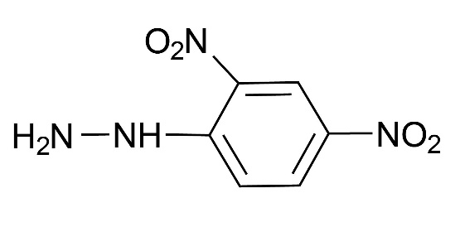
10:56 | Can you draw a structural diagram for any of the reactions taking place? | 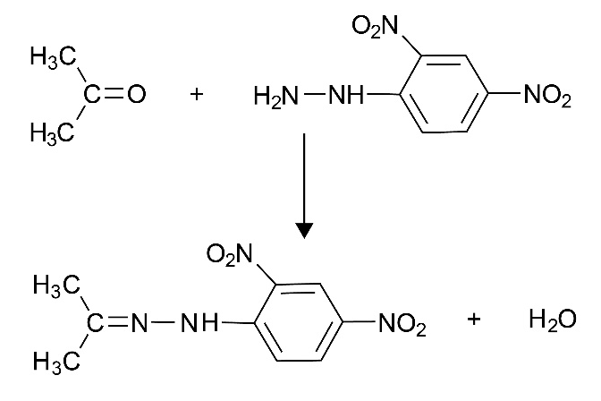
12:21 | Write an ionic equation for the formation of the silver mirror. | Ag⁺(aq) + e⁻ Ag(s)  OR to show the full half equations  [Ag(NH₃)₂] ⁺ + e⁻ Ag + 2NH₃  RCHO + 3OH⁻ RCOO⁻ + 2H₂O + 2e⁻
13:35 | Why are we not using a Bunsen burner to heat the test solutions? | To control the temperature. The best mirrors appear when the silver deposits are allowed to build up slowly at temperatures below 70⁰C. Heating directly in the Bunsen flame could lead to heating up the solution too quickly and to a high temperature. Also, it is best to avoid heating with naked flames when working with flammable liquids.

Pause-and-think questions

Student version
Pause the video at the time stated to test or revise your knowledge of these practical experiments.
Time Question
01:09 What is the difference between qualitative analysis and quantitative analysis?
01:18 What will we be looking for during the chemical tests? How will you know if a test has a positive result?
01:23 How will you ensure that you don’t mix up your results?
02:31 Describe and explain what a positive result will look like when the metal carbonate is added.
03:40 In this experiment, what functional group are we testing for?
04:00 What does a positive result look like? How can we explain this result?
05:33 What is the test to identify the haloalkane functional group?
08:13 Draw and name the primary, secondary and tertiary alcohol with the formula C₄H₉OH.
09:45 When an alcohol is oxidised what is the functional group of the product?
10:05 Draw a 2,4-DNPH molecule.
10:56 Can you draw a structural diagram for any of the reactions taking place?
12:21 Write an ionic equation for the formation of the silver mirror.
13:35 Why are we not using a Bunsen burner to heat the test solutions?

Follow-up worksheet
Part 1
The video Qualitative tests for organic functional groups, available at: rsc.li/3hmgvVM, shows an investigation to identify six unknown samples, one from each of the following organic functional groups:
- alkene
- aldehyde
- ketone
- alcohol
- carboxylic acid
- haloalkane

The results of the tests applied to each sample are given in the table below:
Test for... | carboxylic acids | unsaturated hydrocarbons | haloalkanes | alcohols | carbonyl groups | aldehydes
Test used... | metal carbonate | bromine water | silver nitrate | acidified potassium dichromate | 2,4-DNPH | Tollens’ reagent
A | no change | colour change: orange to colourless | no change | colour change: SLOW | no change
B | no change | no change | no change | colour change: orange to green | no change
C | no change | colour change: orange to colourless | no change | colour change: orange to green | yellow/orange precipitate | silver mirror
D | no change | no change | no change | no change | yellow/orange precipitate
E | no change | no change | cream precipitate
F | effervescence

- Use these results to determine the functional group present in each sample.
- For each unknown explain how you came to your conclusion. You may wish to include an equation in your answer.

Part 2: Functional group test match up

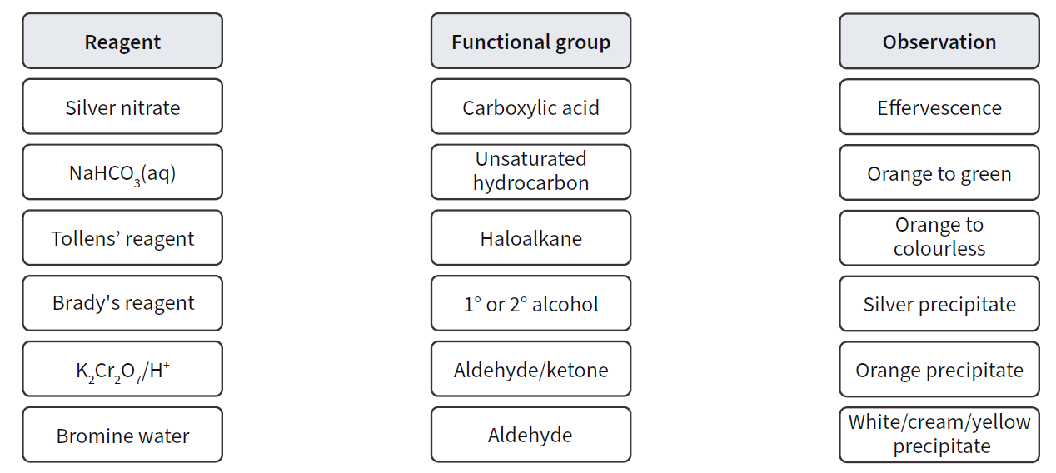
- Match up the reagents with the functional groups they test for and the observation for a positive test.

Part 3 Simple chemical tests

- On the shelf below is a selection of reagents that can be used in simple tests to identify particular functional groups. Identify the reagent(s) that can be used to distinguish between the pairs of organic compounds shown on the next page.
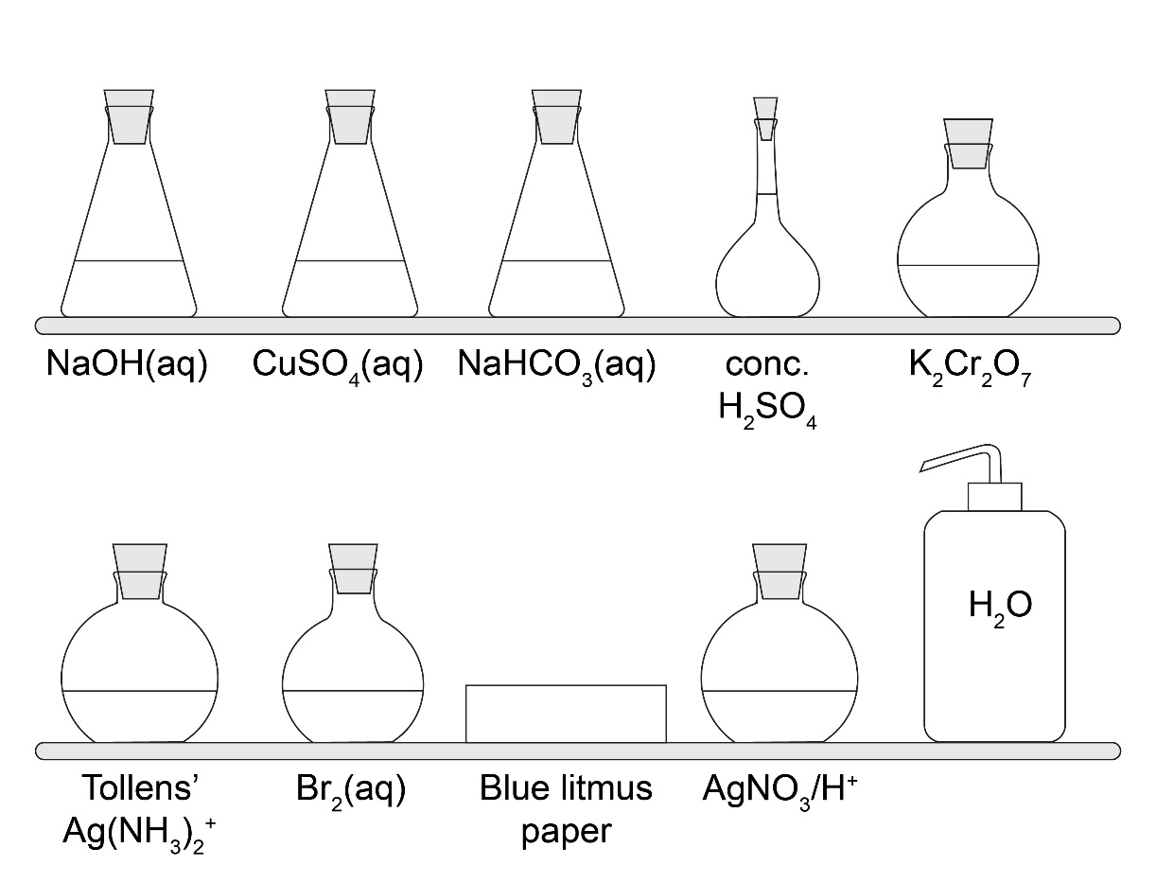

A | B
C | D
CH₃CH₂CH₂OH | (CH₃)₃COH
E | F
CH₃CH₂Br | CH₃CH₂CH₂CH₃
G | H
I | J
K | L

Parts 2 and 3 adapted from Starters for 10: Structure determination – 8.2 functional groups.

Follow-up worksheet: answers
- Use the results to determine the functional group present in each sample.
Sample | Functional group present
A | alkene
B | alcohol
C | aldehyde
D | ketone
E | haloalkane containing bromine
F | carboxylic acid

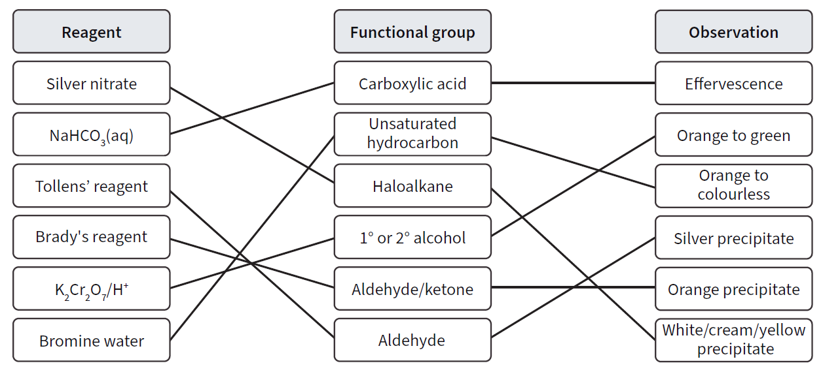
Match up the reagents with the functional groups they test for and the observation for a positive test.
- Simple chemical tests

A and B – NaHCO₃(aq)

C and D – Water and blue litmus paper

E and F – K₂Cr₂O₇ and H₂SO₄

G and H – AgNO₃/H⁺

I and J – Br₂(aq)

K and L – Tollens’ reagent and CuSO₄/NaOH

Test for...
Test used... |  |  |  |  |  |  | Functional group present
A
B
C
D
E
F

