Compounds as ions
Education in Chemistry
March 2020
rsc.li/33qaoHE
Split each compound into its ions:
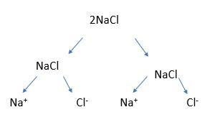
- Draw a graphical representation.
- Write it out.

eg 2NaCl = = 2Na⁺ + 2Cl⁻

Section 1:
NaCl
NaF
LiF
KBr
CaO
BaO
BaS
KI
AlN
GaP

Section 2:
2NaBr
3KI
4MgO
InN
5SrS

Section 3:
CaCl₂
AlCl₃
Na₂O
CaO
Al₂O₃
Li₂S
2Li₂S
3Li₂S
5MgCl₂
8Na₃N
Potassium fluoride
Potassium oxide
Potassium nitride
Calcium nitride

Section 4:
NaOH
Na₂SO₄
Na₂CO₃
2Na₂CO₃
6Li₂CO₃
LiOH
Ca(OH)₂
Al(OH)₃
4Al(OH)₃
MgSO₄
2MgSO₄
Al₂(SO₄)₃
3Al₂(SO₄)₃

Section 5:
2K₂SO₄
CO₂
2CH₄
4Be(OH)₂
Aluminium iodide
Water
Sodium sulfate

Section 6:
Ga(OH)3 (s)
Ga(OH)3 (l)
Ga(OH)3 (aq)
Cl2(aq)
3NaCl(s)
3NaCl(aq)
A solution of potassium iodide
Melted barium fluoride

