Brady’s test for aldehydes and ketones – teacher notes

In this experiment students add various liquid aldehydes and ketones to 2,4- dinitrophenylhydrazine to form solid derivatives. To show that the reaction does not occur with alcohols they also do the test with methanol and ethanol.

Topic

Aldehydes and ketones

Timing

15 minutes

Equipment

Apparatus

- Eye protection
- Plastic well-plate, 24 wells (eg Sigma ref: M 9655)

For preparation of 2,4-dinitrophenylhydrazine:

- Beaker, 100 cm³

Chemicals

Solutions should be contained in plastic pipettes – see the accompanying guidance on apparatus and techniques for microscale chemistry (https://rsc.li/3vT4w71), which includes instructions for preparing solutions.

- Ethanol
- Propanone
- p-Methoxybenzaldehyde (or other aromatic aldehyde or ketone)
- Methanol
- Ethanal (Acetaldehyde)
- Solution of 2,4-dinitrophenylhydrazine (see preparation notes below) – requires 24 hours to dissolve completely

For preparation of 2,4-dinitrophenylhydrazine:

- Deionised water

Preparing a solution of dinitrophenylhydrazine

- Weigh out 0.5 g of 2,4-dinitrophenylhydrazine and dissolve in 10 cm³ of concentrated sulfuric acid in a 100 cm³ beaker. (Leave overnight to allow the compound to dissolve completely.)
- Add this solution carefully to a solution of 15 cm³ of ethanol and 5 cm³ of deionised water. This gives the yellow-brown stock solution.

The solution can be used for about 10 days but it gradually deteriorates as a precipitate forms.

This procedure is based on that described in L. Harwood and R. Moody, Experimental organic chemistry – principles and practice, p 242. Oxford: Blackwell Scientific, 1989.

Observations

Compound | Observation
Ethanal | Immediate yellow precipitate
Propanone | Yellow, crystalline precipitate forms slowly (after 1–2 minutes)
p -Methoxybenzaldehyde (or other aromatic aldehyde or ketone) | Immediate red precipitate
Methanol | No change
Ethanol | No change

The reaction between propanone and dinitrophenylhydrazine:
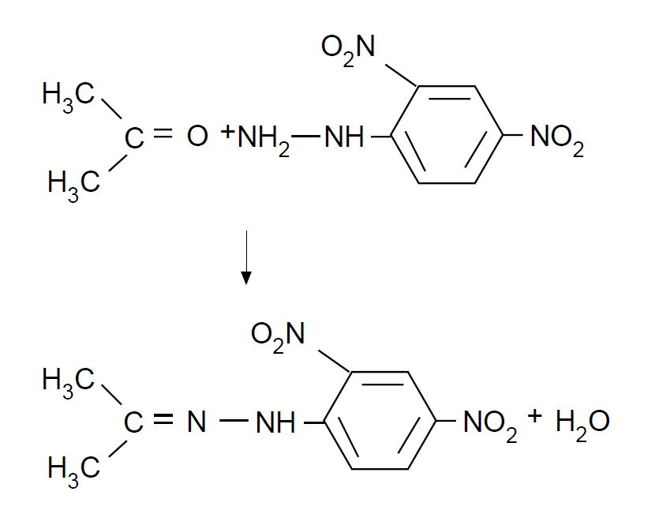

Health, safety and technical notes

- Read our standard health and safety guidance (https://rsc.li/2RXlD8Q).
- Wear eye protection throughout (splash-resistant goggles to BS EN166 3).
- 2,4-dinitrophenylhydrazine, (NO₂)₂C₆H₃NHNH₂(s) – see CLEAPSS Hazcard HC030 and CLEAPSS Recipe Book RB033. 2,4-dinitrophenylhydrazine is FLAMMABLE and HARMFUL if swallowed. It is also dangerous in contact with oxidising agents, and can potentially become explosive if allowed to dry out completely. Avoid skin contact.
- Concentrated sulfuric acid, H₂SO₄(aq) – see CLEAPSS Hazcard HC098a and CLEAPSS RB098. Concentrated sulfuric acid is CORROSIVE and OXIDISING.
- Propanone – see CLEAPSS Hazcard HC085A and CLEAPSS Recipe Book RB002. Propanone is highly FLAMMABLE and IRRITANT to eyes and the respiratory system.
- p-Methoxybenzaldehyde is of low hazard.
- Methanol – see CLEAPSS Hazcard HC040b. Methanol is highly FLAMMABLE, TOXIC by all routes and causes damage to organs (particularly CNS and optic nerve). Propanol could be used as a safer alternative to methanol. It is FLAMMABLE (see CLEAPPS Hazcard HC084A).
- Ethanal (acetaldehyde) – see CLEAPSS Hazcard HC034. Ethanal is highly FLAMMABLE, a carcinogen and an eye/respiratory IRRITANT. Protect face when opening containers and ensure laboratory is well-ventilated. Avoid contact with sulfuric acid – violent polymerisation occurs.

